Worship Prayer…

Father in heaven, I admit I am a sinner and cannot save myself, but trust only in your Son Jesus Christ—true God and true man—who died on the cross for me and rose again to give me new life now and forever. By your Holy Spirit’s power take my heart and life and make me yours; turn me from my own selfish path to always love, trust and follow Jesus. Because you love and forgive me, help me forgive and love others. And now, as we gather together as your church in this place, make us one in truth and love according to the faithful leading and unfailing promises of your living Word. In Jesus’ name….Amen!

Living Word exists to…

- Proclaim God’s Love

- Expand God’s Kingdom

- Mature God’s People

- Live God’s Word!

Pastor Steve Lee
revstevelee@gmail.com
708-334-5883

Living
Word

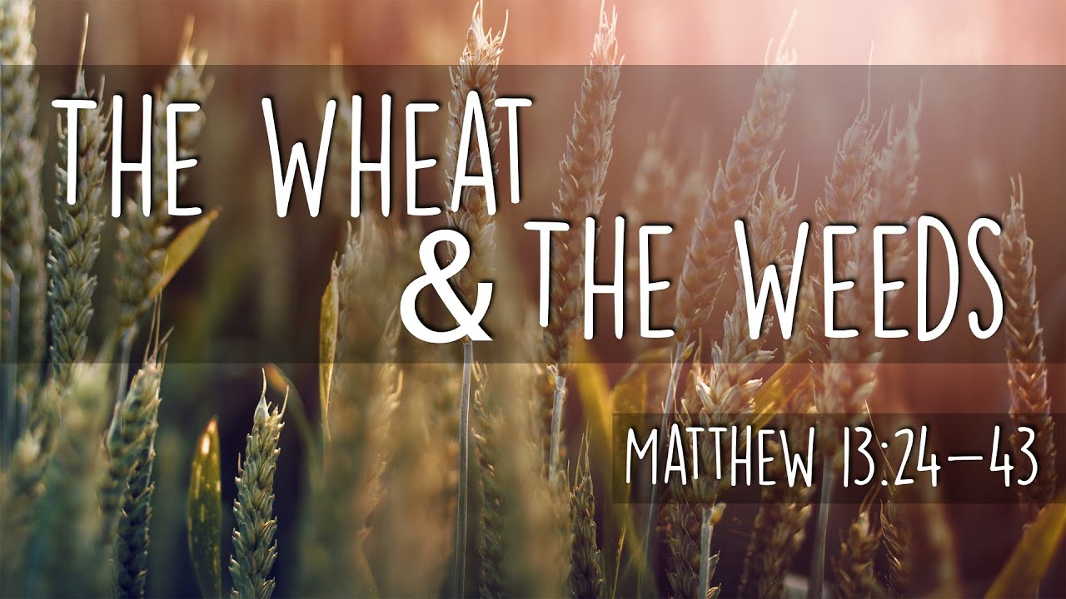

7th Sunday after Pentecost
July 19, 2020
10:00 am Service

‘Come grow with us!’

Living Word Lutheran Church (LCMS)
16301 Wolf Rd, Orland Park, IL 60467
livingwordorland.org (708) 403-9673
WELCOME TO LIVING WORD!

Our candles remind us the Light of the World Jesus Christ is here!
Blue information card, hymnal & Bible are in seat pocket.
Songs/readings on screen—also in Hymnals/Bibles.

WE REJOICE IN GOD’S LOVE…

Welcome & Theme Intro The Parable of the Weeds
youtube.com/watch?v=rQVeIrQTiPo

Opening Prayer & Praise “I Will Delight”

Invocation

Affirmation of Faith: 6th & 7th Lord’s Prayer Petitions & Explanation

WE RECEIVE GOD’S WORD…

Today’s Psalm Psalm 119:57-64

Scripture Readings Facing page

Message Hymn “Great Hope”

Message “Lost in the Weeds” ??

WE RESPOND TO GOD’S CALL…

Prayer of Confession & Forgiveness

Prayers of God’s People & Lord’s Prayer

Communion

Benediction

Closing Song “Rock of Ages”

Please place offerings in basket at sanctuary entrance
“Lost in the Weeds” ??

The Psalmist tells us: “I will hasten and not delay to obey your commands. Though the wicked bind me with ropes, I will not forget your law.” Don’t get tied up and lost in the weeds...

1) Don’t get lost in the weeds of witness.
Do not tremble, do not be afraid. Did I not proclaim this and foretell it long ago? You are my witnesses. Is there any God besides me? No, there is no other Rock; I know not one.” Isaiah 44:8

2) Don’t get lost in the weeds of waiting or weakness.
²² We know that the whole creation has been groaning as in the pains of childbirth right up to the present time. ²³ Not only so, but we ourselves, who have the first fruits of the Spirit, groan inwardly as we wait eagerly for our adoption to sonship, the redemption of our bodies. ²⁴ For in this hope we were saved. But hope that is seen is no hope at all. Who hopes for what they already have? ²⁵ But if we hope for what we do not yet have, we wait for it patiently. ²⁶ In the same way, the Spirit helps us in our weakness. We do not know what we ought to pray for, but the Spirit himself intercedes for us through wordless groans. ²⁷ And he who searches our hearts knows the mind of the Spirit, because the Spirit intercedes for God’s people in accordance with the will of God. Romans 8:22-27

3) Don’t get lost in the weeds of the world.
³⁷ He answered, “The one who sowed the good seed is the Son of Man. ³⁸ The field is the world, and the good seed stands for the people of the kingdom. The weeds are the people of the evil one, ³⁹ and the enemy who sows them is the devil. The harvest is the end of the age, and the harvesters are angels. ⁴⁰ “As the weeds are pulled up and burned in the fire, so it will be at the end of the age. ⁴¹ The Son of Man will send out his angels, and they will weed out of his kingdom everything that causes sin and all who do evil. ⁴² They will throw them into the blazing furnace, where there will be weeping and gnashing of teeth. ⁴³ Then the righteous will shine like the sun in the kingdom of their Father. Whoever has ears, let them hear. Matthew 13:36-43

