Worship Prayer…

Father in heaven, I admit I am a sinner and cannot save myself, but trust only in your Son Jesus Christ—true God and true man—who died on the cross for me and rose again to give me new life now and forever. By your Holy Spirit’s power take my heart and life and make me yours; turn me from my own selfish path to always love, trust and follow Jesus. Because you love and forgive me, help me forgive and love others. And now, as we gather together as your church in this place, make us one in truth and love according to the faithful leading and unfailing promises of your living Word. In Jesus’ name….Amen!

Living Word exists to…

- Proclaim God’s Love

- Expand God’s Kingdom

- Mature God’s People

- Live God’s Word!

Pastor Steve Lee
revstevelee@gmail.com
708-334-5883

Anita Meier - Musician
Diana Motel – Livestream/Tech Booth
Paul Huang – Livestream/Tech Booth

Living
Word

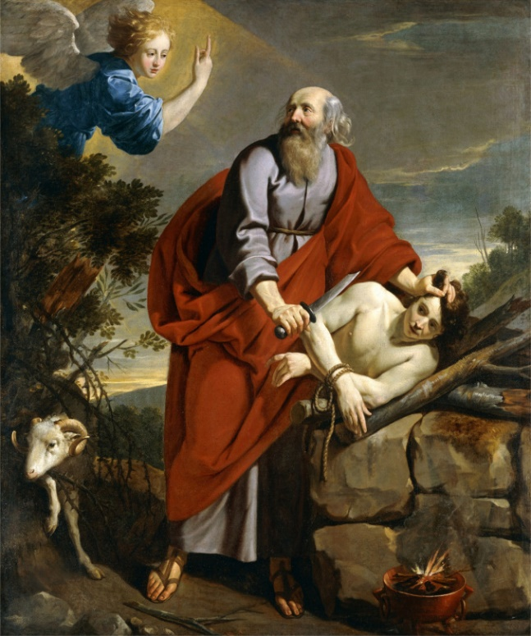

1st Sunday in Lent
February 21st, 2021
10:00 am Service

‘Come grow with us!’

Living Word Lutheran Church (LCMS)
16301 Wolf Rd, Orland Park, IL 60467
livingwordorland.org (708) 403-9673
WELCOME TO LIVING WORD!

Our candles remind us the Light of the World Jesus Christ is here!
Blue information card, hymnal & Bible are in seat pocket.
Songs/readings on screen—also in Hymnals/Bibles.

WE REJOICE IN GOD’S LOVE…

Welcome

Opening Prayer & Praise “God Will Make a Way”
“He Is Able”
Invocation

Affirmation of Faith: 1st Article of Apostles’ Creed with Explanation

WE RECEIVE GOD’S WORD…

Today’s Psalm Psalm 25:1-10

Scripture Readings Facing page

Message Hymn “I Am Trusting You, Lord Jesus”

Theme Intro Abraham, Mount Moriah and Christ's Sacrifice
youtube.com/watch?v=R9oOJwXgYqU 0:00 to 3:30

Message “In God we Trust”

WE RESPOND TO GOD’S CALL…

Prayer of Confession & Forgiveness

Prayers of God’s People & Lord’s Prayer

Communion “You Are My Hiding Place”

Benediction

Closing Song “Shout To The Lord”

Please place offerings in basket at sanctuary entrance
“In God We Trust”

1) I trust in God’s PROVISION.
God tested Abraham. He said to him, “Abraham!” “Here I am,” he replied. ² Then God said, “Take your son, your only son, whom you love—Isaac—and go to the region of Moriah. Sacrifice him there as a burnt offering on a mountain I will show you...” ³ Early the next morning Abraham got up and loaded his donkey. He took with him two of his servants and his son Isaac. When he had cut enough wood for the burnt offering, he set out for the place God had told him about. ⁴ On the third day Abraham looked up and saw the place in the distance. ⁵ He said to his servants, “Stay here with the donkey while I and the boy go over there. We will worship and then we will come back to you.” ⁶ Abraham took the wood for the burnt offering and placed it on his son Isaac, and he himself carried the fire and the knife. As the two of them went on together, ⁷ Isaac spoke up and said to his father Abraham, “Father?” “Yes, my son?” Abraham replied. “The fire and wood are here,” Isaac said, “but where is the lamb for the burnt offering?” ⁸ Abraham answered, “God himself will provide the lamb for the burnt offering, my son…” ⁹ When they reached the place God had told him about, Abraham built an altar there and arranged the wood on it. He bound his son Isaac and laid him on the altar... ¹⁰ Then he reached out his hand and took the knife to slay his son. ¹¹ But the angel of the Lord called out to him from heaven, “Abraham! Abraham!” “Here I am,” he replied. ¹² “Do not lay a hand on the boy,” he said. “Do not do anything to him. Now I know that you fear God, because you have not withheld from me your son, your only son.” ¹³ Abraham looked up and there in a thicket he saw a ram caught by its horns. He went over and took the ram and sacrificed it as a burnt offering instead of his son. ¹⁴ So Abraham called that place The Lord Will Provide.
Genesis 22:1-14a

2) I hope in God’s PROMISES.
¹² Blessed is the one who perseveres under trial because, having stood the test, that person will receive the crown of life that the Lord has promised to those who love him. James 1:12

3) I rest in God’s PROTECTION.
⁹ At that time Jesus came from Nazareth in Galilee and was baptized by John in the Jordan. ¹⁰ Just as Jesus was coming up out of the water, he saw heaven being torn open and the Spirit descending on him like a dove. ¹¹ And a voice came from heaven: “You are my Son, whom I love; with you I am well pleased.” ¹² At once the Spirit sent him out into the wilderness, ¹³ and he was in the wilderness forty days, being tempted by Satan. He was with the wild animals, and angels attended him. Mark 1:9-13

