Worship Prayer…

Father in heaven, I admit I am a sinner and cannot save myself, but trust only in your Son Jesus Christ—true God and true man—who died on the cross for me and rose again to give me new life now and forever. By your Holy Spirit’s power take my heart and life and make me yours; turn me from my own selfish path to always love, trust and follow Jesus. Because you love and forgive me, help me forgive and love others. And now, as we gather together as your church in this place, make us one in truth and love according to the faithful leading and unfailing promises of your living Word. In Jesus’ name….Amen!

Living Word exists to…

- Proclaim God’s Love

- Expand God’s Kingdom

- Mature God’s People

- Live God’s Word!

Pastor Steve Lee
revstevelee@gmail.com
708-334-5883

Anita Meier - Musician
Diana Motel – Livestream/Tech Booth
Paul Huang – Livestream/Tech Booth

Living
Word

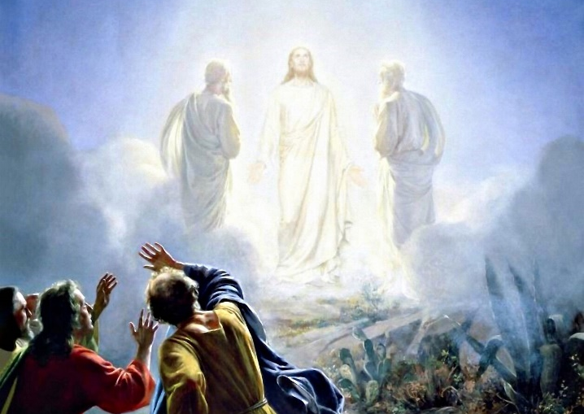

Transfiguration Sunday
February 14th, 2021
10:00 am Service

‘Come grow with us!’

Living Word Lutheran Church (LCMS)
16301 Wolf Rd, Orland Park, IL 60467
livingwordorland.org (708) 403-9673
WELCOME TO LIVING WORD!

Our candles remind us the Light of the World Jesus Christ is here!
Blue information card, hymnal & Bible are in seat pocket.
Songs/readings on screen—also in Hymnals/Bibles.

WE REJOICE IN GOD’S LOVE…

Welcome

Opening Prayer & Praise “Come & Behold Him”

“Open the Eyes of My Heart”
Invocation

Affirmation of Faith: 2nd Article of Apostles Creed with Explanation

WE RECEIVE GOD’S WORD…

Today’s Psalm Psalm 50:1-6

Scripture Readings Facing page

Message Song “I See The Lord”

Theme Intro Mountain of Transfiguration Location
youtube.com/watch?v=B6jDW36a3ps 0:00 to 1:41

Message “Perfect in Beauty”

WE RESPOND TO GOD’S CALL…

Prayer of Confession & Forgiveness

Prayers of God’s People & Lord’s Prayer

Benediction

Closing Song “This Kingdom”

Please place offerings in basket at sanctuary entrance
“Perfect in Beauty”
Today our Psalm says, “From Zion, perfect in beauty, God shines forth.” God shines forth to us in Jesus Christ, who is perfect in beauty.

1) Perfect in beauty, Christ shines behind MOSES’ veil.
²⁹ When Moses came down from Mount Sinai with the two tablets of the covenant law in his hands, he was not aware that his face was radiant because he had spoken with the Lord. ³⁰ When Aaron and all the Israelites saw Moses, his face was radiant, and they were afraid to come near him. ³¹ But Moses called to them; so Aaron and all the leaders of the community came back to him, and he spoke to them.
³² Afterward all the Israelites came near him, and he gave them all the commands the Lord had given him on Mount Sinai. ³³ When Moses finished speaking to them, he put a veil over his face. Exodus 34:29-35

2) Perfect in beauty, Christ shines past MY veil.
¹³ We are not like Moses, who would put a veil over his face to prevent the Israelites from seeing the end of what was passing away…
¹⁶ But whenever anyone turns to the Lord, the veil is taken away. ¹⁷ Now the Lord is the Spirit, and where the Spirit of the Lord is, there is freedom. ¹⁸ And we all, who with unveiled faces contemplate the Lord’s glory, are being transformed into his image with ever-increasing glory, which comes from the Lord, who is the Spirit.
2 Corinthians 3:13, 16-18

3) Perfect in beauty, Christ shines through MAN’S veil.
² After six days Jesus took Peter, James and John with him and led them up a high mountain, where they were all alone. There he was transfigured before them. ³ His clothes became dazzling white, whiter than anyone in the world could bleach them. ⁴ And there appeared before them Elijah and Moses, who were talking with Jesus. ⁵ Peter said to Jesus, “Rabbi, it is good for us to be here. Let us put up three shelters—one for you, one for Moses and one for Elijah.” ⁶ (He did not know what to say, they were so frightened.) ⁷ Then a cloud appeared and covered them, and a voice came from the cloud: “This is my Son, whom I love. Listen to him!” ⁸ Suddenly, when they looked around, they no longer saw anyone with them except Jesus. ⁹ As they were coming down the mountain, Jesus gave them orders not to tell anyone what they had seen until the Son of Man had risen from the dead. Mark 9:2-9

