Worship Prayer…

Father in heaven, I admit I am a sinner and cannot save myself, but trust only in your Son Jesus Christ—true God and true man—who died on the cross for me and rose again to give me new life now and forever. By your Holy Spirit’s power take my heart and life and make me yours; turn me from my own selfish path to always love, trust and follow Jesus. Because you love and forgive me, help me forgive and love others. And now, as we gather together as your church in this place, make us one in truth and love according to the faithful leading and unfailing promises of your living Word. In Jesus’ name….Amen!

Living Word exists to…

- Proclaim God’s Love

- Expand God’s Kingdom

- Mature God’s People

- Live God’s Word!

Pastor Steve Lee
revstevelee@gmail.com
708-334-5883

Living
Word

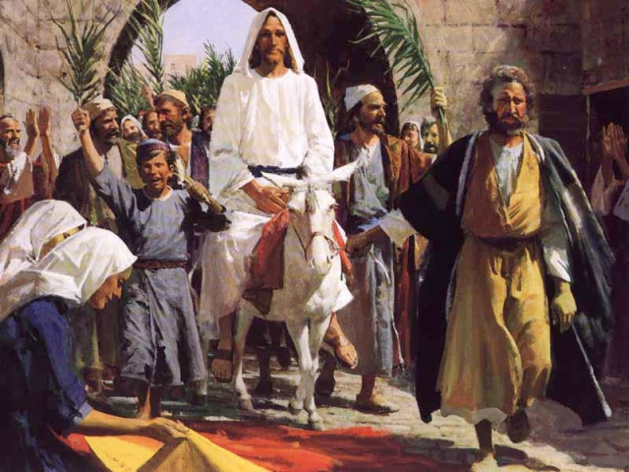

Palm Sunday
March 28th, 2021
10:00 am Service

‘Come grow with us!’

Living Word Lutheran Church (LCMS)
16301 Wolf Rd, Orland Park, IL 60467
livingwordorland.org (708) 403-9673
WELCOME TO LIVING WORD!

Our candles remind us the Light of the World Jesus Christ is here!
Blue information card, hymnal & Bible are in seat pocket.
Songs/readings on screen—also in Hymnals/Bibles.

WE REJOICE IN GOD’S LOVE…

Welcome

Opening Prayer & Praise “Lord, I Lift Your Name on High”
“Hosanna”

Invocation

Affirmation of Faith: Nicene Creed

WE RECEIVE GOD’S WORD…

Today’s Psalm Psalm 118:19-29

Scripture Readings Facing page

Message Song “Christ Is Our Cornerstone”

Video A Cornerstone Laying
youtube.com/watch?v=Ru5fCxZYPFY

Message “OUR CORNERSTONE”
The stone the builders rejected has become the cornerstone. Ps. 118:22

WE RESPOND TO GOD’S CALL…

Prayer of Confession & Forgiveness

Prayers of God’s People & Lord’s Prayer

Benediction

Closing Song “The Name of The Lord”

Please place offerings in basket at sanctuary entrance
1) My Cornerstone has COME to me.
⁹ Rejoice greatly, Daughter Zion! Shout, Daughter Jerusalem! See, your king comes to you, righteous and victorious, lowly and riding on a donkey, on a colt, the foal of a donkey. ¹⁰ I will take away the chariots from Ephraim and the warhorses from Jerusalem, and the battle bow will be broken. He will proclaim peace to the nations. His rule will extend from sea to sea and from the River to the ends of the earth. ¹¹ As for you, because of the blood of my covenant with you, I will free your prisoners from the waterless pit. ¹² Return to your fortress, you prisoners of hope; even now I announce that I will restore twice as much to you. Zechariah 9:9-12

2) My Cornerstone was CRUCIFIED for me.
⁵ In your relationships with one another, have the same mindset as Christ Jesus: ⁶ Who, being in very nature God, did not consider equality with God something to be used to his own advantage; ⁷ rather, he made himself nothing by taking the very nature of a servant, being made in human likeness. ⁸ And being found in appearance as a man, he humbled himself by becoming obedient to death—even death on a cross! ⁹ Therefore God exalted him to the highest place and gave him the name that is above every name, ¹⁰ that at the name of Jesus every knee should bow, in heaven and on earth and under the earth, ¹¹ and every tongue acknowledge that Jesus Christ is Lord, to the glory of God the Father. Philippians 2:5-11

3) My Cornerstone is COMPASSIONATE with me.
Six days before the Passover, Jesus came to Bethany, where Lazarus lived, whom Jesus had raised from the dead. ² Here a dinner was given in Jesus’ honor. Martha served, while Lazarus was among those reclining at the table with him. ³ Then Mary took about a pint of pure nard, an expensive perfume; she poured it on Jesus’ feet and wiped his feet with her hair. And the house was filled with the fragrance of the perfume. ⁴ But one of his disciples, Judas Iscariot, who was later to betray him, objected, ⁵ “Why wasn’t this perfume sold and the money given to the poor? It was worth a year’s wages.” ⁶ He did not say this because he cared about the poor but because he was a thief; as keeper of the money bag, he used to help himself to what was put into it. ⁷ “Leave her alone,” Jesus replied. “It was intended that she should save this perfume for the day of my burial. ⁸ You will always have the poor among you, but you will not always have me.” ⁹ Meanwhile a large crowd of Jews found out that Jesus was there and came, not only because of him but also to see Lazarus, whom he had raised from the dead. ¹⁰ So the chief priests made plans to kill Lazarus as well, ¹¹ for on account of him many of the Jews were going over to Jesus and believing in him. John 12:1-11

