Worship Prayer…

Father in heaven, I admit I am a sinner and cannot save myself, but trust only in your Son Jesus Christ—true God and true man—who died on the cross for me and rose again to give me new life now and forever. By your Holy Spirit’s power take my heart and life and make me yours; turn me from my own selfish path to always love, trust and follow Jesus. Because you love and forgive me, help me forgive and love others. And now, as we gather together as your church in this place, make us one in truth and love according to the faithful leading and unfailing promises of your living Word. In Jesus’ name….Amen!

Living Word exists to…

- Proclaim God’s Love

- Expand God’s Kingdom

- Mature God’s People

- Live God’s Word!

Pastor Steve Lee
revstevelee@gmail.com
708-334-5883

Anita Meier - Musician
Paul Huang – Livestream/Tech Booth
Living
Word

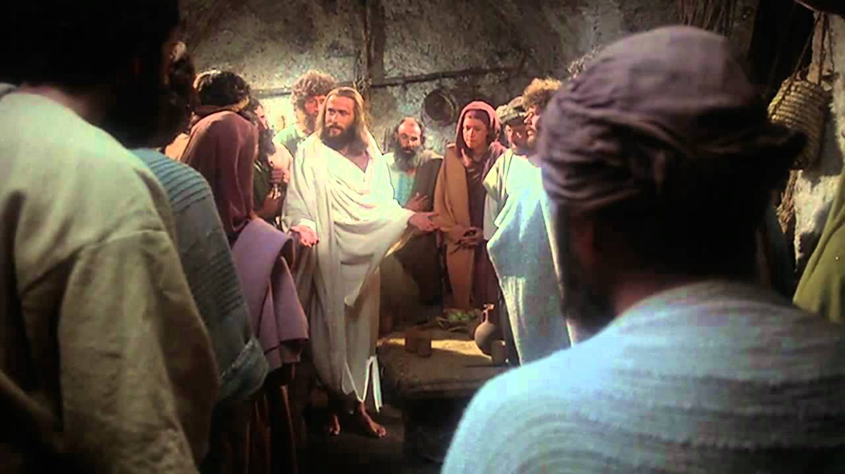
Jesus himself stood among them and said, “Peace be with you.”
Luke 24:36

3rd Sunday of Easter
April 18th, 2021
10:00 am Service

‘Come grow with us!’

Living Word Lutheran Church (LCMS)
16301 Wolf Rd, Orland Park, IL 60467
livingwordorland.org (708) 403-9673

WELCOME TO LIVING WORD!

Our candles remind us the Light of the World Jesus Christ is here!
Blue information card, hymnal & Bible are in seat pocket.
Songs/readings on screen—also in Hymnals/Bibles.

WE REJOICE IN GOD’S LOVE…

Welcome

Opening Prayer & Praise “More Love, More Power”

Invocation

Affirmation of Faith: Lord’s Prayer 4th Petition with Explanation

WE RECEIVE GOD’S WORD…

Today’s Psalm Psalm 4

Scripture Readings Facing page

Message Hymn “Promises”

Video Psalm 4 - Melissa Breems (Lyrics)
youtube.com/watch?v=3tPo6_pVR3g

Message “Who Will Bring Us Prosperity?”

WE RESPOND TO GOD’S CALL…

Prayer of Confession & Forgiveness

Prayers of God’s People & Lord’s Prayer

Communion “Above All”

Benediction

Closing Song “We Walk By Faith”

Please place offerings in basket at sanctuary entrance
“Who Will Bring Us Prosperity?”

How do we truly prosper in life? Today our Bible readings give us answers to the Psalmist’s question: “Who will bring us prosperity…?”

1) God the Holy Spirit prospers us with His POWER.
¹² …[Peter] said to them: “Fellow Israelites, why does [healing this lame man] surprise you? Why do you stare at us as if by our own power or godliness we had made this man walk? ¹³ The God of Abraham, Isaac and Jacob, the God of our fathers, has glorified his servant Jesus. You handed him over to be killed, and you disowned him before Pilate, though he had decided to let him go. ¹⁴ You disowned the Holy and Righteous One and asked that a murderer be released to you. ¹⁵ You killed the author of life, but God raised him from the dead. We are witnesses of this. ¹⁶ By faith in the name of Jesus, this man whom you see and know was made strong. It is Jesus’ name and the faith that comes through him that has completely healed him, as you can all see…¹⁹ Repent, then, and turn to God, so that your sins may be wiped out, that times of refreshing may come from the Lord, ²⁰ and that he may send the Messiah, who has been appointed for you—even Jesus. Acts 3:12-16, 19-20

2) God the Son prospers us with His PURITY.
See what great love the Father has lavished on us, that we should be called children of God! And that is what we are! The reason the world does not know us is that it did not know him. ² Dear friends, now we are children of God, and what we will be has not yet been made known. But we know that when Christ appears, we shall be like him, for we shall see him as he is. ³ All who have this hope in him purify themselves, just as he is pure. 1 John 3:1-3

3) God the Father prospers us with His PROMISES.
⁴⁶ [Jesus] told them, “This is what is written: The Messiah will suffer and rise from the dead on the third day, ⁴⁷ and repentance for the forgiveness of sins will be preached in his name to all nations, beginning at Jerusalem. ⁴⁸ You are witnesses of these things. ⁴⁹ I am going to send you what my Father has promised; but stay in the city until you have been clothed with power from on high.” Luke 24:46-49

