Worship Prayer…

Father in heaven, I admit I am a sinner and cannot save myself, but trust only in your Son Jesus Christ—true God and true man—who died on the cross for me and rose again to give me new life now and forever. By your Holy Spirit’s power take my heart and life and make me yours; turn me from my own selfish path to always love, trust and follow Jesus. Because you love and forgive me, help me forgive and love others. And now, as we gather together as your church in this place, make us one in truth and love according to the faithful leading and unfailing promises of your living Word. In Jesus’ name….Amen!

Living Word exists to…

- Proclaim God’s Love

- Expand God’s Kingdom

- Mature God’s People

- Live God’s Word!

Pastor Steve Lee
revstevelee@gmail.com
708-334-5883

Anita Meier - Musician
Diana Motel – Livestream/Tech Booth
Paul Huang – Livestream/Tech Booth

Living
Word

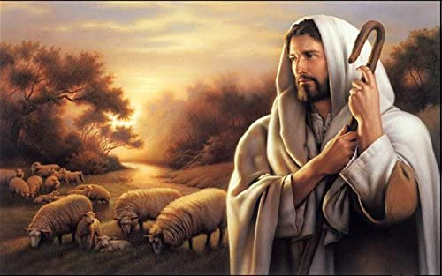

Good Shepherd Sunday
April 25th, 2021
10:00 am Service

‘Come grow with us!’

Living Word Lutheran Church (LCMS)
16301 Wolf Rd, Orland Park, IL 60467
livingwordorland.org (708) 403-9673
WELCOME TO LIVING WORD!

Our candles remind us the Light of the World Jesus Christ is here!
Blue information card, hymnal & Bible are in seat pocket.
Songs/readings on screen—also in Hymnals/Bibles.

WE REJOICE IN GOD’S LOVE…

Welcome

Opening Prayer & Praise “God Is So Good” & “Fill Me”

Invocation

Affirmation of Faith: Apostles Creed

WE RECEIVE GOD’S WORD…

Today’s Psalm Psalm 23

Scripture Readings Facing page

Message Song “Gentle Shepherd”

Video Parable of the Lost Sheep - Luke 15:1-7 youtube.com/watch?v=WlOPi4HOmIY

Message “The Lord is My Shepherd”

WE RESPOND TO GOD’S CALL…

Prayer of Confession & Forgiveness

Prayers of God’s People & Lord’s Prayer

Benediction

Closing Song “God Is Good All The Time”

Please place offerings in basket at sanctuary entrance
“The Lord is My Shepherd”
On Good Shepherd Sunday our Psalm is the well-known Psalm 23. Today, we explore its opening words: “The Lord is my Shepherd…”

1) A good shepherd lays down his LOGOS.
The priests and the captain of the temple guard and the Sadducees came up to Peter and John while they were speaking to the people. ² They were greatly disturbed because the apostles were teaching the people, proclaiming [“katangellein” comp. of “down” & “announce”] in Jesus the resurrection of the dead. ³ They seized Peter and John and, because it was evening, they put them in jail until the next day. ⁴ But many who heard the message [“logon”] believed; so the number of men who believed grew to about five thousand. Acts 4:1-4

2) A good shepherd lays down his LOVE.
¹⁶ This is how we know what love is: Jesus Christ laid down his life for us. And we ought to lay down our lives for our brothers and sisters. ¹⁷ If anyone has material possessions and sees a brother or sister in need but has no pity on them, how can the love of God be in that person? ¹⁸ Dear children, let us not love with words or speech but with actions and in truth. 1 John 3:16-18

3) A good shepherd lays down his LIFE.
¹¹ “I am the good shepherd. The good shepherd lays down his life for the sheep. ¹² The hired hand is not the shepherd and does not own the sheep. So when he sees the wolf coming, he abandons the sheep and runs away. Then the wolf attacks the flock and scatters it. ¹³ The man runs away because he is a hired hand and cares nothing for the sheep. ¹⁴ “I am the good shepherd; I know my sheep and my sheep know me— ¹⁵ just as the Father knows me and I know the Father—and I lay down my life for the sheep. ¹⁶ I have other sheep that are not of this sheep pen. I must bring them also. They too will listen to my voice, and there shall be one flock and one shepherd. ¹⁷ The reason my Father loves me is that I lay down my life—only to take it up again.
¹⁸ No one takes it from me, but I lay it down of my own accord. I have authority to lay it down and authority to take it up again. This command I received from my Father.” John 10:11-18

“He makes me lie down in green pastures…”
Psalm 23:2a

