Worship Prayer…

Father in heaven, I admit I am a sinner and cannot save myself, but trust only in your Son Jesus Christ—true God and true man—who died on the cross for me and rose again to give me new life now and forever. By your Holy Spirit’s power take my heart and life and make me yours; turn me from my own selfish path to always love, trust and follow Jesus. Because you love and forgive me, help me forgive and love others. And now, as we gather together as your church in this place, make us one in truth and love according to the faithful leading and unfailing promises of your living Word. In Jesus’ name….Amen!

Living Word exists to…

- Proclaim God’s Love

- Expand God’s Kingdom

- Mature God’s People

- Live God’s Word!

Pastor Steve Lee
revstevelee@gmail.com
708-334-5883

Anita Meier - Musician
Diana Motel – Livestream/Tech Booth
Paul Huang – Livestream/Tech Booth

Living
Word

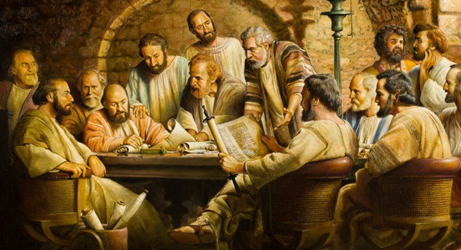
Matthias is chosen to replace Judas

7th Sunday of Easter
May 16th, 2021
10:00 am Service

‘Come grow with us!’

Living Word Lutheran Church (LCMS)
16301 Wolf Rd, Orland Park, IL 60467
livingwordorland.org (708) 403-9673
WELCOME TO LIVING WORD!
Our candles remind us the Light of the World Jesus Christ is here!
Blue information card, hymnal & Bible are in seat pocket.
Songs/readings on screen—also in Hymnals/Bibles.

WE REJOICE IN GOD’S LOVE…

Welcome

Opening Prayer & Praise “I Will Delight in the Law of the Lord”

Invocation

Affirmation of Faith:
Lord’s Prayer 7th Petition & Conclusion with Explanation

WE RECEIVE GOD’S WORD…

Today’s Psalm Psalm 1

Scripture Readings Facing page

Message Hymn “Take My Life and Let It Be”

Video: Matthias Chosen to Replace Judas - English - Jesus Film Project
www.jesusfilm.org/watch/book-of-acts.html/matthias-chosen-to-replace-judas/english.html

Message “Walking God’s Way”

WE RESPOND TO GOD’S CALL…

Prayer of Confession & Forgiveness

Prayers of God’s People & Lord’s Prayer

Communion “Feed Us Now”

Benediction

Closing Song “God Will Make A Way”

Please place offerings in basket at sanctuary entrance
“Walking God’s Way”

Psalm 1 says, “Blessed is the one who does not walk in step with the wicked or stand in the way that sinners take or sit in the company of mockers, but whose delight is in the law of the Lord.” How do we delight in the law of the Lord? How do we walk God’s way…?

1) We walk the way of God’s WITNESS.
²¹ [Peter said] “Therefore it is necessary to choose one of the men who have been with us the whole time the Lord Jesus was living among us, ²² beginning from John’s baptism to the time when Jesus was taken up from us. For one of these must become a witness with us of his resurrection.” ²³ So they nominated two men: Joseph called Barsabbas (also known as Justus) and Matthias. ²⁴ Then they prayed, “Lord, you know everyone’s heart. Show us which of these two you have chosen ²⁵ to take over this apostolic ministry, which Judas left to go where he belongs.” ²⁶ Then they cast lots, and the lot fell to Matthias; so he was added to the eleven apostles. Acts 1:21-26

2) We walk the way of God’s WILL.
¹³ I write these things to you who believe in the name of the Son of God so that you may know that you have eternal life. ¹⁴ This is the confidence we have in approaching God: that if we ask anything according to his will, he hears us. ¹⁵ And if we know that he hears us—whatever we ask—we know that we have what we asked of him. 1 John 5:13-15

3) We walk the way of God’s ONENESS and WORD.
Holy Father, protect them by the power of your name, the name you gave me, so that they may be one as we are one. ¹² While I was with them, I protected them and kept them safe by that name you gave me. None has been lost except the one doomed to destruction so that Scripture would be fulfilled. ¹³ “I am coming to you now, but I say these things while I am still in the world, so that they may have the full measure of my joy within them. ¹⁴ I have given them your word and the world has hated them, for they are not of the world any more than I am of the world. ¹⁵ My prayer is not that you take them out of the world but that you protect them from the evil one. ¹⁶ They are not of the world, even as I am not of it. ¹⁷ Sanctify them by the truth; your word is truth. John 17:11-17

