Worship Prayer…

Father in heaven, I admit I am a sinner and cannot save myself, but trust only in your Son Jesus Christ—true God and true man—who died on the cross for me and rose again to give me new life now and forever. By your Holy Spirit’s power take my heart and life and make me yours; turn me from my own selfish path to always love, trust and follow Jesus. Because you love and forgive me, help me forgive and love others. And now, as we gather together as your church in this place, make us one in truth and love according to the faithful leading and unfailing promises of your living Word. In Jesus’ name….Amen!

Living Word exists to…

- Proclaim God’s Love

- Expand God’s Kingdom

- Mature God’s People

- Live God’s Word!

Pastor Steve Lee
revstevelee@gmail.com
708-334-5883

Anita Meier - Musician
Diana Motel – Livestream/Tech Booth
Paul Huang – Livestream/Tech Booth
Living
Word

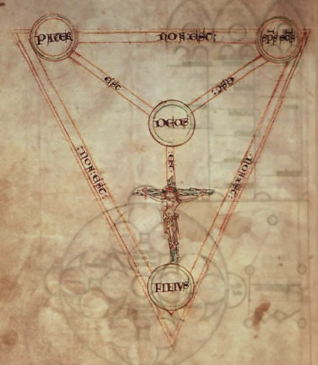
Oldest known drawing of "Scutum Fidei"
— “Shield of the Trinity” [c. 1210 A.D.]

Trinity Sunday
May 30th, 2021
10:00 am Service

‘Come grow with us!’

Living Word Lutheran Church (LCMS)
16301 Wolf Rd, Orland Park, IL 60467
livingwordorland.org (708) 403-9673
WELCOME TO LIVING WORD!
Blue church information card is in seat pocket

WE REJOICE IN GOD’S LOVE & FORGIVENESS…

Opening Prayer

Praise Songs “Come and Sing Praises”
“Glorify Thy Name”
Invocation

Confession & Forgiveness On screen or Hymnal p. 158

Affirmation of Faith: Nicene Creed

WE RECEIVE GOD’S WORD…

Today’s Psalm Psalm 29

Scripture Readings Facing page

Message Song “Holy, Holy, Holy”

Video Council of Nicea in 3 1/2 minutes
youtube.com/watch?v=VpND8dj1RoE

Message “The Voice of the Lord”

WE RESPOND TO GOD’S CALL…

Prayers of God’s People

Lord’s Prayer

Benediction

Closing Song “How Shall I Call You?”

Please place offerings in basket at sanctuary entrance
“The Voice of the Lord”
Today, our Psalm proclaims, “The voice of the Lord is powerful.” Today, listen to the powerful voice of our Trinitarian God…

1) The voice of the Lord—the Father—SENDS.
⁸ I heard the voice of the Lord saying, “Whom shall I send? And who will go for us?” And I said, “Here am I. Send me!” Isaiah 6:8

2) The voice of the Lord—the Son—SAVES.
¹⁴ Then Peter stood up with the Eleven, raised his voice and addressed the crowd…
²² “Fellow Israelites, listen to this: Jesus of Nazareth was a man accredited by God to you by miracles, wonders and signs, which God did among you through him, as you yourselves know. ²³ This man was handed over to you by God’s deliberate plan and foreknowledge; and you, with the help of wicked men, put him to death by nailing him to the cross. ²⁴ But God raised him from the dead, freeing him from the agony of death, because it was impossible for death to keep its hold on him.” Acts 2:14a, 22-24

3) The voice of the Lord—the Holy Spirit—SANCTIFIES.
⁵ Jesus [said], “Very truly I tell you, no one can enter the kingdom of God unless they are born of water and the Spirit. ⁶ Flesh gives birth to flesh, but the Spirit gives birth to spirit. ⁷ You should not be surprised at my saying, ‘You must be born again.’ ⁸ The wind blows wherever it pleases. You hear its sound, but you cannot tell where it comes from or where it is going. So it is with everyone born of the Spirit.” ⁹ “How can this be?” Nicodemus asked. ¹⁰ “You are Israel’s teacher,” said Jesus, “and do you not understand these things? ¹¹ Very truly I tell you, we speak of what we know, and we testify to what we have seen, but still you people do not accept our testimony. ¹² I have spoken to you of earthly things and you do not believe; how then will you believe if I speak of heavenly things? ¹³ No one has ever gone into heaven except the one who came from heaven—the Son of Man. ¹⁴ Just as Moses lifted up the snake in the wilderness, so the Son of Man must be lifted up, ¹⁵ that everyone who believes may have eternal life in him.” ¹⁶ For God so loved the world that he gave his one and only Son, that whoever believes in him shall not perish but have eternal life. ¹⁷ For God did not send his Son into the world to condemn the world, but to save the world through him. John 3:5-17

