Worship Prayer…

Father in heaven, I admit I am a sinner and cannot save myself, but trust only in your Son Jesus Christ—true God and true man—who died on the cross for me and rose again to give me new life now and forever. By your Holy Spirit’s power take my heart and life and make me yours; turn me from my own selfish path to always love, trust and follow Jesus. Because you love and forgive me, help me forgive and love others. And now, as we gather together as your church in this place, make us one in truth and love according to the faithful leading and unfailing promises of your living Word. In Jesus’ name….Amen!

Living Word exists to…

- Proclaim God’s Love

- Expand God’s Kingdom

- Mature God’s People

- Live God’s Word!

Pastor Steve Lee
revstevelee@gmail.com
708-334-5883

Anita Meier - Musician
Diana Motel – Livestream/Tech Booth
Paul Huang – Livestream/Tech Booth
Living
Word

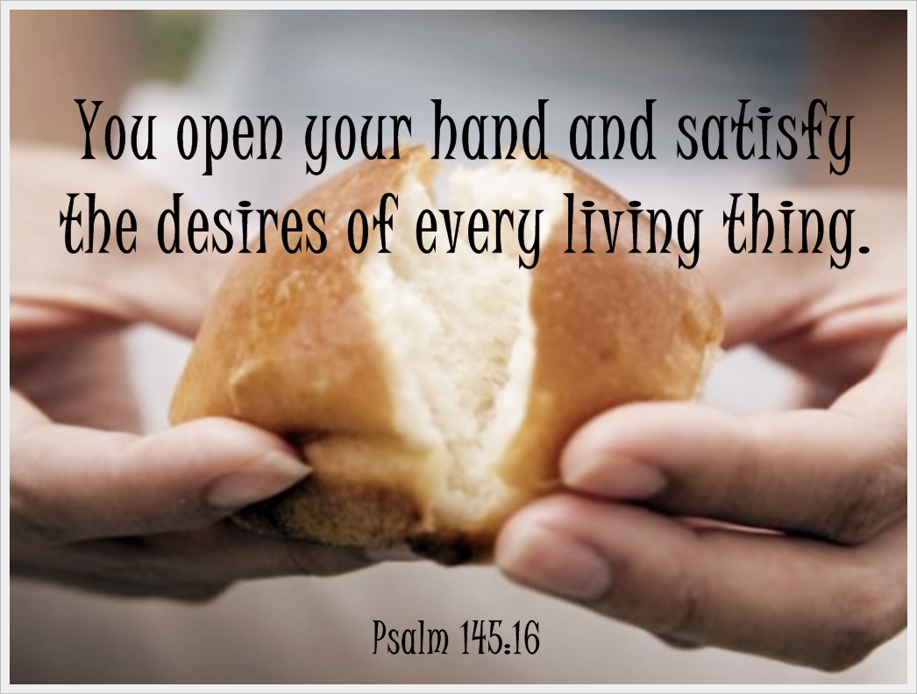

10th Sunday after Pentecost
August 1st, 2021
10:00 am Service

‘Come grow with us!’

Living Word Lutheran Church (LCMS)
16301 Wolf Rd, Orland Park, IL 60467
livingwordorland.org (708) 403-9673
WELCOME TO LIVING WORD!
Blue church information card is in seat pocket

WE REJOICE IN GOD’S LOVE & FORGIVENESS…

Opening Prayer

Praise Songs “Your Power Will Pull Us Through”
“The Strong Name of Jesus”
Invocation

Confession & Forgiveness On screen or Hymnal p. 158

Affirmation of Faith: Apostles’ Creed

WE RECEIVE GOD’S WORD…

Today’s Psalm Psalm 145:10-21

Scripture Readings Facing page

Message Song “The Old Rugged Cross”

Video New Jersey - Olivia's Testimony - Sean Feucht youtube.com/watch?v=NqcBbms7oBU

Message “Satisfied”

WE RESPOND TO GOD’S CALL…

Prayers of God’s People

Lord’s Prayer

Communion

Benediction

Closing Song “In You Alone”
Please place offerings in basket at sanctuary entrance
“Satisfied”

Psalm 145 says: “You open your hand and satisfy the desires of every living thing.” In Christ we find true satisfaction in life…

1) Christ satisfies me with His PROVISION.
² In the desert the whole community grumbled against Moses and Aaron. ³ The Israelites said to them, “If only we had died by the
Lord’s hand in Egypt! There we sat around pots of meat and ate all the food we wanted, but you have brought us out into this desert to starve this entire assembly to death...” ¹¹ The Lord said to Moses,
¹² “I have heard the grumbling of the Israelites. Tell them, ‘At twilight you will eat meat, and in the morning you will be filled with bread. Then you will know that I am the Lord your God.’” ¹³ That evening quail came and covered the camp, and in the morning there was a layer of dew around the camp. ¹⁴ When the dew was gone, thin flakes like frost on the ground appeared on the desert floor. ¹⁵ When the Israelites saw it, they said to each other, “What is it?” For they did not know what it was. Moses said to them, “It is the bread the Lord has given you to eat. Exodus 16:2-3, 11-15

2) Christ satisfies me with His purpose, place & POWER.
I urge you to live a life worthy of the calling you have received. ² Be completely humble and gentle; be patient, bearing with one another in love. ³ Make every effort to keep the unity of the Spirit through the bond of peace. ⁴ There is one body and one Spirit, just as you were called to one hope when you were called; ⁵ one Lord, one faith, one baptism; ⁶ one God and Father of all, who is over all and through all and in all. ⁷ But to each one of us grace has been given as Christ apportioned it…¹⁶ From him the whole body, joined and held together by every supporting ligament, grows and builds itself up in love, as each part does its work. Ephesians 4:1b-7, 16
3) Christ satisfies me with His faithful PROMISES. [Jesus said] ²⁷ Do not work for food that spoils, but for food that endures to eternal life… ²⁸ Then they asked him, “What must we do to do the works God requires?” ²⁹ Jesus answered, “The work of God is this: to believe in the one he has sent…” ³⁵ Then Jesus declared, “I am the bread of life. Whoever comes to me will never go hungry, and whoever believes in me will never be thirsty. John 6:27a-28-29, 35

