**Worship Prayer…**

Father in heaven, I admit I am a sinner and cannot save myself, but trust only in your Son Jesus Christ—true God and true man—who died on the cross for me and rose again to give me new life now and forever. By your Holy Spirit’s power take my heart and life and make me yours; turn me from my own selfish path to always love, trust and follow Jesus. Because you love and forgive me, help me forgive and love others. And now, as we gather together as your church in this place, make us one in truth and love according to the faithful leading and unfailing promises of your *living Word. In Jesus’ name….Amen!*

Living Word exists to…

* *Proclaim God’s Love*
* *Expand God’s Kingdom*
* *Mature God’s People*
* *Live God’s Word!*

**Pastor Steve Lee**

[revstevelee@gmail.com](mailto:revstevelee@gmail.com)

708-334-5883

Anita Meier - Musician

Diana Motel – Livestream/Tech Booth

Paul Huang – Livestream/Tech Booth

***Living***

***Word***

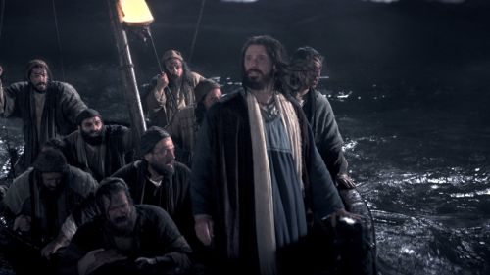

*Jesus calms the storm*

**9th Sunday after Pentecost**

July 25th, 2021

10:00 am Service

***‘Come grow with us!’***

Living Word Lutheran Church (LCMS)

16301 Wolf Rd, Orland Park, IL 60467

livingwordorland.org (708) 403-9673

***WELCOME TO LIVING WORD!***

*Blue church information card is in seat pocket*

## ***WE REJOICE IN GOD’S LOVE & FORGIVENESS…***

## Opening Prayer

## Praise Song *“Your Grace Is Sufficient”*



Invocation

Confession & Forgiveness *On screen or Hymnal p. 158*

Affirmation of Faith: Apostles’ Creed

***WE RECEIVE GOD’S WORD…***

## Today’s Psalm *Psalm 136:1-9*

Scripture Readings *Facing page*

Message Song *“God Is Good All The Time”*

Video *Typhoon Hits US Navy 3rd Fleet Ships at Sea*

youtube.com/watch?v=iTV0qIoJgYA

Message *“For He Is Good”*

***WE RESPOND TO GOD’S CALL…***

Prayers of God’s People

Lord’s Prayer

Benediction

Closing Song *“Fear Not”*

*Please place offerings in basket at sanctuary entrance*

***“For He Is Good”***

Psalm 136 says: *“Give thanks to the Lord, for he is good. His love endures forever.”* God *IS* good, His love *DOES* endure forever, so we give Him thanks. We are filled with confidence, for He is good…

***In life’s storms…***

***1) I have confidence that comes from God’s COVENANT.***

**8**Then God said to Noah and to his sons with him: **9**“I now establish my covenant with you and with your descendants after you **10**and with every living creature that was with you—the birds, the livestock and all the wild animals, all those that came out of the ark with you—every living creature on earth. **11**I establish my covenant

with you: Never again will all life be destroyed by the waters of a flood; never again will there be a flood to destroy the earth.”

Genesis 9:8-11

***2) I have confidence that comes from the Father’s CHRIST.***

**14**For this reason I kneel before the Father, **15**from whom every family in heaven and on earth derives its name. **16**I pray that out of his glorious riches he may strengthen you with power through his Spirit in your inner being, **17**so that Christ may dwell in your hearts

through faith. And I pray that you, being rooted and established in love, **18**may have power, together with all the Lord’s holy people, to grasp how wide and long and high and deep is the love of Christ.

Ephesians 3:14-18

***3) I have confidence to live COURAGEOUSLY.***

**45**Immediately Jesus made his disciples get into the boat and go on ahead of him to Bethsaida, while he dismissed the crowd. **46**After leaving them, he went up on a mountainside to pray. **47**Later that night, the boat was in the middle of the lake, and he was alone on land. **48**He saw the disciples straining at the oars, because the wind was against them. Shortly before dawn he went out to them, walking on the lake. He was about to pass by them, **49**but when they saw him walking on the lake, they thought he was a ghost. They cried out, **50**because they all saw him and were terrified. Immediately he spoke to them and said, “Take courage! It is I. Don’t be afraid.” **51**Then he climbed into the boat with them, and the wind died down. They were completely amazed. Mark 6:45-51