**Worship Prayer…**

Father in heaven, I admit I am a sinner and cannot save myself, but trust only in your Son Jesus Christ—true God and true man—who died on the cross for me and rose again to give me new life now and forever. By your Holy Spirit’s power take my heart and life and make me yours; turn me from my own selfish path to always love, trust and follow Jesus. Because you love and forgive me, help me forgive and love others. And now, as we gather together as your church in this place, make us one in truth and love according to the faithful leading and unfailing promises of your *living Word. In Jesus’ name….Amen!*

Living Word exists to…

* *Proclaim God’s Love*
* *Expand God’s Kingdom*
* *Mature God’s People*
* *Live God’s Word!*

**Pastor Steve Lee**

[revstevelee@gmail.com](mailto:revstevelee@gmail.com)

708-334-5883

Anita Meier - Musician

Diana Motel – Livestream/Tech Booth

***Living***

***Word***

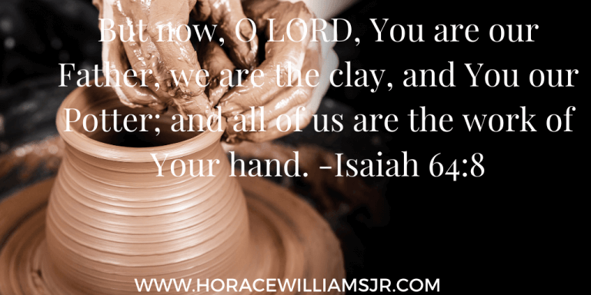

**13th Sunday after Pentecost**

August 22nd, 2021

10:00 am Service

***‘Come grow with us!’***

Living Word Lutheran Church (LCMS)

16301 Wolf Rd, Orland Park, IL 60467

livingwordorland.org (708) 403-9673

***WELCOME TO LIVING WORD!***

*Blue church information card is in seat pocket*

## ***WE REJOICE IN GOD’S LOVE & FORGIVENESS…***

## Opening Prayer

## Praise Songs *“Create in Me”*

*“Open Our Eyes”*

Invocation

Confession & Forgiveness *On screen or Hymnal p. 158*

Affirmation of Faith: Apostles’ Creed

***WE RECEIVE GOD’S WORD…***

## Today’s Psalm *Psalm 14*

Scripture Readings *Facing page*

Message Song *“Have Thine Own Way”*

Video *George Soros 60 Minutes Interview Dec. 20, 1998*

youtube.com/watch?v=AiqHiQYuoOs 7:36 to 10:17

Message *“No God or Know God?”*

***WE RESPOND TO GOD’S CALL…***

Prayers of God’s People

Lord’s Prayer

Benediction

Closing Song *“Thy Word”*

*Please place offerings in basket at sanctuary entrance*

***“No God or Know God?”***

Psalm 14 says: *“The fool says in his heart, ‘There is no God’”* and, *“Do all these evildoers know nothing? …They never call on the Lord.”*

Do we live like there is no God, or do we know Him…?

***1) Am I a pot or a POTTER?***

You turn things upside down, as if the potter were thought to be like the clay! Shall what is formed say to the one who formed it, “You did not make me”? Can the pot say to the potter, “You know nothing”? Isaiah 29:16

***2) Am I a hater or a LOVER?***

**22**Wives, submit yourselves to your own husbands as you do to the Lord. **23**For the husband is the head of the wife as Christ is the head of the church, his body, of which he is the Savior. **24**Now as the church submits to Christ, so also wives should submit to their husbands in everything. **25**Husbands, love your wives, just as Christ loved the church and gave himself up for her **26**to make her holy, cleansing her by the washing with water through the word, **27**and to present her to himself as a radiant church, without stain or wrinkle or any other blemish, but holy and blameless. **28**In this same way, husbands ought to love their wives as their own bodies. He who loves his wife loves himself. **29**After all, no one ever hated their own body, but they feed and care for their body, just as Christ does the church— **30**for we are members of his body. **31**“For this reason a man will leave his father and mother and be united to his wife, and the two will become one flesh.” **32**This is a profound mystery—but I am talking about Christ and the church. **33**However, each one of you also must love his wife as he loves himself, and the wife must respect her husband.

Ephesians 5:22-33

***3) Am I a nullifier or an AFFIRMER?***

**9**And [Jesus] continued, “You have a fine way of setting aside the commands of God in order to observe your own traditions! **10**For Moses said, ‘Honor your father and mother,’ and, ‘Anyone who curses their father or mother is to be put to death.’ **11**But you say that if anyone declares that what might have been used to help their father or mother is Corban (that is, devoted to God)— **12**then you no longer let them do anything for their father or mother. **13**Thus you nullify the word of God by your tradition that you have handed down. And you do many things like that.” Mark 7:9-13