Worship Prayer…

Father in heaven, I admit I am a sinner and cannot save myself, but trust only in your Son Jesus Christ—true God and true man—who died on the cross for me and rose again to give me new life now and forever. By your Holy Spirit’s power take my heart and life and make me yours; turn me from my own selfish path to always love, trust and follow Jesus. Because you love and forgive me, help me forgive and love others. And now, as we gather together as your church in this place, make us one in truth and love according to the faithful leading and unfailing promises of your living Word. In Jesus’ name….Amen!

Living Word exists to…

- Proclaim God’s Love

- Expand God’s Kingdom

- Mature God’s People

- Live God’s Word!

Pastor Steve Lee
revstevelee@gmail.com
708-334-5883

Anita Meier - Musician
Diana Motel – Livestream/Tech Booth

Living Word

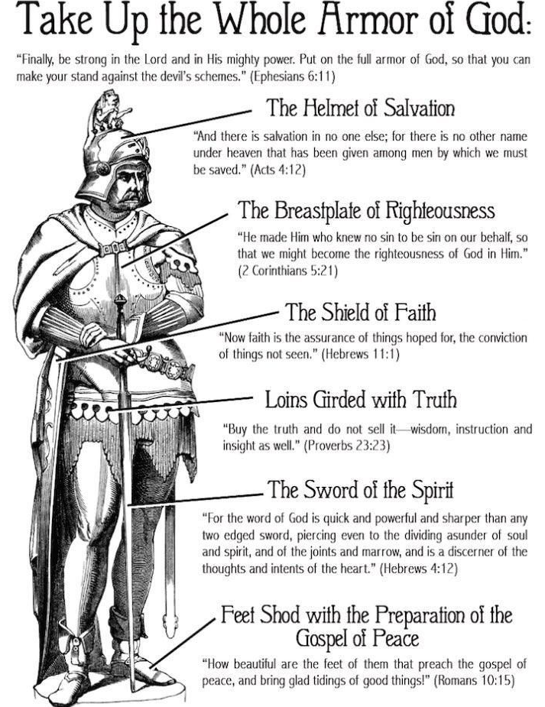

14th Sunday after Pentecost
August 29th, 2021
10:00 am Service

Living Word Lutheran Church (LCMS)
16301 Wolf Rd, Orland Park, IL 60467
livingwordorland.org (708) 403-9673
WELCOME TO LIVING WORD!
Blue church information card is in seat pocket

WE REJOICE IN GOD’S LOVE & FORGIVENESS…

Opening Prayer

Praise Songs “His Name Is Wonderful”
“Cry of My Heart”
Invocation

Confession & Forgiveness On screen or Hymnal p. 158

Affirmation of Faith: Close of the Commandments [Catechism]

WE RECEIVE GOD’S WORD…

Today’s Psalm Psalm 119:129-136

Scripture Readings Facing page

Message Song “The Battle Belongs to the Lord”

Video Psalm 19 The Law of the Lord is Perfect w Lyrics
youtube.com/watch?v=F-ykfw3-i7s

Message “Wonderful”

WE RESPOND TO GOD’S CALL…

Prayers of God’s People

Lord’s Prayer

Benediction

Closing Song “Victory Chant”

Please place offerings in basket at sanctuary entrance
“Wonderful”

Psalm 119 says: “Your statutes are wonderful; therefore I obey them.
The unfolding of your words gives light; it gives understanding to the simple.” Come bask in the light of three wonderful God-given gifts…

1) God’s LAW is wonderful.
Now, Israel, hear the decrees and laws I am about to teach you. Follow them so that you may live and may go in and take possession of the land the Lord, the God of your ancestors, is giving you.
Deuteronomy 4:1
2) God’s ARMOR is wonderful.
¹⁰ Finally, be strong in the Lord and in his mighty power. ¹¹ Put on the full armor of God, so that you can take your stand against the devil’s schemes. ¹² For our struggle is not against flesh and blood, but against the rulers, against the authorities, against the powers of this dark world and against the spiritual forces of evil in the heavenly realms. ¹³ Therefore put on the full armor of God, so that when the day of evil comes, you may be able to stand your ground, and after you have done everything, to stand. ¹⁴ Stand firm then, with the belt of truth buckled around your waist, with the breastplate of righteousness in place, ¹⁵ and with your feet fitted with the readiness that comes from the gospel of peace. ¹⁶ In addition to all this, take up the shield of faith, with which you can extinguish all the flaming arrows of the evil one. ¹⁷ Take the helmet of salvation and the sword of the Spirit, which is the word of God. ¹⁸ And pray in the Spirit on all occasions with all kinds of prayers and requests. With this in mind, be alert and always keep on praying for all the Lord’s people. Ephesians 6:10-18

3) God’s COUNSELOR is wonderful.
¹⁵ [Jesus said] “Nothing outside a person can defile them by going into them. Rather, it is what comes out of a person that defiles them.”
²¹ For it is from within, out of a person’s heart, that evil thoughts come—sexual immorality, theft, murder, ²² adultery, greed, malice, deceit, lewdness, envy, slander, arrogance and folly. ²³ All these evils come from inside and defile a person.” Mark 7:15, 21-23

For to us a child is born, to us a Son is given, and the government will be on his shoulders. And he will be called Wonderful Counselor, Mighty God, Everlasting Father, Prince of Peace. Isaiah 9:6

