Worship Prayer…

Father in heaven, I admit I am a sinner and cannot save myself, but trust only in your Son Jesus Christ—true God and true man—who died on the cross for me and rose again to give me new life now and forever. By your Holy Spirit’s power take my heart and life and make me yours; turn me from my own selfish path to always love, trust and follow Jesus. Because you love and forgive me, help me forgive and love others. And now, as we gather together as your church in this place, make us one in truth and love according to the faithful leading and unfailing promises of your living Word. In Jesus’ name….Amen!

Living Word exists to…

- Proclaim God’s Love

- Expand God’s Kingdom

- Mature God’s People

- Live God’s Word!

Pastor Steve Lee
revstevelee@gmail.com
708-334-5883

Anita Meier - Musician
Diana Motel – Livestream/Tech Booth

Living
Word

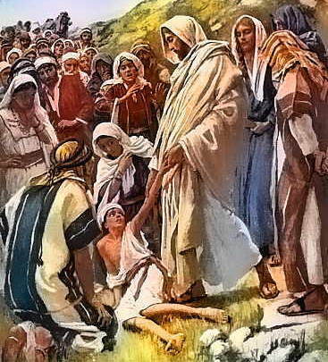
Jesus heals the demon-possessed boy

16th Sunday after Pentecost
September 12th, 2021
10:00 am Service

‘Come grow with us!’

Living Word Lutheran Church (LCMS)
16301 Wolf Rd, Orland Park, IL 60467
livingwordorland.org (708) 403-9673
WELCOME TO LIVING WORD!
Blue church information card is in seat pocket

WE REJOICE IN GOD’S LOVE & FORGIVENESS…

Opening Prayer

Praise Songs “Blest Be the Tie That Binds”
“Holy Ground”
Invocation

Confession & Forgiveness On screen or Hymnal p. 158

Affirmation of Faith: 2nd Commandment with Explanation

WE RECEIVE GOD’S WORD…

Today’s Psalm Psalm 116:1-9

Scripture Readings Facing page

Message Song “Sweet Hour of Prayer”

Video Jesus Heals Boy from Evil Spirit
youtube.com/watch?v=1Shp4cseFSk

Message “He Hears”

WE RESPOND TO GOD’S CALL…

Prayers of God’s People

Lord’s Prayer

Benediction

Closing Song “What a Friend We Have in Jesus””

Please place offerings in basket at sanctuary entrance
“He Hears”
Psalm 116 says: “I love the Lord, for he heard my voice; he heard my cry for mercy.” The Lord hears our cry…

1) “Lord, give me a WELL-INSTRUCTED tongue.”
⁴ The Sovereign Lord has given me a well-instructed tongue, to know the word that sustains the weary. He wakens me morning by morning, wakens my ear to listen like one being instructed. Isaiah 50:4

2) “Lord, give me a TAMED tongue.”
⁸ No human being can tame the tongue. It is a restless evil, full of deadly poison. ⁹ With the tongue we praise our Lord and Father, and with it we curse human beings, who have been made in God’s likeness. ¹⁰ Out of the same mouth come praise and cursing. My brothers and sisters, this should not be. James 3:8-10

3) “Lord, give me a PRAYING tongue.”
¹⁷ A man in the crowd [said], “Teacher, I brought you my son, who is possessed by a spirit that has robbed him of speech. ¹⁸ Whenever it seizes him, it throws him to the ground. He foams at the mouth, gnashes his teeth and becomes rigid. I asked your disciples to drive out the spirit, but they could not.” ¹⁹ “You unbelieving generation,” Jesus replied, “how long shall I stay with you? How long shall I put up with you? Bring the boy to me.” ²⁰ So they brought him. When the spirit saw Jesus, it immediately threw the boy into a convulsion. He fell to the ground and rolled around, foaming at the mouth. ²¹ Jesus asked the boy’s father, “How long has he been like this?” “From childhood,” he answered. ²² “It has often thrown him into fire or water to kill him. But if you can do anything, take pity on us and help us.” ²³ “‘If you can’?”
said Jesus. “Everything is possible for one who believes.” ²⁴ Immediately the boy’s father exclaimed, “I do believe; help me overcome my unbelief!” ²⁵ When Jesus saw that a crowd was running to the scene, he rebuked the impure spirit. “You deaf and mute spirit,” he said, “I command you, come out of him and never enter him again.” ²⁶ The spirit shrieked, convulsed him violently and came out. The boy looked so much like a corpse that many said, “He’s dead.” ²⁷ But Jesus took him by the hand and lifted him to his feet, and he stood up. ²⁸ After Jesus had gone indoors, his disciples asked him privately, “Why couldn’t we drive it out?” ²⁹ He replied, “This kind can come out only by prayer.”
Mark 9:17-29

