Worship Prayer…

Father in heaven, I admit I am a sinner and cannot save myself, but trust only in your Son Jesus Christ—true God and true man—who died on the cross for me and rose again to give me new life now and forever. By your Holy Spirit’s power take my heart and life and make me yours; turn me from my own selfish path to always love, trust and follow Jesus. Because you love and forgive me, help me forgive and love others. And now, as we gather together as your church in this place, make us one in truth and love according to the faithful leading and unfailing promises of your living Word. In Jesus’ name….Amen!

Living Word exists to…

- Proclaim God’s Love

- Expand God’s Kingdom

- Mature God’s People

- Live God’s Word!

Pastor Steve Lee
revstevelee@gmail.com
708-334-5883

Anita Meier - Musician
Diana Motel – Livestream/Tech Booth

Living
Word

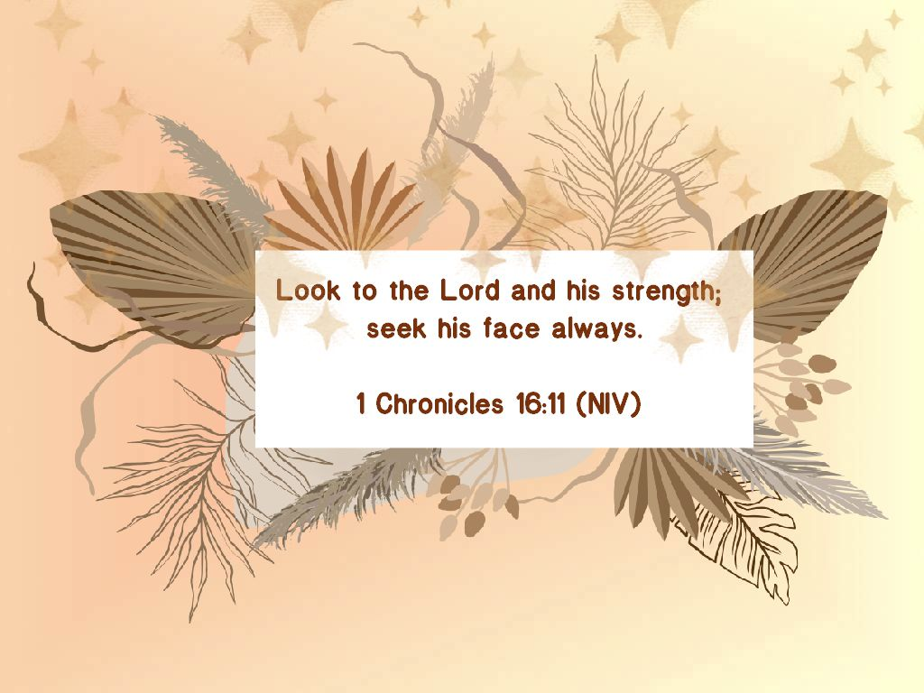

18th Sunday after Pentecost
September 26th, 2021
10:00 am Service

‘Come grow with us!’

Living Word Lutheran Church (LCMS)
16301 Wolf Rd, Orland Park, IL 60467
livingwordorland.org (708) 403-9673
WELCOME TO LIVING WORD!
Blue church information card is in seat pocket

WE REJOICE IN GOD’S LOVE & FORGIVENESS…

Opening Prayer

Praise Songs “Praise Adonai”
“Fill Me”
Invocation

Confession & Forgiveness On screen or Hymnal p. 158

Affirmation of Faith: Apostles’ Creed

WE RECEIVE GOD’S WORD…

Today’s Psalm Psalm 104:27-35

Scripture Readings Facing page

Message Song “My Faith looks Up to Thee”

Video “The Ten Commandments” 1956 – Disk 44
https://youtu.be/Cc3SPXqdbHE

Message “Looking to the Lord”

WE RESPOND TO GOD’S CALL…

Prayers of God’s People

Lord’s Prayer

Benediction

Closing Song “Blessed Assurance”

Please place offerings in basket at sanctuary entrance

“Looking to the Lord”

Psalm 104:27 says: “All creatures look to you to give them their food at the proper time.” Do we trust the Lord to give us what we need, when we need it? Do we look to the Lord …?

1) What do I CRAVE?

⁴ The rabble with them began to crave other food, and again the Israelites started wailing and said, “If only we had meat to eat! ⁵ We remember the fish we ate in Egypt at no cost—also the cucumbers, melons, leeks, onions and garlic.
Numbers 11:4-5

2) What do I PRAY?

¹³ Is anyone among you in trouble? Let them pray. Is anyone happy? Let them sing songs of praise. ¹⁴ Is anyone among you sick? Let them call the elders of the church to pray over them and anoint them with oil in the name of the Lord. ¹⁵ And the prayer offered in faith will make the sick person well; the Lord will raise them up. If they have sinned, they will be forgiven. ¹⁶ Therefore confess your sins to each other and pray for each other so that you may be healed.
The prayer of a righteous person is powerful and effective.
James 5:13-16

3) What do I SAY?

³⁸ “Teacher,” said John, “we saw someone driving out demons in your name and we told him to stop, because he was not one of us.” ³⁹ “Do not stop him,” Jesus said. “For no one who does a miracle in my name can in the next moment say anything bad about me, ⁴⁰ for whoever is not against us is for us. ⁴¹ Truly I tell you, anyone who gives you a cup of water in my name because you belong to the Messiah will certainly not lose their reward.
Mark 9:38-41

