Worship Prayer…

Father in heaven, I admit I am a sinner and cannot save myself, but trust only in your Son Jesus Christ—true God and true man—who died on the cross for me and rose again to give me new life now and forever. By your Holy Spirit’s power take my heart and life and make me yours; turn me from my own selfish path to always love, trust and follow Jesus. Because you love and forgive me, help me forgive and love others. And now, as we gather together as your church in this place, make us one in truth and love according to the faithful leading and unfailing promises of your living Word. In Jesus’ name….Amen!

Living Word exists to…

- Proclaim God’s Love

- Expand God’s Kingdom

- Mature God’s People

- Live God’s Word!

Pastor Steve Lee
revstevelee@gmail.com
708-334-5883

Anita Meier - Musician
Diana Motel – Livestream/Tech Booth
Paul Huang – Livestream/Tech Booth

Living
Word

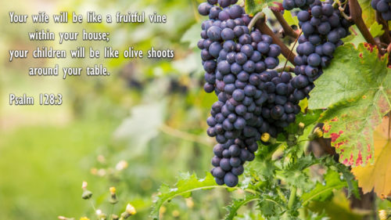

19th Sunday after Pentecost
October 3rd, 2021
10:00 am Service

‘Come grow with us!’

Living Word Lutheran Church (LCMS)
16301 Wolf Rd, Orland Park, IL 60467
livingwordorland.org (708) 403-9673
WELCOME TO LIVING WORD!
Blue church information card is in seat pocket

WE REJOICE IN GOD’S LOVE & FORGIVENESS…

Opening Prayer

Praise Songs “Ancient of Days”

Invocation

Confession & Forgiveness On screen or Hymnal p. 158

Affirmation of Faith: 4th Commandment with Luther’s Explanation

WE RECEIVE GOD’S WORD…

Today’s Psalm Psalm 128

Scripture Readings Facing page

Message Song “I Am the Vine”

Video “Family Pics from Pastor’s Phone…”

Message “Fruitful Vines & Olive Shoots”

WE RESPOND TO GOD’S CALL…

Prayers of God’s People

Lord’s Prayer

Communion “Father Welcomes”

Benediction

Closing Song “Go Out As People of God”

Please place offerings in basket at sanctuary entrance
“Fruitful Vines & Olive Shoots”
Psalm 128 says: “Blessed are all who fear the Lord, who walk in obedience to him. You will eat the fruit of your labor; blessings and prosperity will be yours. Your wife will be like a fruitful vine within your house; your children will be like olive shoots around your table.”

1) My relationships were planted in creation COMMITMENT.
¹⁸ The Lord God said, “It is not good for the man to be alone. I will make a helper suitable for him.” …But for Adam no suitable helper was found. ²¹ So the Lord God caused the man to fall into a deep sleep; and while he was sleeping, he took one of the man’s ribs and then closed up the place with flesh. ²² Then the Lord God made a woman from the rib he had taken out of the man, and he brought her to the man. ²³ The man said, “This is now bone of my bones and flesh of my flesh; she shall be called ‘woman,’ for she was taken out of man.” ²⁴ That is why a man leaves his father and mother and is united to his wife, and they become one flesh. Genesis 2:18, 20b-24

2) My love grows from Christ’s COMPASSION.
² Some Pharisees came and tested him by asking, “Is it lawful for a man to divorce his wife?” ³ “What did Moses command you?” he replied. ⁴ They said, “Moses permitted a man to write a certificate of divorce and send her away.” ⁵ “It was because your hearts were hard that Moses wrote you this law,” Jesus replied. ⁶ “But at the beginning of creation God ‘made them male and female.’ ⁷ ‘For this reason a man will leave his father and mother and be united to his wife, ⁸ and the two will become one flesh.’ So they are no longer two, but one flesh. ⁹ Therefore what God has joined together, let no one separate.” ¹³ People were bringing little children to Jesus for him to place his hands on them, but the disciples rebuked them. ¹⁴ When Jesus saw this, he was indignant. He said to them, “Let the little children come to me, and do not hinder them. Mark 10:2-14a

3) My family bears fruit through Church COMMUNION.
¹¹ Both the one who makes people holy and those who are made holy are of the same family. So Jesus is not ashamed to call them brothers and sisters. Hebrews 2:11

“God sets the lonely in families.”
Psalm 68:6

