Worship Prayer…

Father in heaven, I admit I am a sinner and cannot save myself, but trust only in your Son Jesus Christ—true God and true man—who died on the cross for me and rose again to give me new life now and forever. By your Holy Spirit’s power take my heart and life and make me yours; turn me from my own selfish path to always love, trust and follow Jesus. Because you love and forgive me, help me forgive and love others. And now, as we gather together as your church in this place, make us one in truth and love according to the faithful leading and unfailing promises of your living Word. In Jesus’ name….Amen!

Living Word exists to…

- Proclaim God’s Love

- Expand God’s Kingdom

- Mature God’s People

- Live God’s Word!

Pastor Steve Lee
revstevelee@gmail.com
708-334-5883

Anita Meier - Musician
Diana Motel – Livestream/Tech Booth

Living
Word

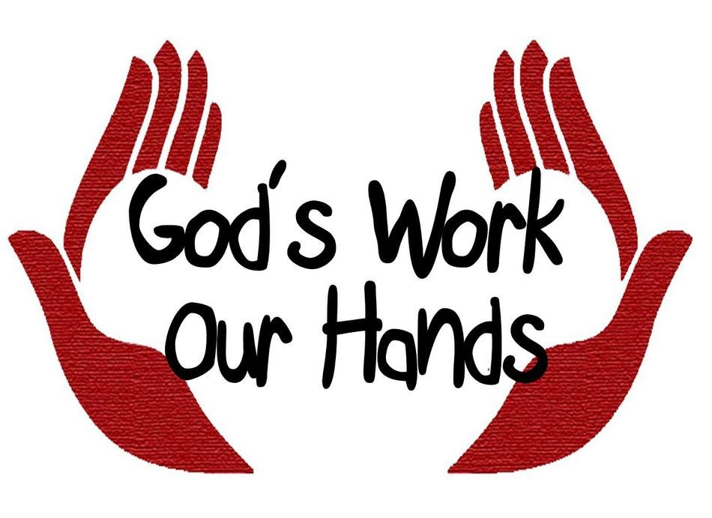

20th Sunday after Pentecost
October 10th, 2021
10:00 am Service

‘Come grow with us!’

Living Word Lutheran Church (LCMS)
16301 Wolf Rd, Orland Park, IL 60467
livingwordorland.org (708) 403-9673
WELCOME TO LIVING WORD!
Blue church information card is in seat pocket

WE REJOICE IN GOD’S LOVE & FORGIVENESS…

Opening Prayer

Praise Songs “Gentle Shepherd”
“We Are His Hands”
Invocation

Confession & Forgiveness On screen or Hymnal p. 158

Affirmation of Faith: Lord’s Prayer 2nd Petition with Explanation

WE RECEIVE GOD’S WORD…

Today’s Psalm Psalm 90:12-17

Scripture Readings Facing page

Message Song “Fight the Good Fight”

Video Virginia mother: DOJ ‘has declared a war on parents’
www.foxnews.com/opinion/biden-garland-justice-department-parents-bully-free-speech-gregg-jarrett

Message “Establish the Work of Our Hands”

WE RESPOND TO GOD’S CALL…

Prayers of God’s People

Lord’s Prayer

Benediction

Closing Song “How Firm a Foundation”

Please place offerings in basket at sanctuary entrance
“Establish the Work of Our Hands”

Psalm 90 says: “Teach us to number our days, that we may gain a heart of wisdom… May the favor of the Lord our God rest on us: establish the work of our hands for us.” How do we work with God?

1) Keep FIGHTING for justice.
¹⁰ There are those who hate the one who upholds justice in court and detest the one who tells the truth… ¹² …There are those who oppress the innocent and take bribes and deprive the poor of justice in the courts. ¹³ Therefore the prudent keep quiet in such times, for the times are evil. ¹⁴ Seek good, not evil, that you may live. Then the Lord God Almighty will be with you, just as you say he is. ¹⁵ Hate evil, love good; maintain justice in the courts. Perhaps the Lord God Almighty will have mercy on the remnant of Joseph. Amos 5:10, 12b-15

2) Hold FIRM in conviction.
¹² See to it, brothers and sisters, that none of you has a sinful, unbelieving heart that turns away from the living God. ¹³ But encourage one another daily, as long as it is called “Today,” so that none of you may be hardened by sin’s deceitfulness. ¹⁴ We have come to share in Christ, if indeed we hold our original conviction firmly to the very end. Hebrews 3:12-14

3) Come FOLLOW our Shepherd.
¹⁷ As Jesus started on his way, a man ran up to him and fell on his knees before him. “Good teacher,” he asked, “what must I do to inherit eternal life?” ¹⁸ “Why do you call me good?” Jesus answered. “No one is good—except God alone. ¹⁹ You know the commandments: ‘You shall not murder, you shall not commit adultery, you shall not steal, you shall not give false testimony, you shall not defraud, honor your father and mother.’” ²⁰ “Teacher,” he declared, “all these I have kept since I was a boy.” ²¹ Jesus looked at him and loved him. “One thing you lack,” he said. “Go, sell everything you have and give to the poor, and you will have treasure in heaven. Then come, follow me.”
²² At this the man’s face fell. He went away sad, because he had great wealth. Mark 10:17-22

