Worship Prayer…

Father in heaven, I admit I am a sinner and cannot save myself, but trust only in your Son Jesus Christ—true God and true man—who died on the cross for me and rose again to give me new life now and forever. By your Holy Spirit’s power take my heart and life and make me yours; turn me from my own selfish path to always love, trust and follow Jesus. Because you love and forgive me, help me forgive and love others. And now, as we gather together as your church in this place, make us one in truth and love according to the faithful leading and unfailing promises of your living Word. In Jesus’ name….Amen!

Living Word exists to…

- Proclaim God’s Love

- Expand God’s Kingdom

- Mature God’s People

- Live God’s Word!

Pastor Steve Lee
revstevelee@gmail.com
708-334-5883

Anita Meier - Musician
Paul Huang – Livestream/Tech Booth

Living
Word

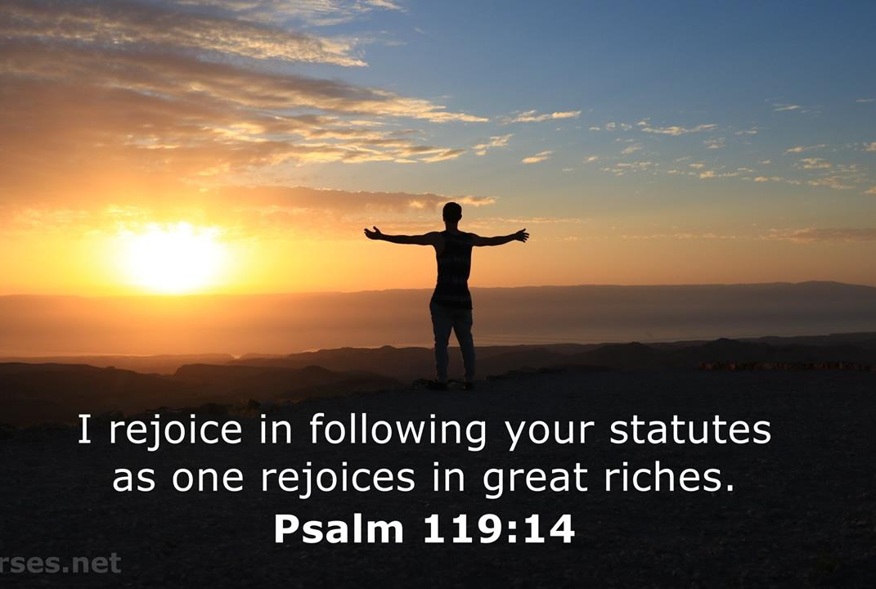

21st Sunday after Pentecost
October 17th, 2021
10:00 am Service

‘Come grow with us!’

Living Word Lutheran Church (LCMS)
16301 Wolf Rd, Orland Park, IL 60467
livingwordorland.org (708) 403-9673
intouchlwlc@yahoo.com
WELCOME TO LIVING WORD!
Blue church information card is in seat pocket

WE REJOICE IN GOD’S LOVE & FORGIVENESS…

Opening Prayer

Praise Songs “We’ll Be Faithful”

Invocation

Confession & Forgiveness On screen or Hymnal p. 158

Affirmation of Faith: Lord’s Prayer 4th Petition with Explanation

WE RECEIVE GOD’S WORD…

Today’s Psalm Psalm 119:9-16

Scripture Readings Facing page

Message Song “Seek Ye First”

Video “The True Story Behind the Kidnapping of Billionaire Paul Getty’s Grandson” youtube.com/watch?v=yECNPRtK2uI

Message “Rejoicing in Our Riches”

WE RESPOND TO GOD’S CALL…

Prayers of God’s People

Lord’s Prayer

Communion “Lead Me to the Cross”

Benediction

Closing Song “You Are My All In All”

Please place offerings in basket at sanctuary entrance
“Rejoicing in Our Riches”

Psalm 119 says: “I rejoice in following your statutes [testimonies] as one rejoices in great riches.” Today we rejoice in our riches…

1) We rejoice in our true RICHES.
¹⁰ Whoever loves money never has enough; whoever loves wealth is never satisfied with their income. This too is meaningless. ¹¹ As goods increase, so do those who consume them. And what benefit are they to the owners except to feast their eyes on them? ¹² The sleep of a laborer is sweet, whether they eat little or much, but as for the rich, their abundance permits them no sleep. Ecclesiastes 5:10-12

2) We rejoice in our Sabbath REST.
⁹ There remains, then, a Sabbath-rest for the people of God; ¹⁰ for anyone who enters God’s rest also rests from their works, just as God did from his. Hebrews 4:9-10

3) We rejoice in our Christian RELATIONSHIPS.
²³ Jesus looked around and said to his disciples, “How hard it is for the rich to enter the kingdom of God!” ²⁴ The disciples were amazed at his words. But Jesus said again, “Children, how hard it is^{[e]} to enter the kingdom of God! ²⁵ It is easier for a camel to go through the eye of a needle than for someone who is rich to enter the kingdom of God.”
²⁶ The disciples were even more amazed, and said to each other, “Who then can be saved?” ²⁷ Jesus looked at them and said, “With man this is impossible, but not with God; all things are possible with God.”²⁸ Then Peter spoke up, “We have left everything to follow you!” ²⁹ “Truly I tell you,” Jesus replied, “no one who has left home or brothers or sisters or mother or father or children or fields for me and the gospel
³⁰ will fail to receive a hundred times as much in this present age: homes, brothers, sisters, mothers, children and fields—along with persecutions—and in the age to come eternal life. ³¹ But many who are first will be last, and the last first.” Mark 10:23-31

My cup overflows. Surely goodness and loving kindness will follow me all the days of my life, and I will dwell in the house of the Lord forever. Psalm 23:5

“I came that [you] may have life, and have it abundantly.” John 10:10

