Worship Prayer…

Father in heaven, I admit I am a sinner and cannot save myself, but trust only in your Son Jesus Christ—true God and true man—who died on the cross for me and rose again to give me new life now and forever. By your Holy Spirit’s power take my heart and life and make me yours; turn me from my own selfish path to always love, trust and follow Jesus. Because you love and forgive me, help me forgive and love others. And now, as we gather together as your church in this place, make us one in truth and love according to the faithful leading and unfailing promises of your living Word. In Jesus’ name….Amen!

Living Word exists to…

- Proclaim God’s Love

- Expand God’s Kingdom

- Mature God’s People

- Live God’s Word!

Pastor Steve Lee
revstevelee@gmail.com
708-334-5883

Anita Meier - Musician
Diana Motel – Livestream/Tech Booth

Living
Word

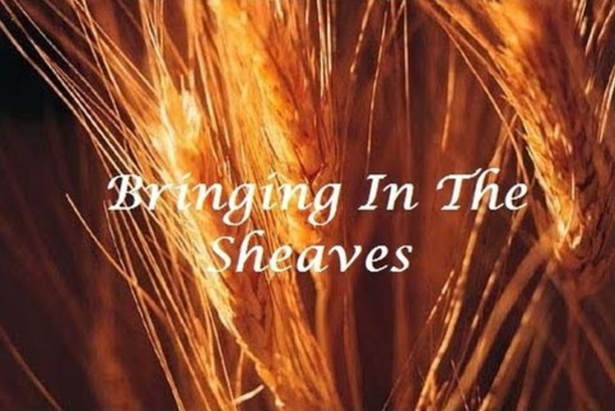

22nd Sunday after Pentecost
October 24th, 2021
10:00 am Service

‘Come grow with us!’

Living Word Lutheran Church (LCMS)
16301 Wolf Rd, Orland Park, IL 60467
livingwordorland.org (708) 403-9673
intouchlwlc@yahoo.com

WELCOME TO LIVING WORD!
Blue church information card is in seat pocket

WE REJOICE IN GOD’S LOVE & FORGIVENESS…

Opening Prayer

Praise Songs “I Love to Be in Your Presence”
“Open the Eyes of My Heart”
Invocation

Confession & Forgiveness On screen or Hymnal p. 158

Affirmation of Faith: Apostles’ Creed

WE RECEIVE GOD’S WORD…

Today’s Psalm Psalm 126

Scripture Readings Facing page

Message Song “Hark, the Voice of Jesus Calling”

Video “Bringing in the Sheaves”
https://www.google.com/url?sa=t&source=web&rct=j&url=https://m.youtube.com/watch%3Fv%3DC8KgZSLXly4&ved=2ahUKEwjK4bDzNbzAhXKKM0KHWHACEcQwqsBegQICxAF&usg=AOvVaw3fm1nBCsSz4nRKhY8kAIFL

Message “Bringing In the Sheaves”

WE RESPOND TO GOD’S CALL…

Prayers of God’s People

Lord’s Prayer

Benediction

Closing Song “Here I Am, Lord”

Please place offerings in basket at sanctuary entrance
“Bringing In the Sheaves”

Psalm 126:6 says: Those who go out weeping, carrying seed to sow,
will return with songs of joy, carrying sheaves ...

1) The Lord sets us FREE.
⁷ This is what the Lord says: “Sing with joy for Jacob; shout for the foremost of the nations. Make your praises heard, and say, ‘Lord, save your people, the remnant of Israel.’ ⁸ See, I will bring them from the land of the north and gather them from the ends of the earth.
Jeremiah 31:7-8a

2) Our High Priest meets our NEEDS.
²³ Now there have been many of those priests, since death prevented them from continuing in office; ²⁴ but because Jesus lives forever, he has a permanent priesthood. ²⁵ Therefore he is able to save completely
those who come to God through him, because he always lives to inter-cede for them. ²⁶ Such a high priest truly meets our need—one who is holy, blameless, pure, set apart from sinners, exalted above the
heavens. ²⁷ Unlike the other high priests, he does not need to offer sacrifices day after day, first for his own sins, and then for the sins of the people. He sacrificed for their sins once for all when he offered himself. ²⁸ For the law appoints as high priests men in all their weak-ness; but the oath, which came after the law, appointed the Son, who has been made perfect forever. Hebrews 7:23-28

3) The Son of David helps us SEE.
⁴⁶ Then they came to Jericho. As Jesus and his disciples, together with a large crowd, were leaving the city, a blind man, Bartimaeus (which means “son of Timaeus”), was sitting by the roadside begging.
⁴⁷ When he heard that it was Jesus of Nazareth, he began to shout, “Jesus, Son of David, have mercy on me!”⁴⁸ Many rebuked him and told him to be quiet, but he shouted all the more, “Son of David, have mercy on me!” ⁴⁹ Jesus stopped and said, “Call him.” So they called to the blind man, “Cheer up! On your feet! He’s calling you.”
⁵⁰ Throwing his cloak aside, he jumped to his feet and came to Jesus.
⁵¹ “What do you want me to do for you?” Jesus asked him. The blind man said, “Rabbi, I want to see.” ⁵² “Go,” said Jesus, “your faith has healed you.” Immediately he received his sight and followed Jesus along the road. Mark 10:46-52

