Worship Prayer…

Father in heaven, I admit I am a sinner and cannot save myself, but trust only in your Son Jesus Christ—true God and true man—who died on the cross for me and rose again to give me new life now and forever. By your Holy Spirit’s power take my heart and life and make me yours; turn me from my own selfish path to always love, trust and follow Jesus. Because you love and forgive me, help me forgive and love others. And now, as we gather together as your church in this place, make us one in truth and love according to the faithful leading and unfailing promises of your living Word. In Jesus’ name….Amen!

Living Word exists to…

- Proclaim God’s Love

- Expand God’s Kingdom

- Mature God’s People

- Live God’s Word!

Pastor Steve Lee
revstevelee@gmail.com
708-334-5883

Anita Meier - Musician
Diana Motel – Livestream/Tech Booth

Living Word
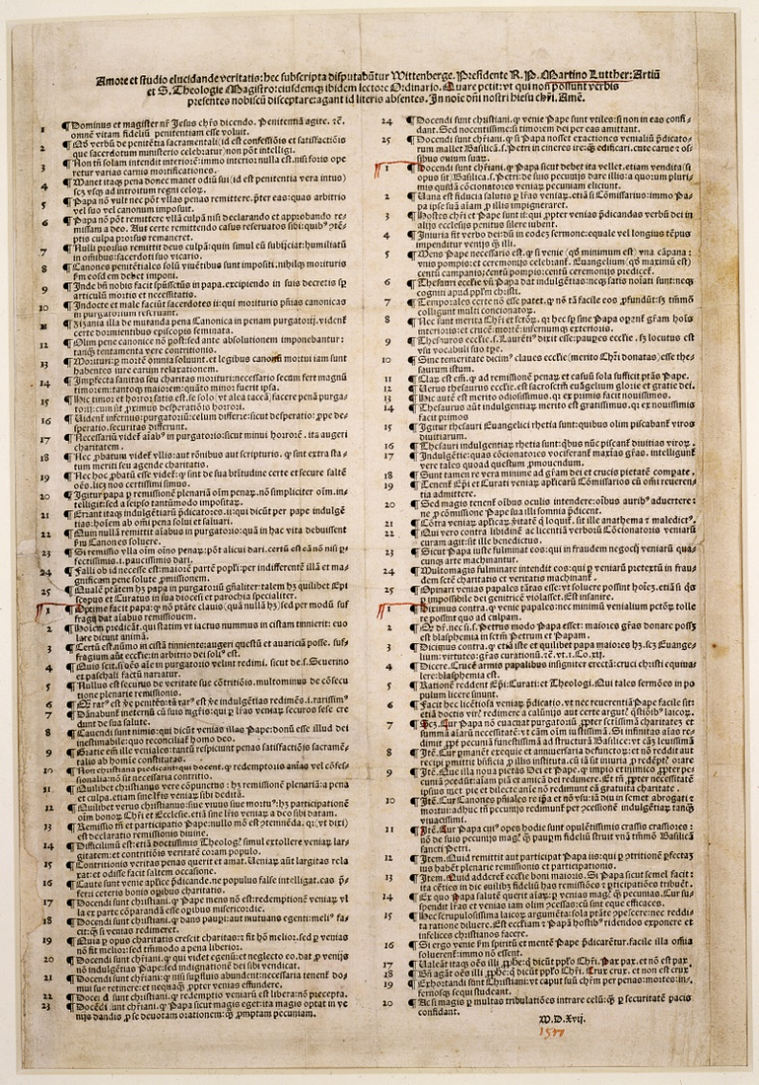
1517 copy of 95 Theses by Martin Luther
(Nuremberg print by Hieronymus Höltzel)

Reformation Sunday
October 31st, 2021
10:00 am Service
Living Word Lutheran Church (LCMS)
16301 Wolf Rd, Orland Park, IL 60467
livingwordorland.org (708) 403-9673
intouchlwlc@yahoo.com
WELCOME TO LIVING WORD!
Blue church information card is in seat pocket

WE REJOICE IN GOD’S LOVE & FORGIVENESS…

Opening Prayer

Praise Songs “Be Exalted, O God”
“Your Grace Is Sufficient”
Invocation

Confession & Forgiveness On screen or Hymnal p. 158

Affirmation of Faith: The Apostles’ Creed with Luther’s Explanation

WE RECEIVE GOD’S WORD…

Today’s Psalm Psalm 46

Scripture Readings Facing page

Message Hymn “A Mighty Fortress”

Video The QUIET MAN | Sean and Mary Kate's Big Argument
youtube.com/watch?v=BmFK0jPpFBI 0:00 to 2:46

Message “A Mighty Fortress is Our God”

WE RESPOND TO GOD’S CALL…

Prayers of God’s People

Lord’s Prayer

Benediction

Closing Song “We Choose the Fear of the Lord”

Please place offerings in basket at sanctuary entrance
“A Mighty Fortress is Our God”

Psalm 46 says: “The God of Jacob is our fortress.” As Luther declared in his Reformation hymn, “A mighty fortress is our God…”

1) My FEAR of the Lord encourages me.
⁶ Then I saw another angel flying in midair, and he had the eternal gospel to proclaim to those who live on the earth—to every nation, tribe, language and people. ⁷ He said in a loud voice, “Fear God and give him glory, because the hour of his judgment has come. Worship him who made the heavens, the earth, the sea and the springs of water.” Revelation 14:6-7

2) My FAITH in the Son shields me.
¹⁹ Now we know that whatever the law says, it says to those who are under the law, so that every mouth may be silenced and the whole world held accountable to God. ²⁰ Therefore no one will be declared righteous in God’s sight by the works of the law; rather, through the law we become conscious of our sin. ²¹ But now apart from the law the righteousness of God has been made known, to which the Law and the Prophets testify. ²² This righteousness is given through faith in Jesus Christ to all who believe. There is no difference between Jew and Gentile, ²³ for all have sinned and fall short of the glory of God, ²⁴ and all are justified freely by his grace through the redemption that came by Christ Jesus. ²⁵ God presented Christ as a sacrifice of atonement,
through the shedding of his blood—to be received by faith...
²⁸ For we maintain that a person is justified by faith apart from the works of the law. Romans 3:19-25, 28

3) My FORTUNE from the Father frees me.
³¹ To the Jews who had believed him, Jesus said, “If you hold to my teaching, you are really my disciples. ³² Then you will know the truth, and the truth will set you free.” ³³ They answered him, “We are Abraham’s descendants and have never been slaves of anyone. How can you say that we shall be set free?” ³⁴ Jesus replied, “Very truly I tell you, everyone who sins is a slave to sin. ³⁵ Now a slave has no permanent place in the family, but a son belongs to it forever. ³⁶ So if the Son sets you free, you will be free indeed. John 8:31-36

