Worship Prayer…

Father in heaven, I admit I am a sinner and cannot save myself, but trust only in your Son Jesus Christ—true God and true man—who died on the cross for me and rose again to give me new life now and forever. By your Holy Spirit’s power take my heart and life and make me yours; turn me from my own selfish path to always love, trust and follow Jesus. Because you love and forgive me, help me forgive and love others. And now, as we gather together as your church in this place, make us one in truth and love according to the faithful leading and unfailing promises of your living Word. In Jesus’ name….Amen!

Living Word exists to…

- Proclaim God’s Love

- Expand God’s Kingdom

- Mature God’s People

- Live God’s Word!

Pastor Steve Lee
revstevelee@gmail.com
708-334-5883

Anita Meier - Musician
Diana Motel – Livestream/Tech Booth

Living
Word

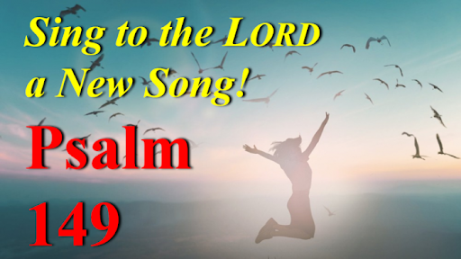

All Saints’ Day (Observed)
November 7th, 2021
10:00 am Service

‘Come grow with us!’

Living Word Lutheran Church (LCMS)
16301 Wolf Rd, Orland Park, IL 60467
livingwordorland.org (708) 403-9673
WELCOME TO LIVING WORD!
Blue church information card is in seat pocket

WE REJOICE IN GOD’S LOVE & FORGIVENESS…

Welcome & All Saints Remembrance

Opening Prayer

Praise Song “For All the Saints”

Invocation

Confession & Forgiveness On screen or Hymnal p. 158

Affirmation of Faith: Nicene Creed

WE RECEIVE GOD’S WORD…

Today’s Psalm Psalm 149

Scripture Readings Facing page

Message Song “Great is Thy Faithfulness”

Video Paul and Silas Acts 16
youtube.com/watch?v=WGRCCkzpTgI

Message “A New Song”

WE RESPOND TO GOD’S CALL…

Prayers of God’s People

Lord’s Prayer

Communion “Saints of God, the Faithful Band”

Benediction

Closing Song “Find Us Faithful”

Please place offerings in basket at sanctuary entrance
“A New Song”
Psalm 149 says: “Sing to the Lord a new song…!”
1) We sing about our new SALVATION.
⁹ After this I looked, and there before me was a great multitude that no one could count, from every nation, tribe, people and language,
standing before the throne and before the Lamb…
¹⁰ And they cried out in a loud voice: “Salvation belongs to our God, who sits on the throne, and to the Lamb…”
¹⁷ The Lamb at the center of the throne will be their shepherd; ‘he will lead them to springs of living water.’ ‘And God will wipe away every tear from their eyes.’” Revelation 7:9a, 10, 17

2) We sing about our new SIGHT.
3 See what great love the Father has lavished on us, that we should be called children of God! And that is what we are! The reason the world does not know us is that it did not know him. ² Dear friends,
now we are children of God, and what we will be has not yet been made known. But we know that when Christ appears, we shall be like him, for we shall see him as he is. ³ All who have this hope in him purify themselves, just as he is pure. 1 John 3:1-3

3) We sing about our new SPIRIT.
5 Now when Jesus saw the crowds, he went up on a mountainside and sat down. His disciples came to him, ² and he began to teach them.
He said: ³ “Blessed are the poor in spirit, for theirs is the kingdom of heaven. ⁴ Blessed are those who mourn, for they will be comforted.
⁵ Blessed are the meek, for they will inherit the earth. ⁶ Blessed are those who hunger and thirst for righteousness, for they will be filled.
⁷ Blessed are the merciful, for they will be shown mercy. ⁸ Blessed are the pure in heart, for they will see God. ⁹ Blessed are the peacemakers,
for they will be called children of God. ¹⁰ Blessed are those who are persecuted because of righteousness, for theirs is the kingdom of heaven. ¹¹ “Blessed are you when people insult you, persecute you and falsely say all kinds of evil against you because of me. ¹² Rejoice and be glad, because great is your reward in heaven, for in the same way they persecuted the prophets who were before you. Matthew 5:1-12

The Lord’s mercies are new every morning; great is your faithfulness!
Jeremiah 3:22-23

