Worship Prayer…

Father in heaven, I admit I am a sinner and cannot save myself, but trust only in your Son Jesus Christ—true God and true man—who died on the cross for me and rose again to give me new life now and forever. By your Holy Spirit’s power take my heart and life and make me yours; turn me from my own selfish path to always love, trust and follow Jesus. Because you love and forgive me, help me forgive and love others. And now, as we gather together as your church in this place, make us one in truth and love according to the faithful leading and unfailing promises of your living Word. In Jesus’ name….Amen!

Living Word exists to…

- Proclaim God’s Love

- Expand God’s Kingdom

- Mature God’s People

- Live God’s Word!

Pastor Steve Lee
revstevelee@gmail.com
708-334-5883

Anita Meier - Musician
Diana Motel – Livestream/Tech Booth

Living
Word

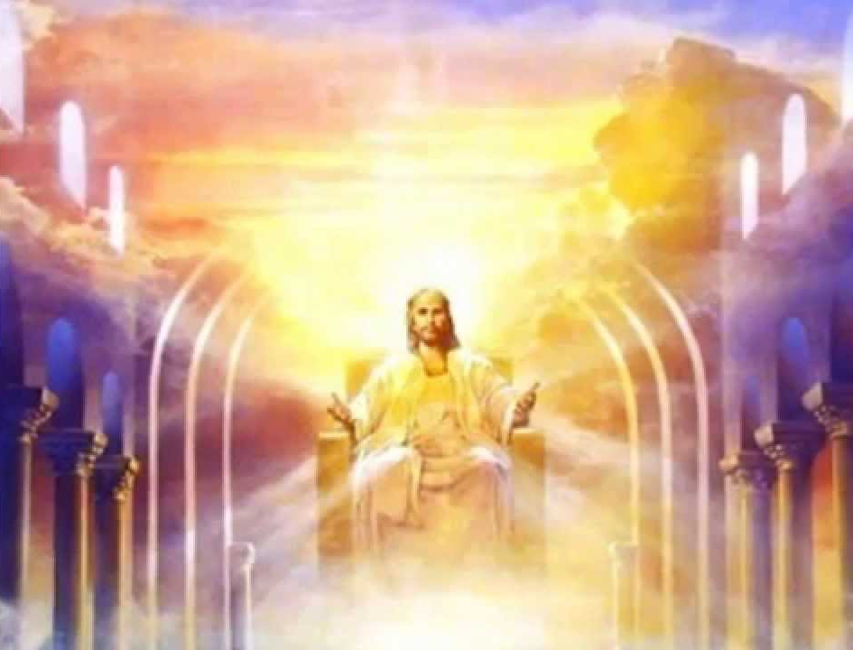

Last Sunday of the Church Year
November 21st, 2021
10:00 am Service

‘Come grow with us!’

Living Word Lutheran Church (LCMS)
16301 Wolf Rd, Orland Park, IL 60467
livingwordorland.org (708) 403-9673
intouchlwlc@yahoo.com
WELCOME TO LIVING WORD!
Blue church information card is in seat pocket

WE REJOICE IN GOD’S LOVE & FORGIVENESS…

Opening Prayer

Praise Song “Great and Mighty is He”

Invocation

Confession & Forgiveness On screen or Hymnal p. 158

Affirmation of Faith: Nicene Creed

WE RECEIVE GOD’S WORD…

Today’s Psalm Psalm 93

Scripture Readings Facing page

Message Song “Ancient of Days”

Video https://www.youtube.com/watch?v=LDAvUcJqCyE
“Our God Reigns (How Lovely on the Mountains) Ingrid Dumosch” 3:57

Message “The Lord Reigns”

WE RESPOND TO GOD’S CALL…

Prayers of God’s People

Lord’s Prayer

Communion “Think About His Love”

Benediction

Closing Song “My Faith Looks Up to Thee”

Please place offerings in basket at sanctuary entrance

“The Lord Reigns”

Psalm 93 says: "The Lord reigns." Because God is on His throne, we have confidence, peace and purpose, knowing the Lord reigns...!

1) The Lord reigns, keep the FAITH.

⁹ “As I looked, “thrones were set in place, and the Ancient of Days
took his seat. His clothing was as white as snow; the hair of his head was white like wool. His throne was flaming with fire, and its wheels
were all ablaze. ¹⁰ A river of fire was flowing, coming out from before him. Thousands upon thousands attended him; ten thousand times ten thousand stood before him. The court was seated, and the books were opened. … ¹³ “In my vision at night I looked, and there before me was one like a son of man, coming with the clouds of heaven. He ap-proached the Ancient of Days and was led into his presence. ¹⁴ He was given authority, glory and sovereign power; all nations and peoples of every language worshiped him. His dominion is an everlasting dominion that will not pass away, and his kingdom is one that will never be destroyed. Daniel 7:9-10, 13-14

2) The Lord reigns, keep in God’s LOVE.

²⁰ But you, dear friends, by building yourselves up in your most holy faith and praying in the Holy Spirit, ²¹ keep yourselves in God’s love as you wait for the mercy of our Lord Jesus Christ to bring you to eternal life. Jude 20-21

3) The Lord reigns, keep WATCH.

³³ Be on guard! Be alert! You do not know when that time will come. ³⁴ It’s like a man going away: He leaves his house and puts his servants in charge, each with their assigned task, and tells the one at the door to keep watch. ³⁵ “Therefore keep watch because you do not know when the owner of the house will come back—whether in the evening, or at midnight, or when the rooster crows, or at dawn. ³⁶ If he comes suddenly, do not let him find you sleeping. ³⁷ What I say to you, I say to everyone: ‘Watch!’” Mark 13:33-37

