Worship Prayer…

Father in heaven, I admit I am a sinner and cannot save myself, but trust only in your Son Jesus Christ—true God and true man—who died on the cross for me and rose again to give me new life now and forever. By your Holy Spirit’s power take my heart and life and make me yours; turn me from my own selfish path to always love, trust and follow Jesus. Because you love and forgive me, help me forgive and love others. And now, as we gather together as your church in this place, make us one in truth and love according to the faithful leading and unfailing promises of your living Word. In Jesus’ name….Amen!

Living Word exists to…

- Proclaim God’s Love

- Expand God’s Kingdom

- Mature God’s People

- Live God’s Word!

Pastor Steve Lee
revstevelee@gmail.com
708-334-5883

Anita Meier - Musician
Diana Motel – Livestream/Tech Booth

Living
Word

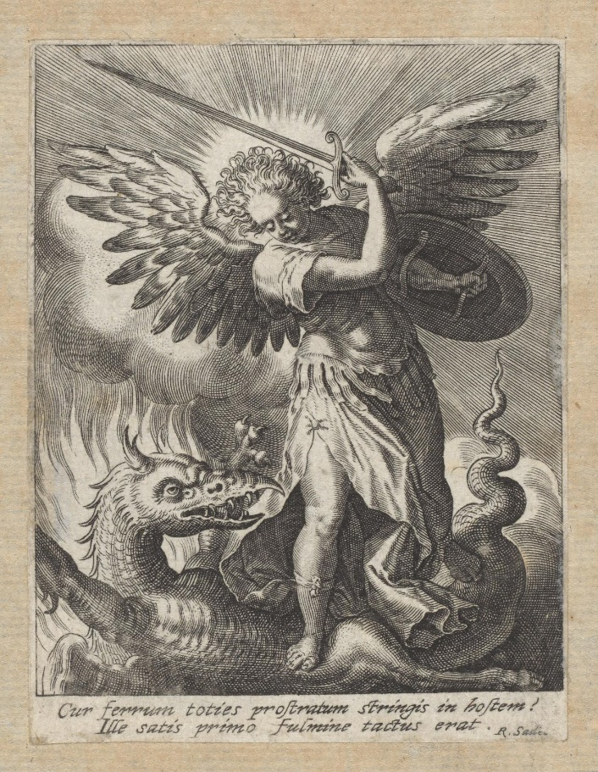
Michael slaying the Dragon

25th Sunday after Pentecost
November 14th, 2021
10:00 am Service

‘Come grow with us!’

Living Word Lutheran Church (LCMS)
16301 Wolf Rd, Orland Park, IL 60467
livingwordorland.org (708) 403-9673
intouchlwlc@yahoo.com
WELCOME TO LIVING WORD!
Blue church information card is in seat pocket

WE REJOICE IN GOD’S LOVE & FORGIVENESS…

Opening Prayer

Praise Songs “Christ Above Me”
“As High As The Heavens”
Invocation

Confession & Forgiveness On screen or Hymnal p. 158

Affirmation of Faith: 3rd Article of Apostles Creed with Explanation

WE RECEIVE GOD’S WORD…

Today’s Psalm Psalm 16

Scripture Readings Facing page

Message Song “Heaven Is In My Heart”

Video “Luther”
youtube.com/watch?v=C8x-mKwfc9k 1:13:57 to 1:18:04

Message “A Delightful Inheritance”

WE RESPOND TO GOD’S CALL…

Prayers of God’s People

Lord’s Prayer

Benediction

Closing Song “Stand Up, Stand Up for Jesus”

Please place offerings in basket at sanctuary entrance
“A Delightful Inheritance”
Psalm 16 says: “Lord, you alone are my portion and my cup; you make my lot secure. The boundary lines have fallen for me in pleasant places; surely I have a delightful inheritance…”

1) Delight in the Lord’s PROTECTION.
“At that time Michael, the great prince who protects your people, will arise. There will be a time of distress such as has not happened from the beginning of nations until then. But at that time your people, everyone whose name is found written in the book, will be delivered.
² Multitudes who sleep in the dust of the earth will awake; some to everlasting life, others to shame and everlasting contempt. ³ Those who are wise will shine like the brightness of the heavens; those who lead many to righteousness, like the stars for ever and ever. Daniel 12:1-3

2) Delight in the Lord’s PRESENCE.
¹⁹ Therefore, brothers and sisters, since we have confidence to enter the Most Holy Place by the blood of Jesus, ²⁰ by a new and living way opened for us through the curtain, that is, his body, ²¹ and since we have a great priest over the house of God, ²² let us draw near to God with a sincere heart and with the full assurance that faith brings, having our hearts sprinkled to cleanse us from a guilty conscience and having our bodies washed with pure water. ²³ Let us hold unswervingly to the hope we profess, for he who promised is faithful. ²⁴ And let us consider how we may spur one another on toward love and good deeds, ²⁵ not giving up meeting together, as some are in the habit of doing, but encouraging one another—and all the more as you see the Day approaching. Hebrews 10:19-25

3) Delight in the Lord’s POWER & PEACE.
⁵ Jesus said to them: “Watch out that no one deceives you. ⁶ Many will come in my name, claiming, ‘I am he,’ and will deceive many.
⁷ When you hear of wars and rumors of wars, do not be alarmed. Such things must happen, but the end is still to come… ¹¹ Whenever you are arrested and brought to trial, do not worry beforehand about what to say. Just say whatever is given you at the time, for it is not you speaking, but the Holy Spirit. ¹² “Brother will betray brother to death, and a father his child. Children will rebel against their parents and have them put to death. ¹³ Everyone will hate you because of me, but the one who stands firm to the end will be saved. Mark 13:5-7, 11-13

