Christmas Prayer

P: Father in heaven, today on Christmas we give you
thanks.

C: Thank you for the gift of love born in your Son Jesus!

P: Lord Jesus, today we celebrate your birth in Bethlehem.

C: Thank you for your birth to save the world from sin!

P: Holy Spirit, today we praise you for your comfort in His
birth.

C: Thank you that Jesus Christ is born again in our hearts. May we always have His love and peace within. May we always know the hope and joy of His salvation. May we always live His love and speak His truth to all!

The Lord's Prayer

All: Our Father Who art in heaven,
hallowed be Thy name,
Thy kingdom come,
Thy will be done on earth as it is in heaven;
give us this day our daily bread;
and forgive us our trespasses as we forgive
those who trespass against us;
and lead us not into temptation,
but deliver us from evil.
For Thine is the kingdom
and the power and the glory
forever and ever. Amen.

Benediction

P: The Lord bless you and keep you.
The Lord make His face shine upon you
and be gracious unto you.
The Lord lift up His countenance upon you
and give you peace.

C: Amen.

Closing Hymn Joy to the World LW # 53
Living
Word

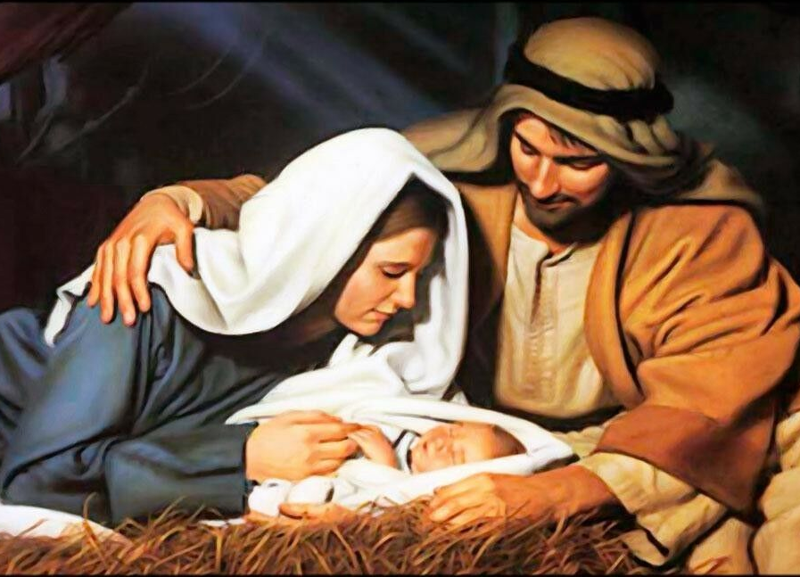

Christmas Day Service
December 25th, 2021
10 AM

‘Come grow with us!’

Living Word Lutheran Church (LCMS)
16301 Wolf Rd, Orland Park, IL 60467
livingwordorland.org (708) 403-9673
Welcome to Living Word’s
Christmas Day Service

Opening Solo Away In A Manger

Hymn First Noel

Christmas Proclamation

P: Christ Jesus is born! Our Savior has come! Today we sing with the angels in heaven, praise our Lord, and joyfully say:

C: Glory to God in the Highest! Alleluia! Christ our Savior is born! Alleluia!

Please Stand

Our Confession and God’s Forgiveness

P: In the name of God the Father, Son and Holy Spirit.
C: Amen.

P: The people who walked in darkness have seen a great
light.

C: Jesus Christ is the Light of the world, the Light no darkness can overcome.

P: “This is the message we have heard from him and declare to you: God is light; in him there is no darkness at all. If we claim to have fellowship with him and yet walk in the darkness, we lie and do not live out the truth. But if we walk in the light, as he is in the light, we have fellowship with one another, and the blood of Jesus, his Son, purifies us from all sin. If we claim to be without sin, we deceive ourselves and the truth is not in us, but if we confess our sins, he is faithful and just and will forgive us our sins and purify us from all unrighteousness” (1 John 1:5-9). Therefore, before God, in the quietness of our hearts, let us confess our sin…

Silence for self-examination and confession

P: Good News! Great Joy! To us a Child is born, to us a
Son is given, a Savior, Christ the Lord!
Upon this your confession, I, by virtue of my office, as a called and ordained servant of the Word, announce the grace of God to all of you, and in the stead and by the command of my Lord Jesus Christ forgive you all your sins in the name of the Father and of the Son and of the Holy Spirit.
Please be seated

Song What Child is This LW # 61

Scripture Readings Insert

Affirmation of Faith 2nd Article of the Nicene Creed

All: I believe in one Lord Jesus Christ the only begotten
Son of God, begotten of his Father before all worlds:
God of God, Light of Light, very God of very God,
begotten, not made, being of one substance with
the Father, by whom all things were made:
Who for us and our salvation came down from heaven and was incarnate by the Holy Spirit of the virgin Mary and was made man:
And was crucified also for us under Pontius Pilate.
He suffered and was buried. The third day he rose again according to the Scriptures and ascended into heaven; and sits at the right hand of the Father.
And he will come again with glory to judge both the living and the dead, whose kingdom will have no end.

Please be seated

Message Hymn “Angels We Have Heard on High“ LW # 55

Message “The True Light”

John 1:9-12: “The true light that gives light to everyone was coming into the world. He was in the world, and though the world was made through him, the world did not recognize him. He came to that which was his own, but his own did not receive him. Yet to all who did receive him, to those who believed in his name, he gave the right to become children of God.”

