Worship Prayer…

Father in heaven, I admit I am a sinner and cannot save myself, but trust only in your Son Jesus Christ—true God and true man—who died on the cross for me and rose again to give me new life now and forever. By your Holy Spirit’s power take my heart and life and make me yours; turn me from my own selfish path to always love, trust and follow Jesus. Because you love and forgive me, help me forgive and love others. And now, as we gather together as your church in this place, make us one in truth and love according to the faithful leading and unfailing promises of your living Word. In Jesus’ name….Amen!

Living Word exists to…

- Proclaim God’s Love

- Expand God’s Kingdom

- Mature God’s People

- Live God’s Word!

Anita Meier - Musician
Diana Motel – Livestream/Tech Booth

Living
Word

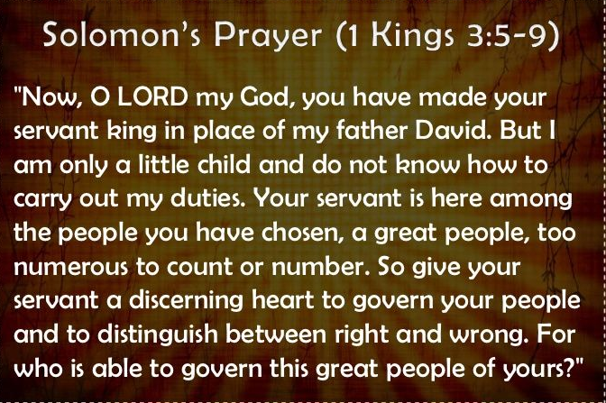

Second Sunday after Christmas
January 2nd, 2022
10:00 am Service

‘Come grow with us!’

Living Word Lutheran Church (LCMS)
16301 Wolf Rd, Orland Park, IL 60467
livingwordorland.org (708) 403-9673
intouchlwlc@yahoo.com
WELCOME TO LIVING WORD!
Blue church information card is in seat pocket

WE REJOICE IN GOD’S LOVE & FORGIVENESS…

Opening Prayer

Praise Song “I Will Delight in the Law of the Lord”

Invocation

Confession & Forgiveness On screen or Hymnal p. 158

Affirmation of Faith: Nicene Creed

WE RECEIVE GOD’S WORD…

Today’s Psalm Psalm 119:97-104

Scripture Readings Facing page

Message Song “Sweet, Sweet Spirit”

Video The Law Of The LORD Is Perfect (Psalm19)
youtube.com/watch?v=JDduu5iA8gA
Posted by Jester Ethuemar (25 followers) from Fais Island (1 square mile in size—population 220), Caroline Islands (Western Pacific)

Message “Sweeter Than Honey”

WE RESPOND TO GOD’S CALL…

Prayers of God’s People

Lord’s Prayer

Communion “The Sweetest Name of All”

Benediction

Closing Song “There Is a Redeemer”

Please place offerings in basket at sanctuary entrance
“Sweeter Than Honey”
Psalm 119 says: “How sweet are your words to my taste, sweeter than honey to my mouth!” Taste the sweetness of God’s Word…!

1) God’s Word gives me a “Solomon” HEART.
⁷ [Solomon prayed] “Now, Lord my God, you have made your servant king in place of my father David. But I am only a little child and do not know how to carry out my duties. ⁹ So give your servant a discerning heart to govern your people and to distinguish between right and wrong. For who is able to govern this great people of yours?” ¹⁰ The Lord was pleased that Solomon had asked for this. 1 Kings 3:7, 9-10

2) God’s Word “messages” me His saving GOSPEL.
¹³ And you also were included in Christ when you heard the message of truth, the gospel of your salvation. When you believed, you were marked in him with a seal, the promised Holy Spirit, ¹⁴ who is a deposit guaranteeing our inheritance until the redemption of those who are God’s possession—to the praise of his glory. Ephesians 1:13-14

3) God’s “Logos” answers my searching QUESTIONS.
⁴¹ Every year Jesus’ parents went to Jerusalem for the Festival of the Passover. ⁴² When he was twelve years old, they went up to the festival, according to the custom. ⁴³ After the festival was over, while his parents were returning home, the boy Jesus stayed behind in Jerusalem, but they were unaware of it. ⁴⁴ Thinking he was in their company, they traveled on for a day. Then they began looking for him among their relatives and friends. ⁴⁵ When they did not find him, they went back to Jerusalem to look for him. ⁴⁶ After three days they found him in the temple courts, sitting among the teachers, listening to them and asking them questions. ⁴⁷ Everyone who heard him was amazed at his understanding and his answers. ⁴⁸ When his parents saw him, they were astonished. His mother said to him, “Son, why have you treated us like this? Your father and I have been anxiously searching for you.” ⁴⁹ “Why were you searching for me?” he asked. “Didn’t you know I had to be in my Father’s house?” ⁵⁰ But they did not understand what he was saying to them. ⁵¹ Then he went down to Nazareth with them and was obedient to them. But his mother treasured all these things in her heart. ⁵² And Jesus grew in wisdom and stature, and in favor with God and man. Luke 2:41-52

