Worship Prayer…

Father in heaven, I admit I am a sinner and cannot save myself, but trust only in your Son Jesus Christ—true God and true man—who died on the cross for me and rose again to give me new life now and forever. By your Holy Spirit’s power take my heart and life and make me yours; turn me from my own selfish path to always love, trust and follow Jesus. Because you love and forgive me, help me forgive and love others. And now, as we gather together as your church in this place, make us one in truth and love according to the faithful leading and unfailing promises of your living Word. In Jesus’ name….Amen!

Living Word exists to…

- Proclaim God’s Love

- Expand God’s Kingdom

- Mature God’s People

- Live God’s Word!

Anita Meier - Musician
Diana Motel – Livestream/Tech Booth

Living
Word

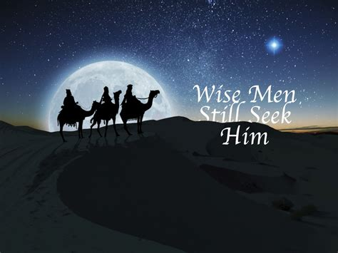

Epiphany
January 16th, 2022
10:00 am Service

‘Come grow with us!’

Living Word Lutheran Church (LCMS)
16301 Wolf Rd, Orland Park, IL 60467
livingwordorland.org (708) 403-9673
intouchlwlc@yahoo.com
WELCOME TO LIVING WORD!
Blue church information card is in seat pocket

WE REJOICE IN GOD’S LOVE & FORGIVENESS…

Opening Prayer

Praise Songs “The Name of the Lord”
“Arise, Shine”
Invocation

Confession & Forgiveness On screen or Hymnal p. 158

Affirmation of Faith: Apostles’ Creed

WE RECEIVE GOD’S WORD…

Today’s Psalm Psalm 72:1-11

Scripture Readings Facing page

Message Song “We Three Kings”

Video The Symbolism of Gold, Frankincense, and Myrrh
youtube.com/watch?v=NgiTPVIZ9hg 0:00—4:52

Message “Prosperity to the People”

WE RESPOND TO GOD’S CALL…

Prayers of God’s People

Lord’s Prayer

Communion “Fill Me”

Benediction

Closing Song “As With Gladness Men of Old”

Please place offerings in basket at sanctuary entrance
“Prosperity to the People”
Psalm 72 says: “May the mountains bring prosperity to the people, the hills the fruit of righteousness.” What “hills” bring prosperity…?

1) I see Epiphany LIGHT above the hills of Nazareth.
“Arise, shine, for your light has come, and the glory of the Lord rises upon you… ³ Nations will come to your light, and kings to the brightness of your dawn. Isaiah 60:1, 3

2) I inherit Epiphany RICHES from the hills of Jerusalem.
⁶ This mystery is that through the gospel the Gentiles are heirs together with Israel, members together of one body, and sharers together in the promise in Christ Jesus. ⁷ I became a servant of this gospel by the gift of God’s grace given me through the working of his power. ⁸ Although I am less than the least of all the Lord’s people, this grace was given me: to preach to the Gentiles the boundless riches of Christ. Ephesians 3:6-8

3) I discover Epiphany JOY in the hills of Bethlehem.
After Jesus was born in Bethlehem in Judea, during the time of King Herod, Magi from the east came to Jerusalem ² and asked, “Where is the one who has been born king of the Jews? We saw his star when it rose and have come to worship him.” ³ When King Herod heard this he was disturbed, and all Jerusalem with him. ⁴ When he had called together all the people’s chief priests and teachers of the law, he asked them where the Messiah was to be born. ⁵ “In Bethlehem in Judea,” they replied, “for this is what the prophet has written: ⁶ “‘But you, Bethlehem, in the land of Judah, are by no means least among the rulers of Judah; for out of you will come a ruler who will shepherd my people Israel.’” ⁷ Then Herod called the Magi secretly and found out from them the exact time the star had appeared. ⁸ He sent them to Bethlehem and said, “Go and search carefully for the child. As soon as you find him, report to me, so that I too may go and worship him.”
⁹ After they had heard the king, they went on their way, and the star they had seen when it rose went ahead of them until it stopped over the place where the child was. ¹⁰ When they saw the star, they were overjoyed. ¹¹ On coming to the house, they saw the child with his mother Mary, and they bowed down and worshiped him. Then they opened their treasures and presented him with gifts of gold, frankincense and myrrh. Matthew 2:1-11

