Worship Prayer…

Father in heaven, I admit I am a sinner and cannot save myself, but trust only in your Son Jesus Christ—true God and true man—who died on the cross for me and rose again to give me new life now and forever. By your Holy Spirit’s power take my heart and life and make me yours; turn me from my own selfish path to always love, trust and follow Jesus. Because you love and forgive me, help me forgive and love others. And now, as we gather together as your church in this place, make us one in truth and love according to the faithful leading and unfailing promises of your living Word. In Jesus’ name….Amen!

Living Word exists to…

- Proclaim God’s Love

- Expand God’s Kingdom

- Mature God’s People

- Live God’s Word!

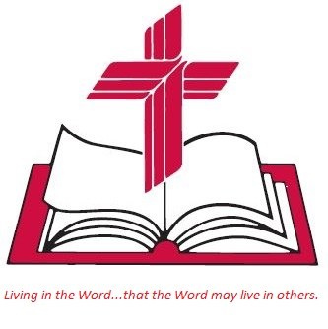

Anita Meier - Musician
Diana Motel – Livestream/Tech Booth

Living
Word

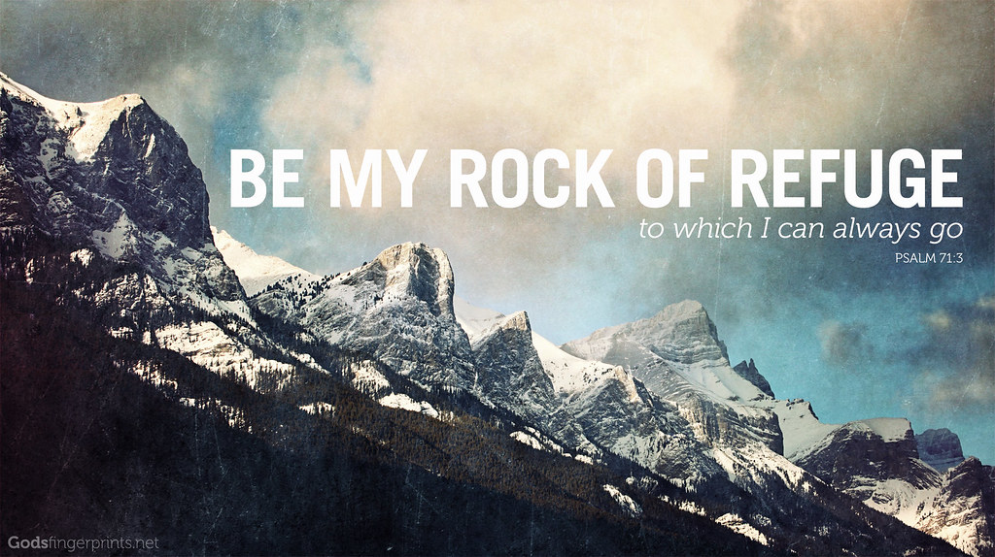

Fourth Sunday after Epiphany
January 30th, 2022
10:00 am Service

‘Come grow with us!’

Living Word Lutheran Church (LCMS)
16301 Wolf Rd, Orland Park, IL 60467
livingwordorland.org (708) 403-9673
intouchlwlc@yahoo.com

WELCOME TO LIVING WORD!
Blue church information card is in seat pocket

WE REJOICE IN GOD’S LOVE & FORGIVENESS…

Opening Prayer

Praise Songs “There Is No Rock (Rock of Ages)”
“Rock of My Salvation”
Invocation

Confession & Forgiveness On screen or Hymnal p. 158

Affirmation of Faith: Apostles’ Creed

WE RECEIVE GOD’S WORD…

Today’s Psalm Psalm 71:1-6

Scripture Readings Facing page

Message Song “The Church’s One Foundation”

Video 459 Rock Of Refuge (Gary Sadler)
youtube.com/watch?v=dhTOnvleNwM

Message “My Rock of Refuge”

WE RESPOND TO GOD’S CALL…

Prayers of God’s People

Lord’s Prayer

Benediction

Closing Song “Rock of Ages, Cleft for Me”

Please place offerings in basket at sanctuary entrance
“My Rock of Refuge”

Psalm 71 prays: “Be my rock of refuge, to which I can always go…”

1) The Lord is my Rock who RESCUES.
⁴ The word of the Lord came to me, saying, ⁵ “Before I formed you in the womb I knew you, before you were born I set you apart; I ap-pointed you as a prophet to the nations.” ⁶ “Alas, Sovereign Lord,” I said, “I do not know how to speak; I am too young.” ⁷ But the Lord
said to me, “Do not say, ‘I am too young.’ You must go to everyone I send you to and say whatever I command you. ⁸ Do not be afraid of them, for I am with you and will rescue you,” declares the Lord.
Jeremiah 1:4-8

2) The Lord is my Rock who REMAINS.
If I speak in the tongues of men or of angels, but do not have love, I am only a resounding gong or a clanging cymbal. ² If I have the gift of prophecy and can fathom all mysteries and all knowledge, and if I have a faith that can move mountains, but do not have love, I am nothing. ³ If I give all I possess to the poor and give over my body to hardship that I may boast, but do not have love, I gain nothing. ⁴ Love is patient, love is kind. It does not envy, it does not boast, it is not proud. ⁵ It does not dishonor others, it is not self-seeking, it is not easily angered, it keeps no record of wrongs. ⁶ Love does not delight in evil but rejoices with the truth. ⁷ It always protects, always trusts, always hopes, always perseveres. ⁸ Love never fails…
¹³ And now these three remain: faith, hope and love. But the greatest of these is love. 1 Corinthians 13:1-8a, 13

3) The Lord is my Rock who REBUKES.
⁴⁰ At sunset, the people brought to Jesus all who had various kinds of sickness, and laying his hands on each one, he healed them. ⁴¹ Moreover, demons came out of many people, shouting, “You are the Son of God!” But he rebuked them and would not allow them to speak, because they knew he was the Messiah. ⁴² At daybreak, Jesus went out to a solitary place. The people were looking for him and when they came to where he was, they tried to keep him from leaving them. ⁴³ But he said, “I must proclaim the good news of the kingdom of God to the other towns also, because that is why I was sent.” ⁴⁴ And he kept on preaching in the synagogues of Judea. Luke 4:40-44

