Worship Prayer…

Father in heaven, I admit I am a sinner and cannot save myself, but trust only in your Son Jesus Christ—true God and true man—who died on the cross for me and rose again to give me new life now and forever. By your Holy Spirit’s power take my heart and life and make me yours; turn me from my own selfish path to always love, trust and follow Jesus. Because you love and forgive me, help me forgive and love others. And now, as we gather together as your church in this place, make us one in truth and love according to the faithful leading and unfailing promises of your living Word. In Jesus’ name….Amen!

Living Word exists to…

- Proclaim God’s Love

- Expand God’s Kingdom

- Mature God’s People

- Live God’s Word!

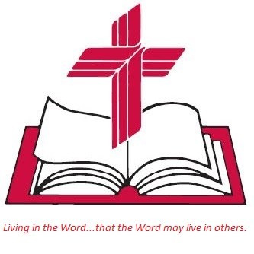

Anita Meier - Musician
Diana Motel – Livestream/Tech Booth

Living
Word

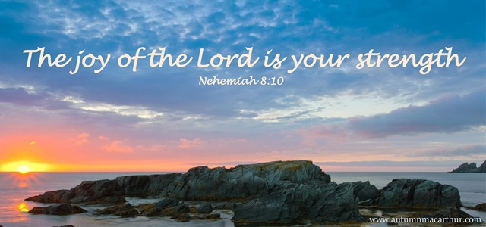

Third Sunday after the Epiphany
January 23rd, 2022
10:00 am Service

‘Come grow with us!’

Living Word Lutheran Church (LCMS)
16301 Wolf Rd, Orland Park, IL 60467
livingwordorland.org (708) 403-9673
intouchlwlc@yahoo.com
WELCOME TO LIVING WORD!
Blue church information card is in seat pocket

WE REJOICE IN GOD’S LOVE & FORGIVENESS…

Opening Prayer

Praise Songs “Almighty”
“Trading My Sorrows”
Invocation

Confession & Forgiveness On screen or Hymnal p. 158

Affirmation of Faith: Apostles’ Creed

WE RECEIVE GOD’S WORD…

Today’s Psalm Psalm 19:7-14

Scripture Readings Facing page

Message Song “Renew Me”

Video Grizzly Lake 2017
youtube.com/watch?v=bv3dizNWp30

Message “Refreshing”

WE RESPOND TO GOD’S CALL…

Prayers of God’s People

Lord’s Prayer

Benediction

Closing Song “All Who Believe and Are Baptized”

Please place offerings in basket at sanctuary entrance

“Refreshing”

Psalm 19:9 says: “The law of the Lord is perfect, refreshing the soul.” Come be refreshed…!

1) God refreshes me with the JOY of the Lord.
⁹ Then Nehemiah the governor, Ezra the priest and teacher of the Law, and the Levites who were instructing the people said to them all, “This day is holy to the Lord your God. Do not mourn or weep.” For all the people had been weeping as they listened to the words of the Law. ¹⁰ Nehemiah said, “Go and enjoy choice food and sweet drinks, and send some to those who have nothing prepared. This day is holy to our Lord. Do not grieve, for the joy of the Lord is your strength.”
Nehemiah 8:9-10

2) God refreshes me with the BAPTISM of the Spirit.
¹² Just as a body, though one, has many parts, but all its many parts form one body, so it is with Christ. ¹³ For we were all baptized by one Spirit so as to form one body—whether Jews or Gentiles, slave or free—and we were all given the one Spirit to drink.
1 Corinthians 12:12-13

3) God refreshes me with the GOSPEL of Jesus.
¹⁶ He went to Nazareth, where he had been brought up, and on the Sabbath day he went into the synagogue, as was his custom. He stood up to read…, ¹⁷ and the scroll of the prophet Isaiah was handed to him. Unrolling it, he found the place where it is written: ¹⁸ “The Spirit of the Lord is on me, because he has anointed me to proclaim good news to the poor. He has sent me to proclaim freedom for the prisoners and recovery of sight for the blind, to set the oppressed free, ¹⁹ to pro-claim the year of the Lord’s favor.” ²⁰ Then he rolled up the scroll, gave it back to the attendant and sat down. The eyes of everyone in the synagogue were fastened on him. ²¹ He began by saying to them, “Today this scripture is fulfilled in your hearing.” ²² All spoke well of him and were amazed at the gracious words that came from his lips.
Luke 4:16-22a

