Worship Prayer…

Father in heaven, I admit I am a sinner and cannot save myself, but trust only in your Son Jesus Christ—true God and true man—who died on the cross for me and rose again to give me new life now and forever. By your Holy Spirit’s power take my heart and life and make me yours; turn me from my own selfish path to always love, trust and follow Jesus. Because you love and forgive me, help me forgive and love others. And now, as we gather together as your church in this place, make us one in truth and love according to the faithful leading and unfailing promises of your living Word. In Jesus’ name….Amen!

Living Word exists to…

- Proclaim God’s Love

- Expand God’s Kingdom

- Mature God’s People

- Live God’s Word!

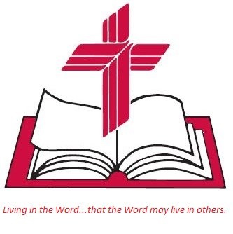

Anita Meier - Musician
Diana Motel – Livestream/Tech Booth

Living
Word

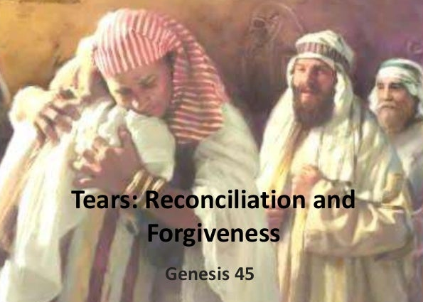
Joseph reconciled to his brothers

Seventh Sunday after Epiphany
February 20th, 2022
10:00 am Service

‘Come grow with us!’

Living Word Lutheran Church (LCMS)
16301 Wolf Rd, Orland Park, IL 60467
livingwordorland.org (708) 403-9673
intouchlwlc@yahoo.com
WELCOME TO LIVING WORD!
Blue church information card is in seat pocket

WE REJOICE IN GOD’S LOVE & FORGIVENESS…

Opening Prayer

Praise Song(s) “As High As the Heavens”

Invocation

Confession & Forgiveness On screen or Hymnal p. 158

Affirmation of Faith: Nicene Creed

WE RECEIVE GOD’S WORD…

Today’s Psalm Psalm 103:1-13

Scripture Readings Facing page

Message Song “The Power of Your Love”

Video: The Jesus Movie 1979 Full
youtube.com/watch?v=EWYuIe8ftHA 26:16 to 28:50

Message “Renewed”

WE RESPOND TO GOD’S CALL…

Prayers of God’s People

Lord’s Prayer

Communion “Today Your Mercy Calls Us”

Benediction

Closing Song “These Things Are True of You”

Please place offerings in basket at sanctuary entrance
“Renewed”
Psalm 103 says: “[The Lord] satisfies your desires with good things …so that your youth is renewed…”

1) I am renewed through Christ’s RECONCILIATION.
³ Joseph said to his brothers, “I am Joseph! Is my father still living?” But his brothers were not able to answer him, because they were terrified at his presence. ⁴ Then Joseph said to his brothers, “Come close to me.” When they had done so, he said, “I am your brother Joseph, the one you sold into Egypt! ⁵ And now, do not be distressed and do not be angry with yourselves for selling me here,
because it was to save lives that God sent me ahead of you…
¹⁴ Then he threw his arms around his brother Benjamin and wept, and Benjamin embraced him, weeping. ¹⁵ And he kissed all his brothers and wept over them. Afterward his brothers talked with him.
Genesis 45:3-5, 14-15

2) I am renewed through Christ’s RESURRECTION.
²¹ For since death came through a man, the resurrection of the dead comes also through a man. 1 Corinthians 15:21

3) I am renewed through Christ’s REWARD.
²⁷ “But to you who are listening I say: Love your enemies, do good to those who hate you, ²⁸ bless those who curse you, pray for those who mistreat you. ²⁹ If someone slaps you on one cheek, turn to them the other also. If someone takes your coat, do not withhold your shirt from them. ³⁰ Give to everyone who asks you, and if anyone takes what belongs to you, do not demand it back. ³¹ Do to others as you would have them do to you. ³² “If you love those who love you, what credit is that to you? Even sinners love those who love them. ³³ And if you do good to those who are good to you, what credit is that to you? Even sinners do that. ³⁴ And if you lend to those from whom you expect repayment, what credit is that to you? Even sinners lend to sinners, expecting to be repaid in full. ³⁵ But love your enemies, do good to them, and lend to them without expecting to get anything back. Then your reward will be great, and you will be children of the Most High, because he is kind to the ungrateful and wicked. ³⁶ Be merciful, just as your Father is merciful. ³⁷ “Do not judge, and you will not be judged. Do not condemn, and you will not be condemned. Forgive, and you will be forgiven. Luke 6:27-37

