Worship Prayer…

Father in heaven, I admit I am a sinner and cannot save myself, but trust only in your Son Jesus Christ—true God and true man—who died on the cross for me and rose again to give me new life now and forever. By your Holy Spirit’s power take my heart and life and make me yours; turn me from my own selfish path to always love, trust and follow Jesus. Because you love and forgive me, help me forgive and love others. And now, as we gather together as your church in this place, make us one in truth and love according to the faithful leading and unfailing promises of your living Word. In Jesus’ name….Amen!

Living Word exists to…

- Proclaim God’s Love

- Expand God’s Kingdom

- Mature God’s People

- Live God’s Word!

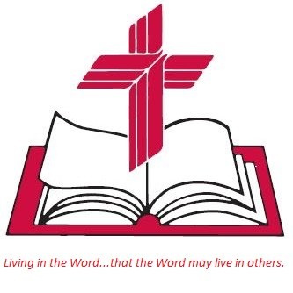

Anita Meier - Musician
Diana Motel – Livestream/Tech Booth

Living
Word

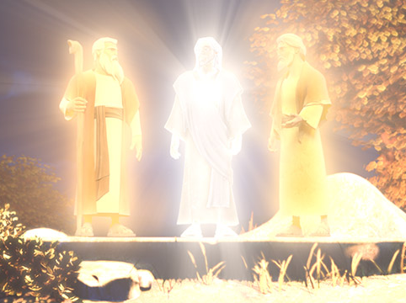
From Superbook video about the Transfiguration of Jesus

Transfiguration Sunday
February 27th, 2022
10:00 am Service

‘Come grow with us!’

Living Word Lutheran Church (LCMS)
16301 Wolf Rd, Orland Park, IL 60467
livingwordorland.org (708) 403-9673
intouchlwlc@yahoo.com
WELCOME TO LIVING WORD!
Blue church information card is in seat pocket

WE REJOICE IN GOD’S LOVE & FORGIVENESS…

Opening Prayer

Praise Song “Great and Mighty Is He”
“Come to Calvary’s Holy Mountain”

Invocation

Confession & Forgiveness On screen or Hymnal p. 158

Affirmation of Faith: Apostles’ Creed

WE RECEIVE GOD’S WORD…

Today’s Psalm Psalm 99

Scripture Readings Facing page

Message Song “Majesty”

Superbook | "The Transfiguration of Jesus" | Teach Us to Pray | Clip 1080p HD
youtube.com/watch?v=9rMiSejyjCc
Find out more at: https://us-en.superbook.cbn.com/

Message “Worship at His Holy Mountain”

WE RESPOND TO GOD’S CALL…

Prayers of God’s People

Lord’s Prayer

Benediction

Closing Song “Shine, Jesus, Shine”

Please place offerings in basket at sanctuary entrance
“Worship at His Holy Mountain”
Psalm 99 says: “Exalt the Lord our God and worship at his holy mountain.” Come worship at Zion, the place where God dwells…!

1) Come worship at MOUNT NEBO.
34 Then Moses climbed Mount Nebo from the plains of Moab to the top of Pisgah, across from Jericho. There the Lord showed him the whole land—from Gilead to Dan, ² all of Naphtali, the territory of Ephraim and Manasseh, all the land of Judah as far as the Mediterranean Sea, ³ the Negev and the whole region from the Valley of Jericho, the City of Palms, as far as Zoar. ⁴ Then the Lord said to him, “This is the land I promised on oath to Abraham, Isaac and Jacob when I said, ‘I will give it to your descendants.’ I have let you see it with your eyes, but you will not cross over into it.” ⁵ And Moses the servant of the Lord died there in Moab, as the Lord had said.
Deuteronomy 34:1-5
2) Come worship at MOUNT CALVARY.
3 Therefore, holy brothers and sisters, who share in the heavenly calling, fix your thoughts on Jesus, whom we acknowledge as our apostle and high priest. ² He was faithful to the one who appointed him, just as Moses was faithful in all God’s house. ³ Jesus has been found worthy of greater honor than Moses, just as the builder of a house has greater honor than the house itself. Hebrews 3:1-3

3) Come worship at the Mount of TRANSFIGURATION.
²⁸ About eight days after Jesus said this, he took Peter, John and James with him and went up onto a mountain to pray. ²⁹ As he was praying, the appearance of his face changed, and his clothes became as bright as a flash of lightning. ³⁰ Two men, Moses and Elijah, appeared in glorious splendor, talking with Jesus. ³¹ They spoke about his departure, which he was about to bring to fulfillment at Jerusalem.
³² Peter and his companions were very sleepy, but when they became fully awake, they saw his glory and the two men standing with him.
³³ As the men were leaving Jesus, Peter said to him, “Master, it is good for us to be here. Let us put up three shelters—one for you, one for Moses and one for Elijah.” (He did not know what he was saying.) ³⁴ While he was speaking, a cloud appeared and covered them, and they were afraid as they entered the cloud. ³⁵ A voice came from the cloud, saying, “This is my Son, whom I have chosen; listen to him.”
Luke 9:28-35

