Worship Prayer…

Father in heaven, I admit I am a sinner and cannot save myself, but trust only in your Son Jesus Christ—true God and true man—who died on the cross for me and rose again to give me new life now and forever. By your Holy Spirit’s power take my heart and life and make me yours; turn me from my own selfish path to always love, trust and follow Jesus. Because you love and forgive me, help me forgive and love others. And now, as we gather together as your church in this place, make us one in truth and love according to the faithful leading and unfailing promises of your living Word. In Jesus’ name….Amen!

Living Word exists to…

- Proclaim God’s Love

- Expand God’s Kingdom

- Mature God’s People

- Live God’s Word!

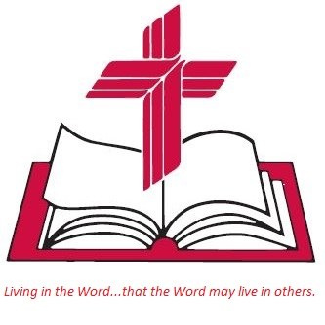

Anita Meier - Musician
Diana Motel – Livestream/Tech Booth

Living
Word

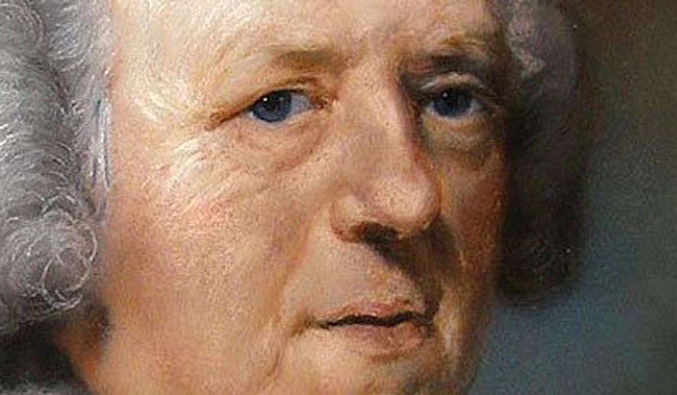
John Newton, composer of “Amazing Grace”

Fourth Sunday in Lent
March 27th, 2022
10:00 am Service

‘Come grow with us!’

Living Word Lutheran Church (LCMS)
16301 Wolf Rd, Orland Park, IL 60467
livingwordorland.org (708) 403-9673
intouchlwlc@yahoo.com
WELCOME TO LIVING WORD!
Blue church information card is in seat pocket

WE REJOICE IN GOD’S LOVE & FORGIVENESS…

Opening Prayer

Praise Song “Fill Me”
“God Is the Strength of My Heart”

Invocation

Confession & Forgiveness On screen or Hymnal p. 158

Affirmation of Faith: Apostles’ Creed

WE RECEIVE GOD’S WORD…

Today’s Psalm Psalm 32

Scripture Readings Facing page

Message Song “Rock of My Salvation”

Video: John Newton and the story behind the song 'Amazing Grace'
youtube.com/watch?v=PMLy3V8BGMk 0:00 to 3:11

Message “Blessed is the One”

WE RESPOND TO GOD’S CALL…

Prayers of God’s People

Lord’s Prayer

Benediction

Closing Song “Amazing Grace”

Please place offerings in basket at sanctuary entrance
“Blessed is the One”
Psalm 32 says: “Blessed is the one whose transgressions are forgiven, whose sins are covered.” In Christ, we are indeed the ones blessed…

1) I am “the one” blessed by “THAT DAY.”
In that day you will say: “I will praise you, Lord. Although you were angry with me, your anger has turned away and you have com-forted me. ² Surely God is my salvation. Isaiah 12:1-2a

2) I am “the one” blessed by A NEW VIEWPOINT.
¹⁶ So from now on we regard no one from a worldly point of view. Though we once regarded Christ in this way, we do so no longer. ¹⁷ Therefore, if anyone is in Christ, the new creation has come: The old has gone, the new is here! 2 Corinthians 6:16-17

3) I am “the one” blessed by JESUS’ LOST & FOUND.
¹¹ Jesus continued: “There was a man who had two sons. ¹² The younger one said to his father, ‘Father, give me my share of the estate.’ So he divided his property between them. ¹³ “Not long after that, the younger son got together all he had, set off for a distant country and there squandered his wealth in wild living. ¹⁴ After he had spent everything, there was a severe famine in that whole country, and he began to be in need. ¹⁵ So he went and hired himself out to a citizen of that country, who sent him to his fields to feed pigs. ¹⁶ He longed to fill his stomach with the pods that the pigs were eating, but no one gave him anything. ¹⁷ “When he came to his senses, he said, ‘How many of my father’s hired servants have food to spare, and here I am starving to death! ¹⁸ I will set out and go back to my father and say to him: Father, I have sinned against heaven and against you. ¹⁹ I am no longer worthy to be called your son; make me like one of your hired servants.’ ²⁰ So he got up and went to his father. “But while he was still a long way off, his father saw him and was filled with compassion for him; he ran to his son, threw his arms around him and kissed him. ²¹ “The son said to him, ‘Father, I have sinned against heaven and against you. I am no longer worthy to be called your son.’ ²² “But the father said to his servants, ‘Quick! Bring the best robe and put it on him. Put a ring on his finger and sandals on his feet. ²³ Bring the fattened calf and kill it. Let’s have a feast and celebrate. ²⁴ For this son of mine was dead and is alive again; he was lost and is found.’
Luke 15:11-24

