out. ¹³ “Then the owner of the vineyard said, ‘What shall I do? I will send my
son, whom I love; perhaps they will respect him.’ ¹⁴ “But when the tenants saw him, they talked the matter over. ‘This is the heir,’ they said. ‘Let’s kill him, and the inheritance will be ours.’ ¹⁵ So they threw him out of the vineyard and killed him. “What then will the owner of the vineyard do to them? ¹⁶ He will come and kill those tenants and give the vineyard to others.” When the people heard this, they said, “God forbid!” ¹⁷ Jesus looked directly at them and asked, “Then what is the meaning of that which is written: “‘The stone the builders rejected
has become the cornerstone’? ¹⁸ Everyone who falls on that stone will be broken to pieces; anyone on whom it falls will be crushed.” ¹⁹ The teachers of the law and the chief priests looked for a way to arrest him immediately, because they knew he had spoken this parable against them. But they were afraid of the people. ²⁰ Keeping a close watch on him, they sent spies, who pretended to be sincere. They hoped to catch Jesus in something he said, so that they might hand him over to the power and authority of the governor.

Worship Prayer…
Father in heaven, I admit I am a sinner and cannot save myself, but trust only in your Son Jesus Christ—true God and true man—who died on the cross for me and rose again to give me new life now and forever. By your Holy Spirit’s power take my heart and life and make me yours; turn me from my own selfish path to always love, trust and follow Jesus. Because you love and forgive me, help me forgive and love others. And now, as we gather together as your church in this place, make us one in truth and love according to the faithful leading and unfailing promises of your living Word. In Jesus’ name….Amen!

Living Word exists to…
Proclaim God’s Love
Expand God’s Kingdom
Mature God’s People
Live God’s Word!

Living
Word

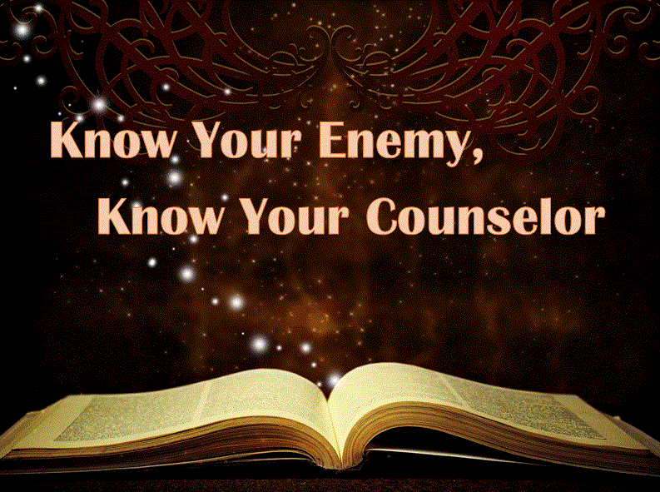

5th Sunday in Lent
April 3rd, 2022
10:00 am Service

‘Come grow with us!’

Living Word Lutheran Church (LCMS)
16301 Wolf Rd, Orland Park, IL 60467
livingwordorland.org (708) 403-9673

Pastor John Bucka
WELCOME TO LIVING WORD!

Our candles remind us the Light of the World Jesus Christ is here!
Blue information card, hymnal & Bible are in seat pocket.
Songs/readings on screen—also in Hymnals/Bibles.

WE REJOICE IN GOD’S LOVE…

Welcome

Opening Prayer & Praise “God Will Make a Way”

“Holy Ground”

Invocation, Confession & Absolution page 158 & 159

Affirmation of Faith: Nicene Creed page 166

WE RECEIVE GOD’S WORD…

Today’s Psalm 126

Scripture Readings Facing page

Message Hymn “Spirit Song”

Message “Know Your Enemy, Know Your Counselor”

WE RESPOND TO GOD’S CALL…

Prayers of God’s People

Lord’s Prayer

Communion
“Draw Me Close”
Benediction

Closing Song “O Holy Spirit, Enter In”

Please place offerings in basket at sanctuary entrance

Old Testament Reading – Isaiah 43:16-21
¹⁶ This is what the Lord says—he who made a way through the sea, a path through the mighty waters, ¹⁷ who drew out the chariots and horses, the army and reinforcements together, and they lay there, never to rise again, extinguished, snuffed out like a wick: ¹⁸ “Forget the former things; do not dwell on the past. ¹⁹ See, I am doing a new thing! Now it springs up; do you not perceive it? I am making a way in the wilderness and streams in the wasteland. ²⁰ The wild animals honor me, the jackals and the owls, because I provide water in the wilderness and streams in the wasteland, to give drink to my people, my chosen, ²¹ the people I formed for myself that they may proclaim my praise.
Epistle Reading – Philippians 3:4b-14
If someone else thinks they have reasons to put confidence in the flesh, I have more: ⁵ circumcised on the eighth day, of the people of Israel, of the tribe of Benjamin, a Hebrew of Hebrews; in regard to the law, a Pharisee; ⁶ as for zeal, persecuting the church; as for righteousness based on the law, faultless.
⁷ But whatever were gains to me I now consider loss for the sake of Christ.
⁸ What is more, I consider everything a loss because of the surpassing worth of knowing Christ Jesus my Lord, for whose sake I have lost all things. I consider them garbage, that I may gain Christ ⁹ and be found in him, not having a righteousness of my own that comes from the law, but that which is through faith in^{[a]} Christ—the righteousness that comes from God on the basis of faith. ¹⁰ I want to know Christ—yes, to know the power of his resurrection and participation in his sufferings, becoming like him in his death, ¹¹ and so, somehow, attaining to the resurrection from the dead. ¹² Not that I have already obtained all this, or have already arrived at my goal, but I press on to take hold of that for which Christ Jesus took hold of me. ¹³ Brothers and sisters, I do not consider myself yet to have taken hold of it. But one thing I do: Forgetting what is behind and straining toward what is ahead, ¹⁴ I press on toward the goal to win the prize for which God has called me heavenward in Christ Jesus.

Gospel Reading – Luke 20:9-20
⁹ He went on to tell the people this parable: “A man planted a vineyard, rented it to some farmers and went away for a long time. ¹⁰ At harvest time he sent a servant to the tenants so they would give him some of the fruit of the vineyard. But the tenants beat him and sent him away empty-handed. ¹¹ He sent another servant, but that one also they beat and treated shamefully and sent away empty-handed. ¹² He sent still a third, and they wounded him and threw him
(over)

