Worship Prayer…

Father in heaven, I admit I am a sinner and cannot save myself, but trust only in your Son Jesus Christ—true God and true man—who died on the cross for me and rose again to give me new life now and forever. By your Holy Spirit’s power take my heart and life and make me yours; turn me from my own selfish path to always love, trust and follow Jesus. Because you love and forgive me, help me forgive and love others. And now, as we gather together as your church in this place, make us one in truth and love according to the faithful leading and unfailing promises of your living Word. In Jesus’ name….Amen!

Living Word exists to…

- Proclaim God’s Love

- Expand God’s Kingdom

- Mature God’s People

- Live God’s Word!

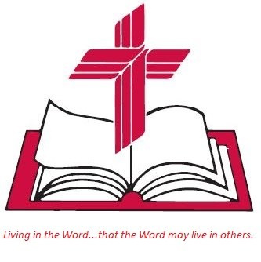

Anita Meier - Musician
Diana Motel – Livestream/Tech Booth

Living
Word

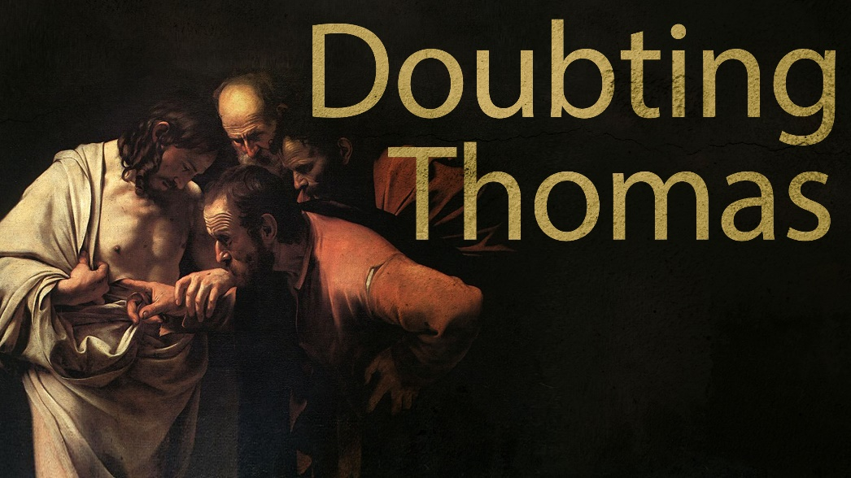

Second Sunday of Easter
April 24th, 2022
10:00 am Service

‘Come grow with us!’

Living Word Lutheran Church (LCMS)
16301 Wolf Rd, Orland Park, IL 60467
livingwordorland.org (708) 403-9673
intouchlwlc@yahoo.com
WELCOME TO LIVING WORD!
Blue church information card is in seat pocket

WE REJOICE IN GOD’S LOVE & FORGIVENESS…

Opening Prayer

Praise Song “Lord, I Lift Your Name on High”
“Praise Adonai”

Invocation

Confession & Forgiveness On screen or Hymnal p. 158

Affirmation of Faith: Apostles’ Creed

WE RECEIVE GOD’S WORD…

Today’s Psalm Psalm 148

Scripture Readings Facing page

Message Song “We Walk By Faith”

Video JOE VERSUS THE VOLCANO ~ Constant Total Amazement
youtube.com/watch?v=ICGIcfj4ZKE

Message “His Splendor”

WE RESPOND TO GOD’S CALL…

Prayers of God’s People

Lord’s Prayer

Benediction

Closing Song “This Kingdom”

Please place offerings in basket at sanctuary entrance
“His Splendor”
Psalm 148 says: “The Lord’s name alone is exalted; his splendor is above the earth and the heavens.” God’s splendor is amazing…!

1) God’s splendor was and is shown through His PEOPLE.
¹² The apostles performed many signs and wonders… Acts 5:12a

2) God’s splendor will be shown in Christ’s “PAROUSIA.”
To him who loves us and has freed us from our sins by his blood, ⁶ and has made us to be a kingdom and priests to serve his God and Father—to him be glory and power for ever and ever! Amen. ⁷ “Look, he is coming with the clouds,” and “every eye will see him, even those who pierced him.” Revelation 1:5b-7a

3) God’s splendor is ultimately shown by Jesus’ PASSION.
¹⁹ On the evening of that first day of the week, when the disciples were together, with the doors locked for fear of the Jewish leaders, Jesus came and stood among them and said, “Peace be with you!” ²⁰ After he said this, he showed them his hands and side. The disciples were overjoyed when they saw the Lord. ²¹ Again Jesus said, “Peace be with you! As the Father has sent me, I am sending you.” ²² And with that he breathed on them and said, “Receive the Holy Spirit. ²³ If you forgive anyone’s sins, their sins are forgiven; if you do not forgive them, they are not forgiven.” ²⁴ Now Thomas (also known as Didymus), one of the Twelve, was not with the disciples when Jesus came. ²⁵ So the other disciples told him, “We have seen the Lord!” But he said to them, “Unless I see the nail marks in his hands and put my finger where the nails were, and put my hand into his side, I will not believe.” ²⁶ A week later his disciples were in the house again, and Thomas was with them. Though the doors were locked, Jesus came and stood among them and said, “Peace be with you!”
²⁷ Then he said to Thomas, “Put your finger here; see my hands. Reach out your hand and put it into my side. Stop doubting and believe.”
²⁸ Thomas said to him, “My Lord and my God!” ²⁹ Then Jesus told him, “Because you have seen me, you have believed; blessed are those who have not seen and yet have believed.” ³⁰ Jesus performed many other signs in the presence of his disciples, which are not recorded in this book. ³¹ But these are written that you may believe that Jesus is the Messiah, the Son of God, and that by believing you may have life in his name. John 20:19-31

