Worship Prayer…

Father in heaven, I admit I am a sinner and cannot save myself, but trust only in your Son Jesus Christ—true God and true man—who died on the cross for me and rose again to give me new life now and forever. By your Holy Spirit’s power take my heart and life and make me yours; turn me from my own selfish path to always love, trust and follow Jesus. Because you love and forgive me, help me forgive and love others. And now, as we gather together as your church in this place, make us one in truth and love according to the faithful leading and unfailing promises of your living Word. In Jesus’ name….Amen!

Living Word exists to…

- Proclaim God’s Love

- Expand God’s Kingdom

- Mature God’s People

- Live God’s Word!

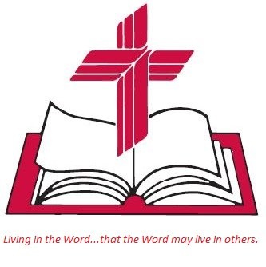

Anita Meier - Musician
Diana Motel – Livestream/Tech Booth

Living
Word

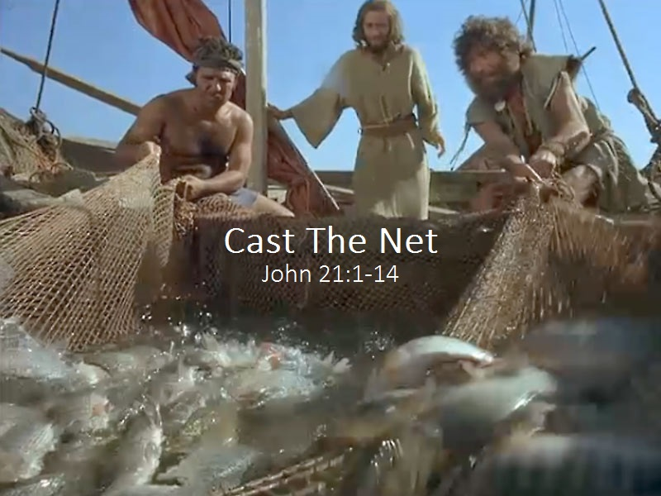

Third Sunday of Easter
May 1st, 2022
10:00 am Service

‘Come grow with us!’

Living Word Lutheran Church (LCMS)
16301 Wolf Rd, Orland Park, IL 60467
livingwordorland.org (708) 403-9673
intouchlwlc@yahoo.com
WELCOME TO LIVING WORD!
Blue church information card is in seat pocket

WE REJOICE IN GOD’S LOVE & FORGIVENESS…

Opening Prayer

Praise Song “As High As the Heavens”

Invocation

Confession & Forgiveness On screen or Hymnal p. 158

Affirmation of Faith: Nicene Creed

WE RECEIVE GOD’S WORD…

Today’s Psalm Psalm 30

Scripture Readings Facing page

Message Song “The Battle Belongs to the Lord”

Video Elon Musk Sits Down With The Babylon Bee
youtube.com/watch?v=jvGnw1sHh9M 1:34:22 to 1:35:50

Message “Out of the Depths”

WE RESPOND TO GOD’S CALL…

Prayers of God’s People

Lord’s Prayer

Communion “I’m Forever Grateful”

Benediction

Closing Song “What a Friend We Have in Jesus”

Please place offerings in basket at sanctuary entrance
“Out of the Depths”
Psalm 30 says: “I will exalt you, Lord, for you lifted me out of the depths…”

1) The LIGHT lifts me out of the depths of darkness.
Meanwhile, Saul was still breathing out murderous threats against the Lord’s disciples. He went to the high priest ² and asked him for letters to the synagogues in Damascus, so that if he found any there who belonged to the Way, he might take them as prisoners to Jerusalem. ³ As he neared Damascus on his journey, suddenly a light from heaven flashed around him…Acts 9:1-3

2) The LION lifts me out of the depths of despair.
Then I saw in the right hand of him who sat on the throne a scroll with writing on both sides and sealed with seven seals. ² And I saw a mighty angel proclaiming in a loud voice, “Who is worthy to break the seals and open the scroll?” ³ But no one in heaven or on earth or under the earth could open the scroll or even look inside it. ⁴ I wept and wept because no one was found who was worthy to open the scroll or look inside. ⁵ Then one of the elders said to me, “Do not weep! See, the Lion of the tribe of Judah, the Root of David, has triumphed. He is able to open the scroll…” Revelation 5:1-5

3) The LORD lifts me out of the depths of death.
Jesus appeared again to his disciples, by the Sea of Galilee. It happened this way: ² Simon Peter, Thomas (also known as Didymus), Nathanael from Cana in Galilee, Zebedee’s sons, and two other disciples were together. ³ “I’m going out to fish,” Simon Peter told them, and they said, “We’ll go with you.” So they went out and got into the boat, but that night they caught nothing. ⁴ Early in the morning, Jesus stood on the shore, but the disciples did not realize that it was Jesus. ⁵ He called out to them, “Friends, haven’t you any fish?” “No,” they answered. ⁶ He said, “Throw your net on the right side of the boat and you will find some.” When they did, they were unable to haul the net in because of the large number of fish. ⁷ Then the disciple whom Jesus loved said to Peter, “It is the Lord!” As soon as Peter heard him, he wrapped his outer garment around him and jumped into the water. ⁸ The other disciples followed in the boat, towing the net full of fish, for they were not far from shore, about a hundred yards. ⁹ When they landed, they saw a fire of burning coals there with fish on it, and some bread. ¹⁰ Jesus said to them, “Bring some of the fish you have just caught.” ¹¹ So Simon Peter climbed back into the boat and dragged the net ashore. It was full of large fish, 153, but even with so many the net was not torn. ¹² Jesus said to them, “Come and have breakfast.” None of the disciples dared ask him, “Who are you?” They knew it was the Lord. ¹³ Jesus came, took the bread and gave it to them, and did the same with the fish. ¹⁴ This was now the third time Jesus appeared to his disciples after he was raised from the dead. John 21:1-14

