Worship Prayer…

Father in heaven, I admit I am a sinner and cannot save myself, but trust only in your Son Jesus Christ—true God and true man—who died on the cross for me and rose again to give me new life now and forever. By your Holy Spirit’s power take my heart and life and make me yours; turn me from my own selfish path to always love, trust and follow Jesus. Because you love and forgive me, help me forgive and love others. And now, as we gather together as your church in this place, make us one in truth and love according to the faithful leading and unfailing promises of your living Word. In Jesus’ name….Amen!

Living Word exists to…

- Proclaim God’s Love

- Expand God’s Kingdom

- Mature God’s People

- Live God’s Word!

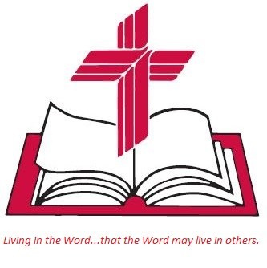

Anita Meier - Musician
Diana Motel – Livestream/Tech Booth

Living
Word

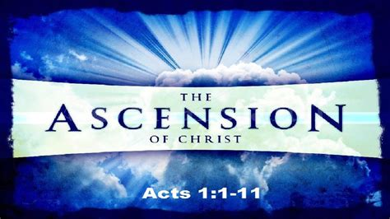

Ascension of Our Lord
May 29th, 2022
10:00 am Service

‘Come grow with us!’

Living Word Lutheran Church (LCMS)
16301 Wolf Rd, Orland Park, IL 60467
livingwordorland.org (708) 403-9673
intouchlwlc@yahoo.com
WELCOME TO LIVING WORD!
Blue church information card is in seat pocket

WE REJOICE IN GOD’S LOVE & FORGIVENESS…

Opening Prayer

Praise Song “Open the Eyes of My Heart”
“People Need the Lord”

Invocation

Confession & Forgiveness On screen or Hymnal p. 158

Affirmation of Faith: Apostles’ Creed

WE RECEIVE GOD’S WORD…

Today’s Psalm Psalm 47

Scripture Readings Facing page

Message Song “A Hymn of Glory Let Us Sing”

Video Salvation Completed—It Is Finished!
youtube.com/watch?v=aSJq1f2wNGY 0:38 to 4:21

Message “King Over All”

WE RESPOND TO GOD’S CALL…

Prayers of God’s People

Lord’s Prayer

Benediction

Closing Song “Shout to the Lord”

Please place offerings in basket at sanctuary entrance
“King Over All”

Psalm 47 says: “For the Lord Most High is awesome, the great King over all the earth.” Our ascended King gives me power…

1) Our ascended King gives me power to PROCLAIM.
[Jesus said] ⁸ “You will receive power when the Holy Spirit comes on you; and you will be my witnesses in Jerusalem, and in all Judea and Samaria, and to the ends of the earth.” ⁹ After he said this, he was taken up before their very eyes, and a cloud hid him from their sight.
Acts 1:8-9

2) Our ascended King gives me power to PRAY.
¹⁵ For this reason, ever since I heard about your faith in the Lord Jesus and your love for all God’s people, ¹⁶ I have not stopped giving thanks for you, remembering you in my prayers. ¹⁷ I keep asking that the God of our Lord Jesus Christ, the glorious Father, may give you the Spirit of wisdom and revelation, so that you may know him better.
¹⁸ I pray that the eyes of your heart may be enlightened in order that you may know the hope to which he has called you, the riches of his glorious inheritance in his holy people, ¹⁹ and his incomparably great power for us who believe. That power is the same as the mighty strength ²⁰ he exerted when he raised Christ from the dead and seated him at his right hand in the heavenly realms. Ephesians 1:15-20

3) Our ascended King gives me power to PRAISE.
⁴⁴ He said to them, “This is what I told you while I was still with you: Everything must be fulfilled that is written about me in the Law of Moses, the Prophets and the Psalms.” ⁴⁵ Then he opened their minds so they could understand the Scriptures. ⁴⁶ He told them, “This is what is written: The Messiah will suffer and rise from the dead on the third day, ⁴⁷ and repentance for the forgiveness of sins will be preached in his name to all nations, beginning at Jerusalem. ⁴⁸ You are witnesses of these things. ⁴⁹ I am going to send you what my Father has promised;
but stay in the city until you have been clothed with power from on high.” ⁵⁰ When he had led them out to the vicinity of Bethany, he lifted up his hands and blessed them. ⁵¹ While he was blessing them, he left them and was taken up into heaven. ⁵² Then they worshiped him and returned to Jerusalem with great joy. ⁵³ And they stayed continually at the temple, praising God. Luke 24:44-53

