Worship Prayer…

Father in heaven, I admit I am a sinner and cannot save myself, but trust only in your Son Jesus Christ—true God and true man—who died on the cross for me and rose again to give me new life now and forever. By your Holy Spirit’s power take my heart and life and make me yours; turn me from my own selfish path to always love, trust and follow Jesus. Because you love and forgive me, help me forgive and love others. And now, as we gather together as your church in this place, make us one in truth and love according to the faithful leading and unfailing promises of your living Word. In Jesus’ name….Amen!

Living Word exists to…

- Proclaim God’s Love

- Expand God’s Kingdom

- Mature God’s People

- Live God’s Word!

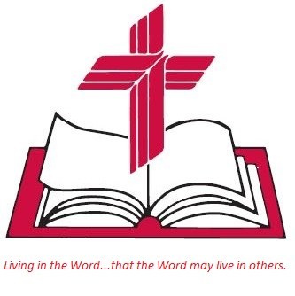

Anita Meier - Musician
Diana Motel – Livestream/Tech Booth

Living
Word

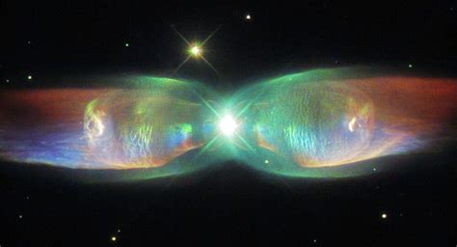

Hubble Telescope Sees the Wings of a Butterfly: The Twin Jet Nebula

“The heavens declare the glory of God; the skies proclaim the work of his hands.”
Psalm 19:1

Fifth Sunday of Easter
May 15th, 2022
10:00 am Service

Living Word Lutheran Church (LCMS)
16301 Wolf Rd, Orland Park, IL 60467
livingwordorland.org (708) 403-9673
intouchlwlc@yahoo.com
WELCOME TO LIVING WORD!
Blue church information card is in seat pocket

WE REJOICE IN GOD’S LOVE & FORGIVENESS…

Opening Prayer

Praise Song “Great is The Lord”

Invocation

Confession & Forgiveness On screen or Hymnal p. 158

Affirmation of Faith: Nicene Creed

WE RECEIVE GOD’S WORD…

Today’s Psalm Psalm 148

Scripture Readings Facing page

Message Song “Majesty”

Video: Can Science Explain Everything? By Professor John Lennox
youtube.com/watch?v=fCe4HpjJQy4

Message “Praise the Lord!”

WE RESPOND TO GOD’S CALL…

Prayers of God’s People

Lord’s Prayer

Communion “Feed Me Now”

Benediction

Closing Song “My Life is in You Lord”

Please place offerings in basket at sanctuary entrance

“Praise the Lord!”
Psalm 148 says: “Let [all creation] praise the name of the Lord, for his name alone is exalted; his splendor is above the earth and the heavens. And he has raised up for his people a horn, the praise of all his faithful servants.” Today we ask, why praise the Lord…?

1) I praise the Lord when I discover His PLAN.
The apostles and the believers throughout Judea heard that the Gentiles also had received the word of God. ² So when Peter went up to Jerusalem, the circumcised believers criticized him ³ and said, “You went into the house of uncircumcised men and ate with them.”
⁴ Starting from the beginning, Peter told them the whole story… ¹⁵ “As I began to speak, the Holy Spirit came on them as he had come on us at the beginning. ¹⁶ Then I remembered what the Lord had said: ‘John baptized with water, but you will be baptized with the Holy Spirit.’ ¹⁷ So if God gave them the same gift he gave us who believed in the Lord Jesus Christ, who was I to think that I could stand in God’s way?” ¹⁸ When they heard this, they had no further objections and praised God, saying, “So then, even to Gentiles God has granted repentance that leads to life.” Acts 11:1-4, 15-18

2) I praise the Lord when I enter His PLACE.
Then I saw “a new heaven and a new earth,” for the first heaven and the first earth had passed away, and there was no longer any sea. ² I saw the Holy City, the new Jerusalem, coming down out of heaven from God, prepared as a bride beautifully dressed for her husband. ³ And I heard a loud voice from the throne saying, “Look! God’s dwelling place is now among the people, and he will dwell with them. They will be his people, and God himself will be with them and be their God. ⁴ ‘He will wipe every tear from their eyes. There will be no more death’ or mourning or crying or pain, for the old order of things has passed away.” ⁶ He said to me: “It is done. I am the Alpha and the Omega, the Beginning and the End. To the thirsty I will give water without cost from the spring of the water of life. ⁷ Those who are victorious will inherit all this… Revelation 21:1-7a

3) I praise the Lord when I find my PURPOSE.
³⁴ “A new command I give you: Love one another. As I have loved you, so you must love one another. ³⁵ By this everyone will know that you are my disciples; if you love one another.” John 13:34-35

