Worship Prayer…

Father in heaven, I admit I am a sinner and cannot save myself, but trust only in your Son Jesus Christ—true God and true man—who died on the cross for me and rose again to give me new life now and forever. By your Holy Spirit’s power take my heart and life and make me yours; turn me from my own selfish path to always love, trust and follow Jesus. Because you love and forgive me, help me forgive and love others. And now, as we gather together as your church in this place, make us one in truth and love according to the faithful leading and unfailing promises of your living Word. In Jesus’ name….Amen!

Living Word exists to…

- Proclaim God’s Love

- Expand God’s Kingdom

- Mature God’s People

- Live God’s Word!

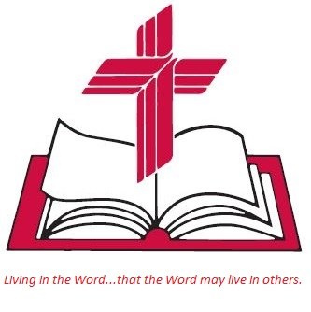

Anita Meier - Musician
Diana Motel – Livestream/Tech Booth
Living
Word

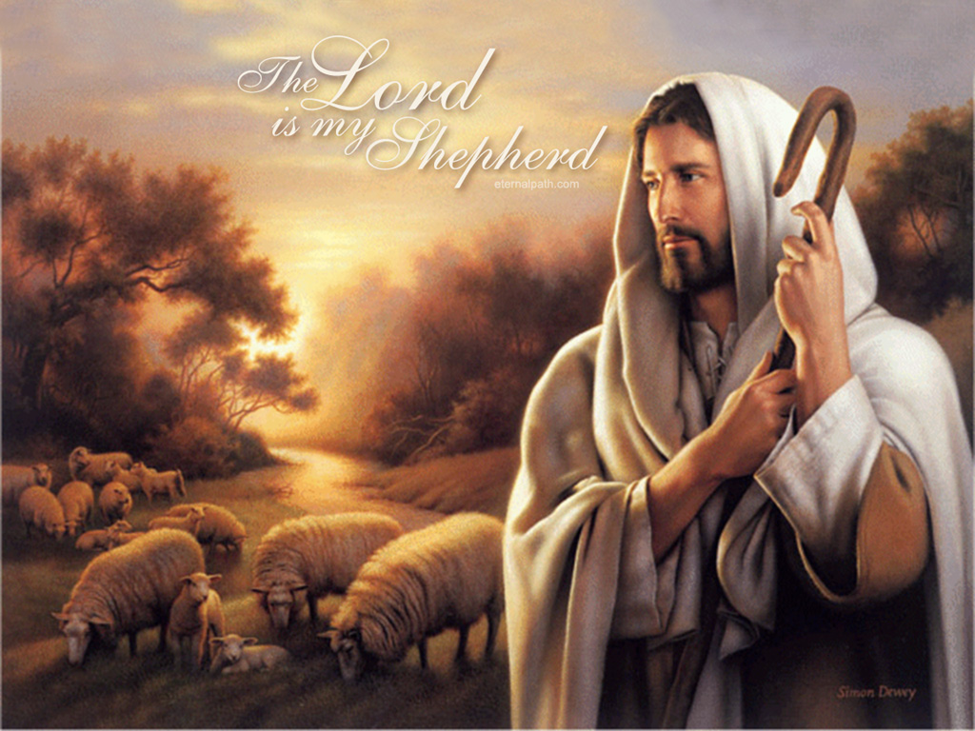

Good Shepherd Sunday
4th Sunday of Easter/Mother’s Day
May 8th, 2022
10:00 am Service

‘Come grow with us!’

Living Word Lutheran Church (LCMS)
16301 Wolf Rd, Orland Park, IL 60467
livingwordorland.org (708) 403-9673
intouchlwlc@yahoo.com
WELCOME TO LIVING WORD!
Blue church information card is in seat pocket

WE REJOICE IN GOD’S LOVE & FORGIVENESS…

Opening Prayer

Praise Song “Gentle Shepherd”

“Jesus, Name Above All Names”

Invocation

Confession & Forgiveness On screen or Hymnal p. 158

Affirmation of Faith: Apostles’ Creed

WE RECEIVE GOD’S WORD…

Today’s Psalm Psalm 23

Scripture Readings Facing page

Message Song “Surely Goodness and Mercy”

Video Mother's Day
youtube.com/watch?v=GHvjTLOtq0U 0:00 to 2:15

Message “The Lord is My Shepherd”

WE RESPOND TO GOD’S CALL…

Prayers of God’s People

Lord’s Prayer

Benediction

Closing Song “The Lord’s My Shepherd, I’ll Not Want”

Please place offerings in basket at sanctuary entrance
“The Lord is My Shepherd”

Psalm 23 says: “The Lord is my Shepherd…”

1) The Holy Spirit makes ELDERS to be church shepherds.
¹⁷ From Miletus, Paul sent to Ephesus for the elders of the church. ¹⁸ When they arrived, he said to them…
²⁸ “Keep watch over yourselves and all the flock of which the Holy Spirit has made you overseers. Be shepherds of the church of God, which he bought with his own blood. ²⁹ I know that after I leave, savage wolves will come in among you and will not spare the flock. ³⁰ Even from your own number men will arise and distort the truth in order to draw away disciples after them. ³¹ So be on your guard!” Acts 20:17-18a, 28-31a

2) God made the LAMB to be the world’s Shepherd.
⁹ After this I looked, and there before me was a great multitude that no one could count, from every nation, tribe, people and language,
standing before the throne and before the Lamb. They were wearing white robes and were holding palm branches in their hands. ¹⁰ And they cried out in a loud voice: “Salvation belongs to our God, who sits on the throne, and to the Lamb…”
¹⁶ ‘Never again will they hunger; never again will they thirst. The sun will not beat down on them, nor any scorching heat. ¹⁷ For the Lamb at the center of the throne will be their shepherd; ‘he will lead them to springs of living water.’ ‘And God will wipe away every tear from their eyes.’” Revelation 7:9-10, 16-17

3) The Father made His Son MESSIAH to be MY Shepherd.
²⁴ The Jews who were there gathered around [Jesus], saying, “How long will you keep us in suspense? If you are the Messiah, tell us plainly.” ²⁵ Jesus answered, “I did tell you, but you do not believe. The works I do in my Father’s name testify about me, ²⁶ but you do not believe because you are not my sheep. ²⁷ My sheep listen to my voice; I know them, and they follow me. ²⁸ I give them eternal life, and they shall never perish; no one will snatch them out of my hand. ²⁹ My Father, who has given them to me, is greater than all; no one can snatch them out of my Father’s hand. ³⁰ I and the Father are one.”
John 10:24-30

