Worship Prayer…

Father in heaven, I admit I am a sinner and cannot save myself, but trust only in your Son Jesus Christ—true God and true man—who died on the cross for me and rose again to give me new life now and forever. By your Holy Spirit’s power take my heart and life and make me yours; turn me from my own selfish path to always love, trust and follow Jesus. Because you love and forgive me, help me forgive and love others. And now, as we gather together as your church in this place, make us one in truth and love according to the faithful leading and unfailing promises of your living Word. In Jesus’ name….Amen!

Living Word exists to…

- Proclaim God’s Love

- Expand God’s Kingdom

- Mature God’s People

- Live God’s Word!

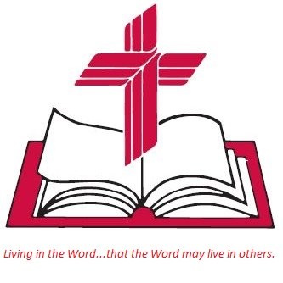

Anita Meier - Musician
Diana Motel – Livestream/Tech Booth

Living
Word

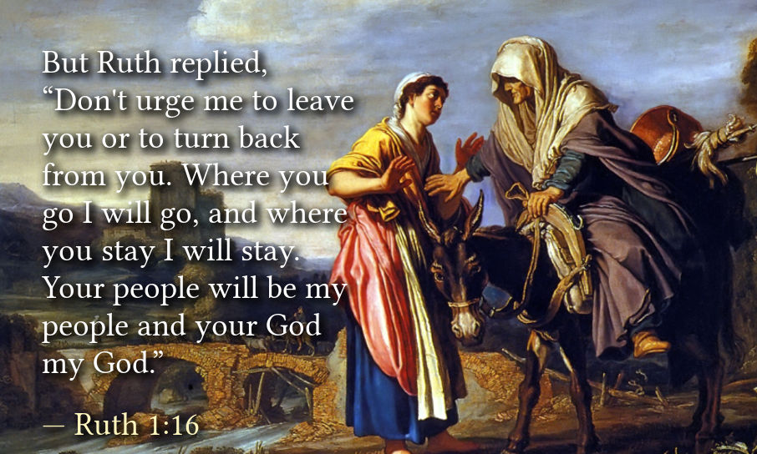

Eighteenth Sunday after Pentecost
October 9th, 2022
10:00 am Service

‘Come grow with us!’

Living Word Lutheran Church (LCMS)
16301 Wolf Rd, Orland Park, IL 60467
livingwordorland.org (708) 403-9673
intouchlwlc@yahoo.com
WELCOME TO LIVING WORD!
Blue church information card is in seat pocket

WE REJOICE IN GOD’S LOVE & FORGIVENESS…

Opening Prayer

Praise Song “Purify My Heart”
“I Give You My Heart”
Invocation

Confession & Forgiveness On screen or Hymnal p. 158

Affirmation of Faith: Apostles’ Creed

WE RECEIVE GOD’S WORD…

Today’s Psalm Psalm 111

Scripture Readings Facing page

Message Song “Cry of My Heart”

Video How To Forgive - Corrie Ten Boom
youtube.com/watch?v=l4gnZt1fXEQ 0:30 to 5:57

Message “With All My Heart”

WE RESPOND TO GOD’S CALL…

Prayers of God’s People

Lord’s Prayer

Benediction

Closing Song “Rejoice, the Lord Is King”

Please place offerings in basket at sanctuary entrance

“With All My Heart”
Psalm 111 says: “I will extol the Lord with all my heart…”

1) With all my heart I will PRESERVE my family.
¹⁵ “Look,” said Naomi, “your sister-in-law is going back to her people and her gods. Go back with her.” ¹⁶ But Ruth replied, “Don’t urge me to leave you or to turn back from you. Where you go I will go, and where you stay I will stay. Your people will be my people and your God my God. ¹⁷ Where you die I will die, and there I will be buried. May the Lord deal with me, be it ever so severely, if even death separates you and me.” ¹⁸ When Naomi realized that Ruth was determined to go with her, she stopped urging her. ¹⁹ So the two women went on until they came to Bethlehem. Ruth 1:15-19a

2) With all my heart I will PROCLAIM my faith.
You then, my son, be strong in the grace that is in Christ Jesus. ² And the things you have heard me say in the presence of many witnesses entrust to reliable people who will also be qualified to teach others.
³ Join with me in suffering, like a good soldier of Christ Jesus. ⁴ No one serving as a soldier gets entangled in civilian affairs, but rather tries to please his commanding officer. ⁷ Reflect on what I am saying, for the Lord will give you insight into all this. ⁸ Remember Jesus Christ, raised from the dead, descended from David. This is my gos-pel, ⁹ for which I am suffering even to the point of being chained like a criminal. But God’s word is not chained. ¹⁰ Therefore I endure every-thing for the sake of the elect, that they too may obtain the salvation that that is in Christ Jesus, with eternal glory. 2 Timothy 2:1-4, 7-10

3) With all my heart I will PRAISE my Father.
¹¹ Now on his way to Jerusalem, Jesus traveled along the border between Samaria and Galilee. ¹² As he was going into a village, ten men who had leprosy met him. They stood at a distance ¹³ and called out in a loud voice, “Jesus, Master, have pity on us!” ¹⁴ When he saw them, he said, “Go, show yourselves to the priests.” And as they went, they were cleansed. ¹⁵ One of them, when he saw he was healed, came back, praising God in a loud voice. ¹⁶ He threw himself at Jesus’ feet and thanked him—and he was a Samaritan. ¹⁷ Jesus asked, “Were not all ten cleansed? Where are the other nine? ¹⁸ Has no one returned to give praise to God except this foreigner?” ¹⁹ Then he said to him, “Rise and go; your faith has made you well.” Luke 17:11-19

