Worship Prayer…

Father in heaven, I admit I am a sinner and cannot save myself, but trust only in your Son Jesus Christ—true God and true man—who died on the cross for me and rose again to give me new life now and forever. By your Holy Spirit’s power take my heart and life and make me yours; turn me from my own selfish path to always love, trust and follow Jesus. Because you love and forgive me, help me forgive and love others. And now, as we gather together as your church in this place, make us one in truth and love according to the faithful leading and unfailing promises of your living Word. In Jesus’ name….Amen!

Living Word exists to…

- Proclaim God’s Love

- Expand God’s Kingdom

- Mature God’s People

- Live God’s Word!

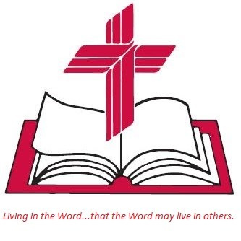

Anita Meier - Musician
Diana Motel – Livestream/Tech Booth

Living
Word

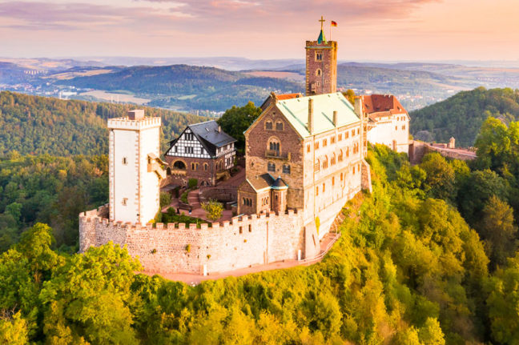
Wartburg Castle Fortress, where Luther translated the Bible

Reformation Sunday
October 30th, 2022
10:00 am Service

Living Word Lutheran Church (LCMS)
16301 Wolf Rd, Orland Park, IL 60467
livingwordorland.org (708) 403-9673
intouchlwlc@yahoo.com

REFORMATION SUNDAY ORDER OF WORSHIP:

Divine Service II (First Setting), Lutheran Worship page 158

Opening Hymn “The Church’s One Foundation” Hymn #289

Invocation Page 158 (in the front of the hymnal)

Confession & Absolution p. 158

Psalm of the Day Psalm 46 p. 328

Kyrie p. 159

Hymn of Praise “This Is the Feast” p. 161

Collect of the Day p. 164

Scripture Readings: 1st Epistle Revelation 14:6-7
2nd Epistle Romans 3:20-28
Gospel John 8:31-36

Hymn of the Day “A Mighty Fortress” Hymn #298

Sermon “Our Fortress”

Creed Nicene Creed p. 166

Prayers of the Church p. 167

Offertory “Let the Vineyards be Fruitful” p. 168
Please place offerings in basket at sanctuary entrance before or after service

Preface and Proper Preface p. 170

Prayer of Thanksgiving and Lord’s Prayer p. 171

Words of Institution and Pax Domini p. 171

Agnus Dei p. 172

~ Communion Distribution ~

Post-Communion Canticle “Thank The Lord” p. 173

Post-Communion Collect and Benediction p. 174

Closing Hymn “Lord, Keep Us Steadfast in Your Word” Hymn #334
“Our Fortress”
Psalm 46 says: “The Lord Almighty is with us; the God of Jacob is our fortress…”

1) God is my fortress of FEAR.
⁶ Then I saw another angel flying in midair, and he had the eternal gospel to proclaim to those who live on the earth—to every nation, tribe, language and people. ⁷ He said in a loud voice, “Fear God and give him glory, because the hour of his judgment has come. Worship him who made the heavens, the earth, the sea and the springs of water.” Revelation 14:6-7

2) God is my fortress of FAITH.
²⁰ Therefore no one will be declared righteous in God’s sight by the works of the law; rather, through the law we become conscious of our sin. ²¹ But now apart from the law the righteousness of God has been made known, to which the Law and the Prophets testify. ²² This righteousness is given through faith in Jesus Christ to all who believe. There is no difference between Jew and Gentile, ²³ for all have sinned and fall short of the glory of God, ²⁴ and all are justified freely by his grace through the redemption that came by Christ Jesus. ²⁵ God presented Christ as a sacrifice of atonement, through the shedding of his blood—to be received by faith. He did this to demonstrate his righteousness, because in his forbearance he had left the sins committed beforehand unpunished— ²⁶ he did it to demonstrate his righteousness at the present time, so as to be just and the one who justifies those who have faith in Jesus. ²⁷ Where, then, is boasting? It is excluded. Because of what law? The law that requires works? No, because of the law that requires faith. ²⁸ For we maintain that a person is justified by faith apart from the works of the law. Romans 3:20-28

3) God is my fortress of FREEDOM.
³¹ To the Jews who had believed him, Jesus said, “If you hold to my teaching, you are really my disciples. ³² Then you will know the truth, and the truth will set you free.” ³³ They answered him, “We are Abraham’s descendants and have never been slaves of anyone. How can you say that we shall be set free?” ³⁴ Jesus replied, “Very truly I tell you, everyone who sins is a slave to sin. ³⁵ Now a slave has no permanent place in the family, but a son belongs to it forever. ³⁶ So if the Son sets you free, you will be free indeed. John 8:31-36

