Worship Prayer…

Father in heaven, I admit I am a sinner and cannot save myself, but trust only in your Son Jesus Christ—true God and true man—who died on the cross for me and rose again to give me new life now and forever. By your Holy Spirit’s power take my heart and life and make me yours; turn me from my own selfish path to always love, trust and follow Jesus. Because you love and forgive me, help me forgive and love others. And now, as we gather together as your church in this place, make us one in truth and love according to the faithful leading and unfailing promises of your living Word. In Jesus’ name….Amen!

Living Word exists to…

- Proclaim God’s Love

- Expand God’s Kingdom

- Mature God’s People

- Live God’s Word!

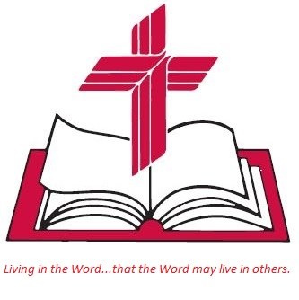

Anita Meier - Musician
Diana Motel – Livestream/Tech Booth

Living
Word

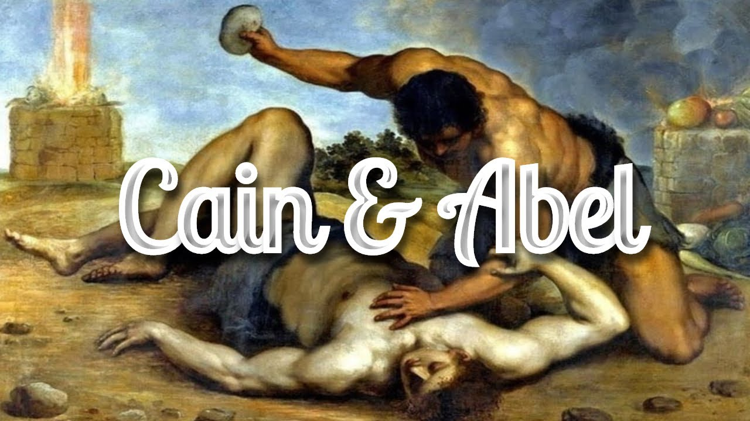

Twentieth Sunday after Pentecost
October 23rd, 2022
10:00 am Service

‘Come grow with us!’

Living Word Lutheran Church (LCMS)
16301 Wolf Rd, Orland Park, IL 60467
livingwordorland.org (708) 403-9673
intouchlwlc@yahoo.com
WELCOME TO LIVING WORD!
Blue church information card is in seat pocket

WE REJOICE IN GOD’S LOVE & FORGIVENESS…

Opening Prayer

Praise Song “I Offer My Life”
“For Those Tears I Died”
Invocation

Confession & Forgiveness On screen or Hymnal p. 158

Affirmation of Faith: Apostles’ Creed

WE RECEIVE GOD’S WORD…

Today’s Psalm Psalm 5

Scripture Readings Facing page

Message Song “Your Grace Is Sufficient”

Video John Steinbeck's East of Eden – trailer
youtube.com/watch?v=KViALN9bwo8

Message “From East of Eden”

WE RESPOND TO GOD’S CALL…

Prayers of God’s People

Lord’s Prayer

Benediction

Closing Song “Fight the Good Fight”

Please place offerings in basket at sanctuary entrance

“From East of Eden”
Psalm 5 says: “With you [God], evil people are not welcome…But I, by your great love, can come into your house.” Christ brings us home from east of Eden…

1) Christ brings me home from SIN.
³ In the course of time Cain brought some of the fruits of the soil as an offering to the Lord. ⁴ And Abel also brought an offering—fat portions from some of the firstborn of his flock. The Lord looked with favor on Abel and his offering, ⁵ but on Cain and his offering he did not look with favor. So Cain was very angry, and his face was downcast. ⁶ Then the Lord said to Cain, “Why are you angry? Why is your face downcast? ⁷ If you do what is right, will you not be accepted? But if you do not do what is right, sin is crouching at your door; it desires to have you, but you must rule over it.” ⁸ Now Cain said to his brother Abel, “Let’s go out to the field.” While they were in the field, Cain attacked his brother Abel and killed him. ⁹ Then the Lord said to Cain, “Where is your brother Abel?” “I don’t know,” he replied. “Am I my brother’s keeper?” ¹⁰ The Lord said, “What have you done? Listen! Your brother’s blood cries out to me from the ground. ¹¹ Now you are under a curse and driven from the ground, which opened its mouth to receive your brother’s blood from your hand.
¹² When you work the ground, it will no longer yield its crops for you. You will be a restless wanderer on the earth.” ¹³ Cain said to the Lord, “My punishment is more than I can bear. ¹⁴ Today you are driving me from the land, and I will be hidden from your presence; I will be a restless wanderer on the earth, and whoever finds me will kill me.” ¹⁵ But the Lord said to him, “Not so; anyone who kills Cain will suffer vengeance seven times over.” Then the Lord put a mark on Cain so that no one who found him would kill him. ¹⁶ So Cain went out from the Lord’s presence and lived in the land of Nod, east of Eden. Genesis 4:1-16

2) Christ brings me home from SUFFERING.
¹⁸ The Lord will rescue me from every evil attack and will bring me safely to his heavenly kingdom. To him be glory for ever and ever. Amen. 2 Timothy 4:18

3) Christ brings me home from SORROW.
⁹ To some who were confident of their own righteousness and looked down on everyone else, Jesus told this parable: ¹⁰ “Two men went up to the temple to pray, one a Pharisee and the other a tax collector. ¹¹ The Pharisee stood by himself and prayed: ‘God, I thank you that I am not like other people—robbers, evildoers, adulterers—or even like this tax collector. ¹² I fast twice a week and give a tenth of all I get.’ ¹³ “But the tax collector stood at a distance. He would not even look up to heaven, but beat his breast and said, ‘God, have mercy on me, a sinner.’ ¹⁴ “I tell you that this man, rather than the other, went home justified before God. For all those who exalt themselves will be humbled, and those who humble themselves will be exalted.” ¹⁵ People were also bringing babies to Jesus for him to place his hands on them. When the disciples saw this, they rebuked them. ¹⁶ But Jesus called the children to him and said, “Let the little children come to me, and do not hinder them, for the kingdom of God belongs to such as these. ¹⁷ Truly I tell you, anyone who will not receive the kingdom of God like a little child will never enter it.”
Luke 18:9-17

