Worship Prayer…

Father in heaven, I admit I am a sinner and cannot save myself, but trust only in your Son Jesus Christ—true God and true man—who died on the cross for me and rose again to give me new life now and forever. By your Holy Spirit’s power take my heart and life and make me yours; turn me from my own selfish path to always love, trust and follow Jesus. Because you love and forgive me, help me forgive and love others. And now, as we gather together as your church in this place, make us one in truth and love according to the faithful leading and unfailing promises of your living Word. In Jesus’ name….Amen!

Living Word exists to…

- Proclaim God’s Love

- Expand God’s Kingdom

- Mature God’s People

- Live God’s Word!

Pastor Steve Lee
revstevelee@gmail.com
708-334-5883

Anita Meier - Musician
Diana Motel – Livestream/Tech Booth

Living
Word

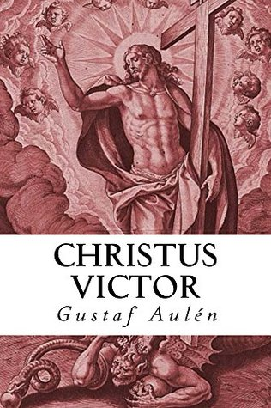

“CHRIST THE VICTOR”

All Saints’ Day
November 6th, 2022
10:00 am Service

‘Come grow with us!’

Living Word Lutheran Church (LCMS)
16301 Wolf Rd, Orland Park, IL 60467
livingwordorland.org (708) 403-9673
WELCOME TO LIVING WORD!
Blue church information card is in seat pocket

WE REJOICE IN GOD’S LOVE & FORGIVENESS…

Welcome & All Saints Remembrance

Opening Prayer

Praise Songs “Almighty”

Invocation

Confession & Forgiveness On screen or Hymnal p. 158

Affirmation of Faith: Nicene Creed

WE RECEIVE GOD’S WORD…

Today’s Psalm Psalm 149

Scripture Readings Facing page

Message Song “For All the Saints”

Video Winston Churchill's "Blood, Toil, Tears and Sweat" Speech
youtube.com/watch?v=fKBR0igDPfM 2:00 to 3:50

Message “Victory!”

WE RESPOND TO GOD’S CALL…

Prayers of God’s People

Lord’s Prayer

Communion “Lead Me to the Cross”

Benediction

Closing Song “Victory”

Please place offerings in basket at sanctuary entrance
“Victory!”
Psalm 149 says: “The Lord takes delight in his people; he crowns the humble with victory.” “Christ the Victor” wins us the victory…!

1) Christ wins the victory over my TEARS.
⁹ After this I looked, and there before me was a great multitude that no one could count, from every nation, tribe, people, and language,
standing before the throne and before the Lamb. They were wearing white robes and were holding palm branches in their hands. ¹⁰ And they cried out in a loud voice: “Salvation belongs to our God, who sits on the throne, and to the Lamb…” ¹⁷ …and God will wipe away every tear from their eyes. Revelation 7:9-10, 17b

2) Christ wins the victory over my TRANSGRESSIONS.
3 See what great love the Father has lavished on us, that we should be called children of God! And that is what we are! ² …Dear friends,
now we are children of God, and what we will be has not yet been made known. But we know that when Christ appears, we shall be like him, for we shall see him as he is. ³ All who have this hope in him purify themselves, just as he is pure. 1 John 3:1a, 2-3

3) Christ wins the victory over my TRIBULATIONS.
5 Now when Jesus saw the crowds, he went up on a mountainside and sat down. His disciples came to him, ² and he began to teach them.
He said: ³ “Blessed are the poor in spirit, for theirs is the kingdom of heaven. ⁴ Blessed are those who mourn, for they will be comforted.
⁵ Blessed are the meek, for they will inherit the earth. ⁶ Blessed are those who hunger and thirst for righteousness, for they will be filled.
⁷ Blessed are the merciful, for they will be shown mercy. ⁸ Blessed are the pure in heart, for they will see God. ⁹ Blessed are the peacemakers,
for they will be called children of God. ¹⁰ Blessed are those who are persecuted because of righteousness, for theirs is the kingdom of heaven. ¹¹ “Blessed are you when people insult you, persecute you and falsely say all kinds of evil against you because of me. ¹² Rejoice and be glad, because great is your reward in heaven, for in the same way they persecuted the prophets who were before you. Matthew 5:1-12

“Thanks be to God,
who gives us the victory through our Lord Jesus Christ!"
1 Corinthians 15:57

