Worship Prayer…

Father in heaven, I admit I am a sinner and cannot save myself, but trust only in your Son Jesus Christ—true God and true man—who died on the cross for me and rose again to give me new life now and forever. By your Holy Spirit’s power take my heart and life and make me yours; turn me from my own selfish path to always love, trust and follow Jesus. Because you love and forgive me, help me forgive and love others. And now, as we gather together as your church in this place, make us one in truth and love according to the faithful leading and unfailing promises of your living Word. In Jesus’ name….Amen!

Living Word exists to…

- Proclaim God’s Love

- Expand God’s Kingdom

- Mature God’s People

- Live God’s Word!

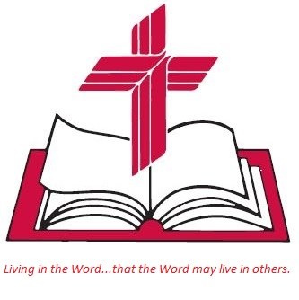

Anita Meier - Musician
Diana Motel – Livestream/Tech Booth

Living
Word

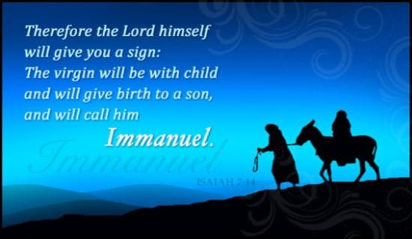

Fourth Sunday in Advent
December 18th, 2022
10:00 am Service

‘Come grow with us!’

Living Word Lutheran Church (LCMS)
16301 Wolf Rd, Orland Park, IL 60467
livingwordorland.org (708) 403-9673
intouchlwlc@yahoo.com
WELCOME TO LIVING WORD!

WE REJOICE IN GOD’S LOVE & FORGIVENESS…

Opening Prayer

Praise Song “Light One Candle”

Invocation

Confession & Forgiveness On screen or Hymnal p. 158

Affirmation of Faith: Nicene Creed

WE RECEIVE GOD’S WORD…

Today’s Psalm Psalm 24

Scripture Readings Facing page

Message Song “Lift Up Your Heads You Mighty Gates”

Video "For Unto Us a Child is Born" from Handel's Messiah
youtube.com/watch?v=2UGKEWJoFCc

“For unto us a Child is born, unto us a Son is given, and the government shall be upon His shoulder; and his name shall be called Wonderful Counsellor, the Mighty God, the Everlasting Father, the Prince of Peace.” — Isaiah 9:5

Message “Vindication”

WE RESPOND TO GOD’S CALL…

Prayers of God’s People

Lord’s Prayer

Communion “Jesus Your Name”

Benediction

Closing Song “King of Glory Comes”

Please place offerings in basket at sanctuary entrance

“Vindication”
“Who may ascend the mountain of the Lord? Who may stand in his holy place? The one who has clean hands and a pure heart, who does not trust in an idol or swear by a false god. They will receive blessing from the Lord and vindication from God their Savior.” Psalm 24:3-5

1) God’s PROPHETS were vindicated.
The Lord himself will give you a sign: The virgin will conceive and give birth to a son, and will call him Immanuel. Isaiah 7:14

2) God’s PROMISES have been vindicated.
Paul, a servant of Christ Jesus, called to be an apostle and set apart for the gospel of God— ² the gospel he promised beforehand through his prophets in the Holy Scriptures ³ regarding his Son, who as to his earthly life was a descendant of David, ⁴ and who through the Spirit of holiness was appointed the Son of God in power by his resurrection from the dead: Jesus Christ our Lord. ⁵ Through him we received grace and apostleship to call all the Gentiles to the obedience that comes from faith for his name’s sake. ⁶ And you also are among those Gentiles who are called to belong to Jesus Christ. Romans 1:1-6

3) God’s PEOPLE are vindicated!
¹⁸ This is how the birth of Jesus the Messiah came about: His mother Mary was pledged to be married to Joseph, but before they came together, she was found to be pregnant through the Holy Spirit. ¹⁹ Because Joseph her husband was faithful to the law, and yet did not want to expose her to public disgrace, he had in mind to divorce her quietly. ²⁰ But after he had considered this, an angel of the Lord appeared to him in a dream and said, “Joseph son of David, do not be afraid to take Mary home as your wife, because what is conceived in her is from the Holy Spirit. ²¹ She will give birth to a son, and you are to give him the name Jesus, because he will save his people from their sins.” ²² All this took place to fulfill what the Lord had said through the prophet: ²³ “The virgin will conceive and give birth to a son, and they will call him Immanuel” (which means “God with us”). ²⁴ When Joseph woke up, he did what the angel of the Lord had commanded him and took Mary home as his wife. ²⁵ But he did not consummate their marriage until she gave birth to a son. And he gave him the name Jesus. Matthew 1:18-25

