Worship Prayer…

Father in heaven, I admit I am a sinner and cannot save myself, but trust only in your Son Jesus Christ—true God and true man—who died on the cross for me and rose again to give me new life now and forever. By your Holy Spirit’s power take my heart and life and make me yours; turn me from my own selfish path to always love, trust and follow Jesus. Because you love and forgive me, help me forgive and love others. And now, as we gather together as your church in this place, make us one in truth and love according to the faithful leading and unfailing promises of your living Word. In Jesus’ name….Amen!

Living Word exists to…

- Proclaim God’s Love

- Expand God’s Kingdom

- Mature God’s People

- Live God’s Word!

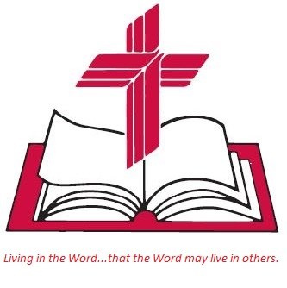

Anita Meier - Musician
Diana Motel – Livestream/Tech Booth

Living
Word

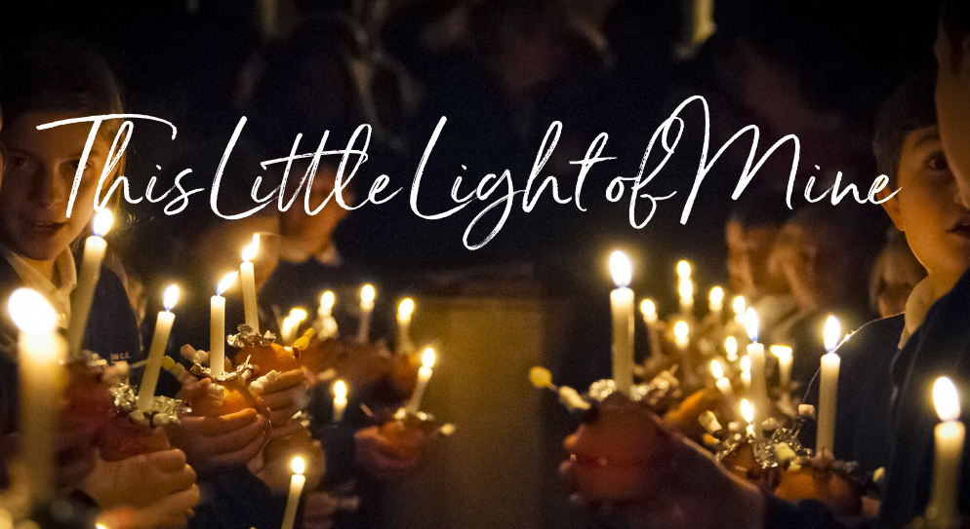

Living Word Early Childhood Christmas Presentation

Third Sunday in Advent
December 11th, 2022
10:00 am Service

‘Come grow with us!’

Living Word Lutheran Church (LCMS)
16301 Wolf Rd, Orland Park, IL 60467
livingwordorland.org (708) 403-9673
intouchlwlc@yahoo.com
WELCOME TO LIVING WORD!
Blue church information card is in seat pocket

WE REJOICE IN GOD’S LOVE & FORGIVENESS…

Opening Prayer

Praise Song “His Name Is Wonderful”
“Freely, Freely”
Invocation

Confession & Forgiveness On screen or Hymnal p. 158

Affirmation of Faith: Apostles’ Creed

WE RECEIVE GOD’S WORD…

Today’s Psalm Psalm 146

Scripture Readings Facing page

Children’s Message with Pastor Lee

Living Word Early Childhood Christmas Program See Insert

Children are dismissed for Children's Church with Mrs. Diana

Message “Set Free!”

WE RESPOND TO GOD’S CALL…

Prayers of God’s People

Lord’s Prayer

Benediction

Closing Song “God Is Good All the Time”

Please place offerings in basket at sanctuary entrance

“Set Free!”

Psalm 146 says: “The Lord sets prisoners free.”
The coming of Jesus means we are set free…!

1) Jesus’ coming sets me free from all FEAR.
⁴ Say to those with fearful hearts, “Be strong, do not fear; your God will come, he will come with vengeance; with divine retribution he will come to save you.” Isaiah 35:4

2) Jesus’ coming sets me free to stand firm like a FARMER.
⁷ Be patient, then, brothers and sisters, until the Lord’s coming. See how the farmer waits for the land to yield its valuable crop, patiently waiting for the autumn and spring rains. ⁸ You too, be patient and stand firm, because the Lord’s coming is near. James 5:7-8

3) Jesus’ coming sets me free by—and for—the FIGHT.
After Jesus had finished instructing his twelve disciples, he went on from there to teach and preach in the towns of Galilee. ² When John, who was in prison, heard about the deeds of the Messiah, he sent his disciples ³ to ask him, “Are you the one who is to come, or should we expect someone else?” ⁴ Jesus replied, “Go back and report to John what you hear and see: ⁵ The blind receive sight, the lame walk, those who have leprosy are cleansed, the deaf hear, the dead are raised, and the good news is proclaimed to the poor. ⁶ Blessed is anyone who does not stumble on account of me.” ⁷ As John’s disciples were leaving, Jesus began to speak to the crowd about John: “What did you go out into the wilderness to see? A reed swayed by the wind? ⁸ If not, what did you go out to see? A man dressed in fine clothes? No, those who wear fine clothes are in kings’ palaces. ⁹ Then what did you go out to see? A prophet? Yes, I tell you, and more than a prophet. ¹⁰ This is the one about whom it is written: “‘I will send my messenger ahead of you, who will prepare your way before you.’ ¹¹ Truly I tell you, among those born of women there has not risen anyone greater than John the Baptist; yet whoever is least in the kingdom of heaven is greater than he. ¹² From the days of John the Baptist until now, the kingdom of heaven has been subjected to violence, and violent people have been raiding it. ¹³ For all the Prophets and the Law prophesied until John.
¹⁴ And if you are willing to accept it, he is the Elijah who was to come.
¹⁵ Whoever has ears, let them hear. Matthew 11:1-15

