New Testament Reading:
1 Corinthians 1:18-31

¹⁸ For the message of the cross is foolishness to those who are perishing, but to us who are being saved it is the power of God. ¹⁹ For it is written: “I will destroy the wisdom of the wise; the intelligence of the intelligent I will frustrate.” ²⁰ Where is the wise person? Where is the teacher of the law? Where is the philosopher of this age? Has not God made foolish the wisdom of the world? ²¹ For since in the wisdom of God the world through its wisdom did not know him, God was pleased through the foolishness of what was preached to save those who believe. ²² Jews demand signs and Greeks look for wisdom, ²³ but we preach Christ crucified: a stumbling block to Jews and foolishness to Gentiles, ²⁴ but to those whom God has called, both Jews and Greeks, Christ the power of God and the wisdom of God. ²⁵ For the foolishness of God is wiser than human wisdom, and the weakness of God is stronger than human strength. ²⁶ Brothers and sisters, think of what you were when you were called. Not many of you were wise by human standards; not many were influential; not many were of noble birth. ²⁷ But God chose the foolish things of the world to shame the wise; God chose the weak things of the world to shame the strong. ²⁸ God chose the lowly things of this world and the despised things—and the things that are not—to nullify the things that are, ²⁹ so that no one may boast before him. ³⁰ It is because of him that you are in Christ Jesus, who has become for us wisdom from God—that is, our righteousness, holiness and redemption. ³¹ Therefore, as it is written: “Let the one who boasts boast in the Lord.” 1 Corinthians 1:18-31

Gospel Reading:
Matthew 5:1-12
Now when Jesus saw the crowds, he went up on a mountainside and sat down. His disciples came to him, ² and he began to teach them. He said: ³ “Blessed are the poor in spirit, for theirs is the kingdom of heaven. ⁴ Blessed are those who mourn, for they will be comforted. ⁵ Blessed are the meek, for they will inherit the earth. ⁶ Blessed are those who hunger and thirst for righteousness, for they will be filled. ⁷ Blessed are the merciful, for they will be shown mercy. ⁸ Blessed are the pure in heart, for they will see God. ⁹ Blessed are the peacemakers, for they will be called children of God. ¹⁰ Blessed are those who are persecuted because of righteousness, for theirs is the kingdom of heaven. ¹¹ “Blessed are you when people insult you, persecute you and falsely say all kinds of evil against you because of me. ¹² Rejoice and be glad, because great is your reward in heaven, for in the same way they persecuted the prophets who were before you.
Matthew 5:1-12

Living
Word

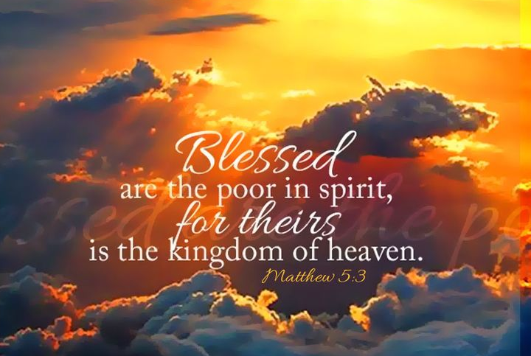

Fourth Sunday after the Epiphany
January 29th, 2023
10:00 am Service

‘Come grow with us!’

Living Word Lutheran Church (LCMS)
16301 Wolf Rd, Orland Park, IL 60467
livingwordorland.org (708) 403-9673
intouchlwlc@yahoo.com
WELCOME TO LIVING WORD!
Blue church information card is in seat pocket.
Order of service shown on-screen.

Today we welcome and thank guest Pastor Richard Mau!

WE REJOICE IN GOD’S LOVE & FORGIVENESS…

Opening Praise Songs “As the Deer”
“God Will Make a Way”
Invocation

Confession & Forgiveness

Affirmation of Faith

WE RECEIVE GOD’S WORD…

Today’s Psalm

Scripture Readings

Message Hymn “Jesus Sat with His Disciples”

Video The Beatitudes

Message: Pastor Mau “Strength in Weakness”

WE RESPOND TO GOD’S CALL…

Prayers of God’s People

Lord’s Prayer

Benediction

Closing Song “Just a Closer Walk with Thee”

Please place offerings in basket at sanctuary entrance
Today’s Psalm:
Psalm 15

Pastor: Lord, who may dwell in your sacred tent? Who may live on your holy mountain?

People: The one whose walk is blameless, who does what is righteous, who speaks the truth from their heart;

Pastor: Whose tongue utters no slander, who does no wrong to a neighbor, and casts no slur on others;

People: Who despises a vile person but honors those who fear the Lord; who keeps an oath even when it hurts, and does not change their mind;

Pastor: who lends money to the poor without interest; who does not accept a bribe against the innocent. Whoever does these things will never be shaken.

Old Testament Reading:
Micah 6:1-8

Listen to what the Lord says: “Stand up, plead my case before the mountains; let the hills hear what you have to say. ² “Hear, you mountains, the Lord’s accusation; listen, you everlasting foundations of the earth. For the Lord has a case against his people; he is lodging a charge against Israel. ³ “My people, what have I done to you? How have I burdened you? Answer me. ⁴ I brought you up out of Egypt and redeemed you from the land of slavery. I sent Moses to lead you, also Aaron and Miriam. ⁵ My people, remember what Balak king of Moab plotted and what Balaam son of Beor answered. Remember your journey from Shittim to Gilgal, that you may know the righteous acts
of the Lord.” ⁶ With what shall I come before the Lord and bow down before the exalted God? Shall I come before him with burnt offerings, with calves a year old? ⁷ Will the Lord be pleased with thousands of rams, with ten thousand rivers of olive oil? Shall I offer my firstborn for my transgression, the fruit of my body for the sin of my soul? ⁸ He has shown you, O mortal, what is good. And what does the Lord require of you? To act justly and to love mercy and to walk humbly with your God.

