New Testament Reading: *2 Peter 1:16-21*

**16**For we did not follow cleverly devised stories when we told you about the coming of our Lord Jesus Christ in power, but we were eyewitnesses of his majesty. **17**He received honor and glory from God the Father when the voice came to him from the Majestic Glory, saying, “This is my Son, whom I love; with him I am well pleased.” **18**We ourselves heard this voice that came from heaven when we were with him on the sacred mountain. **19**We also have the prophetic message as something completely reliable, and you will do well to pay attention to it, as to a light shining in a dark place, until the day dawns and the morning star rises in your hearts. **20**Above all, you must understand

that no prophecy of Scripture came about by the prophet’s own interpretation of things. **21**For prophecy never had its origin in the human will, but prophets, though human, spoke from God as they were carried along by the Holy Spirit.

Gospel Reading: *Matthew 17:1-9*

**The Transfiguration**

**17**After six days Jesus took with him Peter, James and John the brother of James, and led them up a high mountain by themselves.

**2**There he was transfigured before them. His face shone like the sun, and his clothes became as white as the light. **3**Just then there appeared before them Moses and Elijah, talking with Jesus. **4**Peter said to Jesus, “Lord, it is good for us to be here. If you wish, I will put up three shelters—one for you, one for Moses and one for Elijah.” **5**While he was still speaking, a bright cloud covered them, and a voice from the cloud said, “This is my Son, whom I love; with him I am well pleased. Listen to him!” **6**When the disciples heard this, they fell facedown to the ground, terrified. **7**But Jesus came and touched them. “Get up,” he said. “Don’t be afraid.” **8**When they looked up, they saw no one except Jesus. **9**As they were coming down the mountain, Jesus instructed them, “Don’t tell anyone what you have seen, until the Son of Man has been raised from the dead.”

**Pastor Steve Lee**

Anita Meier - Musician

Diana Motel – Livestream/Tech Booth

***Living***

***Word***

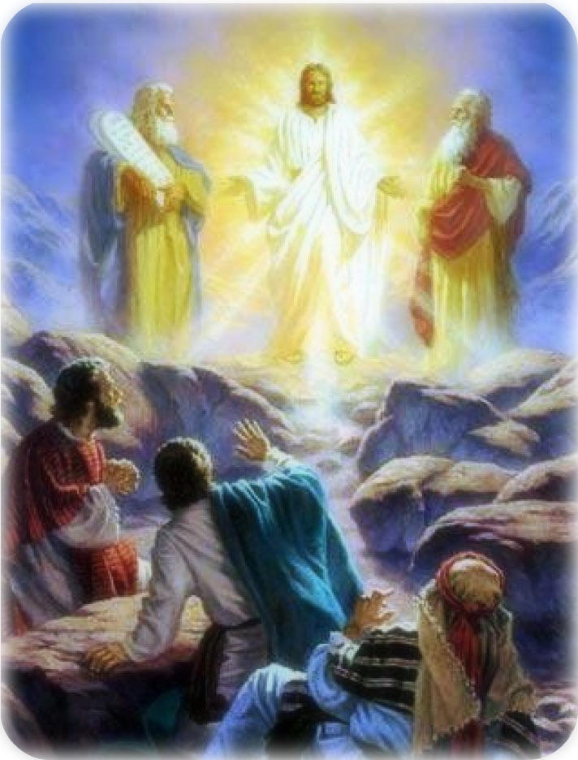

**Transfiguration of Our Lord Sunday**

February 19th, 2023

10:00 am Service

***‘Come grow with us!’***

Living Word Lutheran Church (LCMS)

16301 Wolf Rd, Orland Park, IL 60467

livingwordorland.org (708) 403-9673

intouchlwlc@yahoo.com

***WELCOME TO LIVING WORD!***

Blue church information card is in seat pocket.

Order of service shown on-screen.

*Today we welcome and thank guest Pastor Matthew Dubensky!*

## ***WE REJOICE IN GOD’S LOVE & FORGIVENESS…***

## Opening Praise Songs *“Majesty”*

Invocation

Confession & Forgiveness

Affirmation of Faith *Nicene Creed*

***WE RECEIVE GOD’S WORD…***

## Today’s Psalm

Scripture Readings

Message Hymn *“How Good, Lord, to Be Here”*

Message: Pastor Matt Dubensky

***WE RESPOND TO GOD’S CALL…***

Prayers of God’s People

Lord’s Prayer

Communion *“White As Snow”*

Benediction

Closing Song *“Shine, Jesus Shine”*

*Please place offerings in basket at sanctuary entrance*

Today’s Psalm: *Psalm 2:6-12*

Pastor: “I have installed my king on Zion, my holy mountain.”

People:I will proclaim the Lord’s decree: He said to me, “You

are my son; today I have become your father.

Pastor: Ask me, and I will make the nations your inheritance,  
the ends of the earth your possession.

People:You will break them with a rod of iron; you will dash

them to pieces like pottery.”

Pastor:Therefore, you kings, be wise; be warned, you rulers of the earth.

People: Serve the Lord with fear and celebrate his rule with trembling.

Pastor: Kiss his son, or he will be angry and your way will lead to your destruction, for his wrath can flare up in a moment. Blessed are all who take refuge in him.

Old Testament Reading: *Exodus 24:8-18*

**8**Moses then took the blood, sprinkled it on the people and said, “This is the blood of the covenant that the Lord has made with you in accordance with all these words.” **9**Moses and Aaron, Nadab and Abihu, and the seventy elders of Israel went up **10**and saw the God of Israel. Under his feet was something like a pavement made of lapis lazuli, as bright blue as the sky. **11**But God did not raise his hand against these leaders of the Israelites; they saw God, and they ate and drank. **12**The Lord said to Moses, “Come up to me on the mountain and stay here, and I will give you the tablets of stone with the law and commandments I have written for their instruction.” **13**Then Moses set out with Joshua his aide, and Moses went up on the mountain of God. **14**He said to the elders, “Wait here for us until we come back to you. Aaron and Hur are with you, and anyone involved in a dispute can go to them.” **15**When Moses went up on the mountain, the cloud covered it, **16**and the glory of the Lord settled on Mount Sinai. For six days the cloud covered the mountain, and on the seventh day the Lord called to Moses from within the cloud. **17**To the Israelites the glory of the Lord looked like a consuming fire on top of the mountain. **18**Then Moses entered the cloud as he went on up the mountain. And he stayed on the mountain forty days and forty nights.