3) Am I keeping watch for the Bridegroom’s BANQUET?
25 “At that time the kingdom of heaven will be like ten virgins who took their lamps and went out to meet the bridegroom. ² Five of them were foolish and five were wise. ³ The foolish ones took their lamps but did not take any oil with them. ⁴ The wise ones, however, took oil in jars along with their lamps. ⁵ The bridegroom was a long time in coming, and they all became drowsy and fell asleep. ⁶ “At midnight the cry rang out: ‘Here’s the bridegroom! Come out to meet him!’ ⁷ “Then all the virgins woke up and trimmed their lamps. ⁸ The foolish ones said to the wise, ‘Give us some of your oil; our lamps are going out.’
⁹ “‘No,’ they replied, ‘there may not be enough for both us and you. Instead, go to those who sell oil and buy some for yourselves.’ ¹⁰ “But while they were on their way to buy the oil, the bridegroom arrived. The virgins who were ready went in with him to the wedding banquet. And the door was shut. ¹¹ “Later the others also came. ‘Lord, Lord,’ they said, ‘open the door for us!’ ¹² “But he replied, ‘Truly I tell you, I don’t know you.’ ¹³ “Therefore keep watch, because you do not know the day or the hour. Matthew 25:1-13

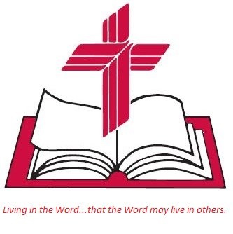

Living
Word

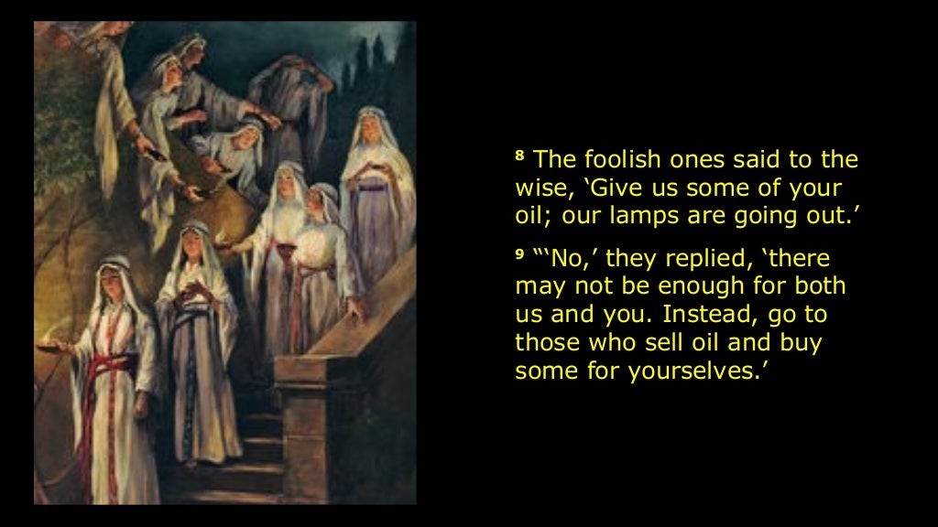

Twenty-fourth Sunday after Pentecost
Blended Service
November 12th, 2023
10:00 am Service

‘Come grow with us!’

Living Word Lutheran Church (LCMS)
16301 Wolf Rd, Orland Park, IL 60467
livingwordorland.org (708) 403-9673
intouchlwlc@yahoo.com

WELCOME TO LIVING WORD!
Blue church information card is in seat pocket.
Order of service shown on-screen.

WE REJOICE IN GOD’S LOVE & FORGIVENESS…

Opening Prayer

Praise Songs “Peace Is Flowing Like a River”

“Your Grace Is Sufficient”

Invocation

Confession & Forgiveness

Affirmation of Faith Nicene Creed

WE RECEIVE GOD’S WORD…

Today’s Psalm: Psalm 70

Scripture Readings Facing page and back of worship folder

Message Song “The Battle Belongs to the Lord”

Message “Maranatha!”

WE RESPOND TO GOD’S CALL…

Prayers of God’s People

Lord’s Prayer

Communion Song & Communion “Lamb of God” (Refrain only)

Benediction

Closing Song “Fight the Good Fight”

Please place offerings in basket at sanctuary entrance

“Maranatha!”

Psalm 70 says: “Hasten, O God, to save me; come quickly, Lord, to help me!” As the end of the church year approaches, we join in the ancient prayer of the church: “Maranatha…Come, Lord Jesus!” But while we eagerly await the Lord’s return at the end of time, we also ask ourselves three questions about our personal readiness…

1) Am I letting roll a river of RIGHTEOUSNESS?
¹⁸ Woe to you who long for the day of the Lord! Why do you long for the day of the Lord? That day will be darkness, not light. ¹⁹ It will be as though a man fled from a lion only to meet a bear, as though he entered his house and rested his hand on the wall only to have a snake bite him. ²⁰ Will not the day of the Lord be darkness, not light—
pitch-dark, without a ray of brightness? ²¹ “I hate, I despise your religious festivals; your assemblies are a stench to me. ²² Even though you bring me burnt offerings and grain offerings, I will not accept them. Though you bring choice fellowship offerings, I will have no regard for them. ²³ Away with the noise of your songs! I will not listen to the music of your harps. ²⁴ But let justice roll on like a river,
righteousness like a never-failing stream! Amos 5:18-24

2) Am I staying encouraged by informed EXPECTATION?
¹³ Brothers and sisters, we do not want you to be uninformed about those who sleep in death, so that you do not grieve like the rest of mankind, who have no hope. ¹⁴ For we believe that Jesus died and rose again, and so we believe that God will bring with Jesus those who have fallen asleep in him. ¹⁵ According to the Lord’s word, we tell you that we who are still alive, who are left until the coming of the Lord,
will certainly not precede those who have fallen asleep. ¹⁶ For the Lord himself will come down from heaven, with a loud command, with the voice of the archangel and with the trumpet call of God, and the dead in Christ will rise first. ¹⁷ After that, we who are still alive and are left
will be caught up together with them in the clouds to meet the Lord in the air. And so we will be with the Lord forever. ¹⁸ Therefore encourage one another with these words. 1 Thessalonians 4:13-18

