that they would seek him and perhaps reach out for him and find him, though he is not far from any one of us. ²⁸ ‘For in him we live and move and have our being.’ As some of your own poets have said, ‘We are his offspring.’ ²⁹ “Therefore since we are God’s offspring, we should not think that the divine being is like gold or silver or stone—an image made by human design and skill. ³⁰ In the past God overlooked such ignorance, but now he commands all people everywhere to repent. ³¹ For he has set a day when he will judge the world with justice by the man he has appointed. He has given proof of this to everyone by raising him from the dead.” ³² When they heard about the resurrection of the dead, some of them sneered, but others said, “We want to hear you again on this subject.” ³³ At that, Paul left the Council. ³⁴ Some of the people became followers of Paul and believed. Acts 17:16-34

3) God shines forth from the Mount of TRANSFIGURATION.
² After six days Jesus took Peter, James and John with him and led them up a high mountain, where they were all alone. There he was transfigured before them. ³ His clothes became dazzling white, whiter than anyone in the world could bleach them. ⁴ And there appeared before them Elijah and Moses, who were talking with Jesus. ⁵ Peter said to Jesus, “Rabbi, it is good for us to be here. Let us put up three shelters—one for you, one for Moses and one for Elijah.” ⁶ (He did not know what to say, they were so frightened.) ⁷ Then a cloud appeared and covered them, and a voice came from the cloud: “This is my Son, whom I love. Listen to him!” ⁸ Suddenly, when they looked around, they no longer saw anyone with them except Jesus. ⁹ As they were coming down the mountain, Jesus gave them orders not to tell anyone what they had seen until the Son of Man had risen from the dead. Mark 9:2-9

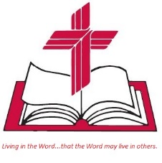
Living Word Lutheran Church (LCMS)
16301 Wolf Rd, Orland Park, IL 60467
livingwordorland.org (708) 403-9673
intouchlwlc@yahoo.com

Living
Word

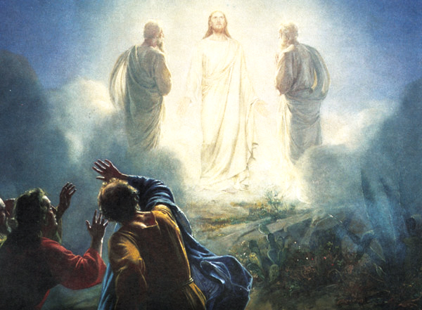

Transfiguration Sunday
February 11th, 2024
10:00 am Service

WELCOME TO LIVING WORD!
Blue church information card is in seat pocket.
Order of service shown on-screen.

WE REJOICE IN GOD’S LOVE & FORGIVENESS…

Opening Prayer

Praise Songs “Only By Grace”
“Lord, I Lift Your Name on High”

Invocation

Confession & Forgiveness

Affirmation of Faith Apostles’ Creed

WE RECEIVE GOD’S WORD…

Today’s Psalm: Psalm 50:1-6

Scripture Readings Facing page

Message Song “Arise and Shine in Splendor”

Message “God Shines Forth”

WE RESPOND TO GOD’S CALL…

Prayers of God’s People

Lord’s Prayer

Benediction

Closing Song “Shine, Jesus Shine”

Please place offerings in basket at sanctuary entrance

“God Shines Forth”

Psalm 50: “From [Mount] Zion, perfect in beauty, God shines forth.”
1) God shines forth from Mount SINAI.
²⁹ When Moses came down from Mount Sinai with the two tablets of the covenant law in his hands, he was not aware that his face was
radiant because he had spoken with the Lord... Exodus 34:29

2) God shines forth from MARS Hill.
¹² Therefore, since we have such a hope, we are very bold….
⁶ For God, who said, “Let light shine out of darkness,” made his light shine in our hearts to give us the light of the knowledge of God’s glory displayed in the face of Christ. 2 Corinthians 3:12, 4:6

¹⁶ While Paul was waiting for them in Athens, he was greatly distressed to see that the city was full of idols. ¹⁷ So he reasoned in the synagogue with both Jews and God-fearing Greeks, as well as in the marketplace day by day with those who happened to be there. ¹⁸ A group of Epicurean and Stoic philosophers began to debate with him. Some of them asked, “What is this babbler trying to say?” Others remarked, “He seems to be advocating foreign gods.” They said this because Paul was preaching the good news about Jesus and the resurrection. ¹⁹ Then they took him and brought him to a meeting of the Areopagus, where they said to him, “May we know what this new teaching is that you are presenting? ²⁰ You are bringing some strange ideas to our ears, and we would like to know what they mean.” ²¹ (All the Athenians and the foreigners who lived there spent their time doing nothing but talking about and listening to the latest ideas.) ²² Paul then stood up in the meeting of the Areopagus and said: “People of Athens! I see that in every way you are very religious. ²³ For as I walked around and looked carefully at your objects of worship, I even found an altar with this inscription: to an unknown god. So you are ignorant of the very thing you worship—and this is what I am going to proclaim to you. ²⁴ “The God who made the world and everything in it is the Lord of heaven and earth and does not live in temples built by human hands. ²⁵ And he is not served by human hands, as if he needed anything. Rather, he himself gives everyone life and breath and everything else. ²⁶ From one man he made all the nations, that they should inhabit the whole earth; and he marked out their appointed times in history and the boundaries of their lands. ²⁷ God did this so

