be any curse. The throne of God and of the Lamb will be in the city, and his servants will serve him. **4**They will see his face, and his name will be on their foreheads. **5**There will be no more night. They will not need the light of a lamp or the light of the sun, for the Lord God will give them light. And they will reign for ever and ever. **6**The angel said to me, “These words are trustworthy and true. The Lord, the God who inspires the prophets, sent his angel to show his servants the things that must soon take place.”… **12**“Look, I am coming soon! My reward is with me, and I will give to each person according to what they have done. **13**I am the Alpha and the Omega, the First and the Last, the Beginning and the End. **14**“Blessed are those who wash their robes, that they may have the right to the tree of life and may go through the gates into the city. **15**Outside are the dogs, those who practice magic arts, the sexually immoral, the murderers, the idolaters and everyone who loves and practices falsehood. **16**“I, Jesus, have sent my angel to give you this testimony for the churches. I am the Root and the Offspring of David, and the bright Morning Star.” **17**The Spirit and the bride say, “Come!” And let the one who hears say, “Come!” Let the one who is thirsty come; and let the one who wishes take the free gift of the water of life. **18**I warn everyone who hears the words of the prophecy of this scroll: If anyone adds anything to them, God will add to that person the plagues described in this scroll. **19**And if anyone takes words away from this scroll of prophecy, God will take away from that person any share in the tree of life and in the Holy City, which are described in this scroll. **20**He who testifies to these things says, “Yes, I am coming soon.” Amen. Come, Lord Jesus. Revelation 22:1-6, 12-20

***3) The Dew of Hermon fills up our HEARTS OF LOVE.***

**20**“My prayer is not for them alone. I pray also for those who will believe in me through their message, **21**that all of them may be one, Father, just as you are in me and I am in you. May they also be in us so that the world may believe that you have sent me. **22**I have given them the glory that you gave me, that they may be one as we are one— **23**I in them and you in me—so that they may be brought to complete unity. Then the world will know that you sent me and have loved them even as you have loved me. **24**“Father, I want those you have given me to be with me where I am, and to see my glory, the glory you have given me because you loved me before the creation of the world. **25**“Righteous Father, though the world does not know you, I know you, and they know that you have sent me. **26**I have made you known to them, and will continue to make you known in order that the love you have for me may be in them and that I myself may be in them.” John 17:20-26

***Living***

***Word***

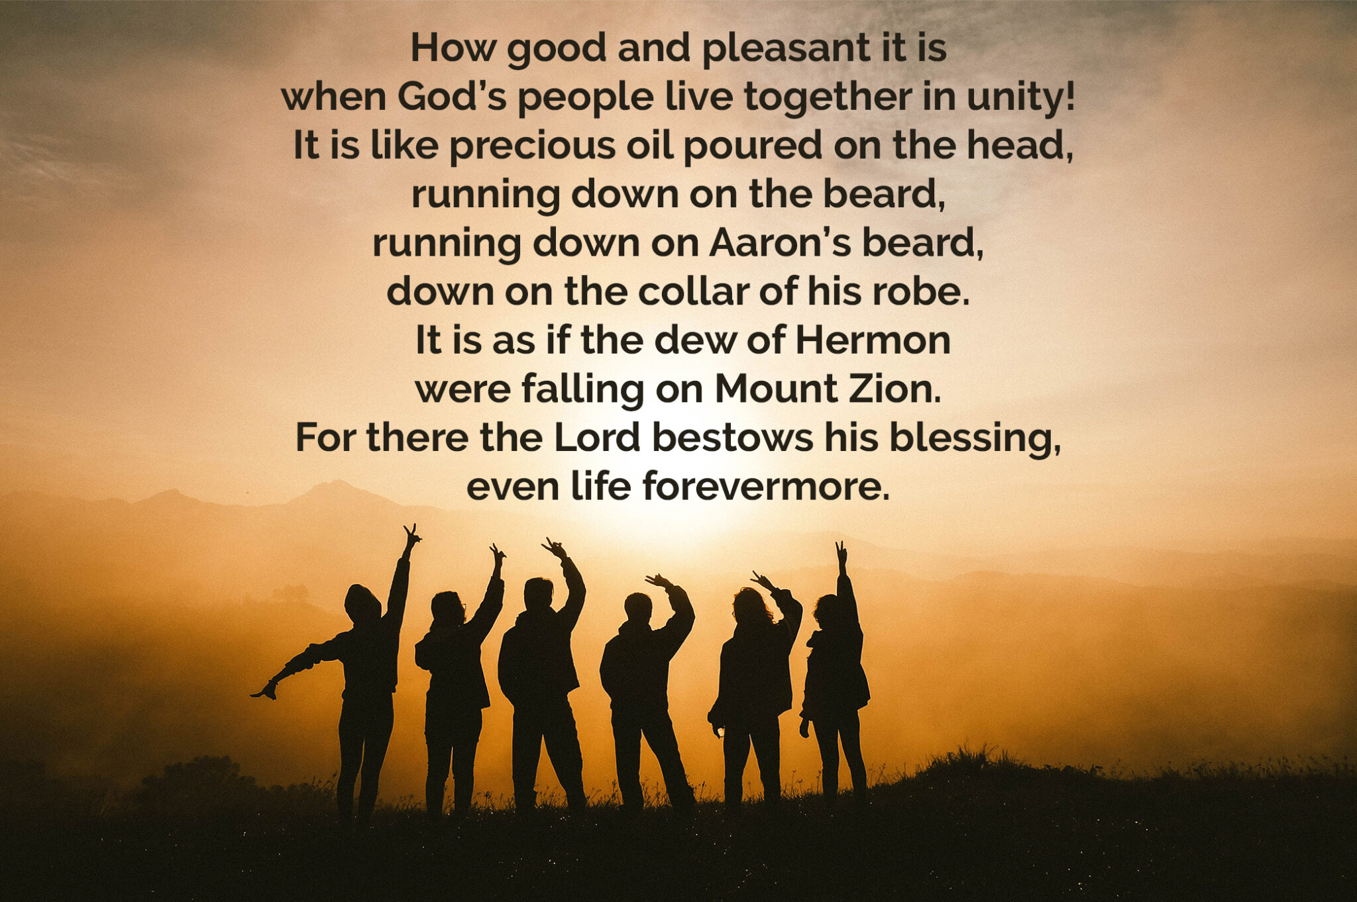

**Seventh Sunday of Easter**

June 1st, 2025

10:00 am Service

***WELCOME TO LIVING WORD!***

*Blue church information card is in seat pocket*

Order of Worship: Lutheran Service Book

Divine Service, Setting Three

p. 184-202

Hymn of Invocation  *“Rise, Shine, You People” LSB #825*

1. Appointed Scripture Readings:

Psalm *Psalm 133*

1st Epistle Reading *Acts 1:12-26*

2nd Epistle Reading *Revelation 22:1-6, 12-20*

Gospel Reading  *John 17:20-26*

Hymn of the Day *“Praise to the Lord, the Almighty” LSB #790*

Sermon *“The Dew of Hermon”*

Closing Hymn *“Forth in Thy Name, O Lord, I Go” LSB #854*

***Please place your offering in the basket at the rear of the sanctuary***

***“The Dew of Hermon”***

Psalm 133 says: *“How good and pleasant it is when God’s people live together in unity! …It is like the dew of Hermon falling on Mount Zion, For there the Lord bestows his blessing, even life forevermore…”*

***1) The Dew of Hermon floods over the FIELD OF BLOOD.***

**12**Then the apostles returned to Jerusalem from the hill called the Mount of Olives, a Sabbath day’s walk from the city. **13**When they arrived, they went upstairs to the room where they were staying. Those present were Peter, John, James and Andrew; Philip and Thomas, Bartholomew and Matthew; James son of Alphaeus and Simon the Zealot, and Judas son of James. **14**They all joined together constantly in prayer, along with the women and Mary the mother of Jesus, and with his brothers. **15**In those days Peter stood up among the believers (a group numbering about a hundred and twenty) **16**and said, “Brothers and sisters, the Scripture had to be fulfilled in which the Holy Spirit spoke long ago through David concerning Judas, who served as guide for those who arrested Jesus. **17**He was one of our number and shared in our ministry.” **18**(With the payment he received for his wickedness, Judas bought a field; there he fell headlong, his body burst open and all his intestines spilled out. **19**Everyone in Jerusalem heard about this, so they called that field in their language Akeldama, that is, Field of Blood.) **20**“For,” said Peter, “it is written in the Book of Psalms: “‘May his place be deserted; let there be no one to dwell in it,’ and, “‘May another take his place of leadership.’ **21**Therefore it is necessary to choose one of the men who have been with us the whole time the Lord Jesus was living among us, **22**beginning from John’s baptism to the time when Jesus was taken up from us. For one of these must become a witness with us of his resurrection.” **23**So they nominated two men: Joseph called Barsabbas (also known as Justus) and Mathias. **24**Then they prayed, “Lord, you know everyone’s heart. Show us which of these two you have chosen **25**to take over this apostolic ministry, which Judas left to go where he belongs.” **26**Then they cast lots, and the lot fell to Matthias; so he was added to the eleven apostles.

Acts 1:12-26

***2) The Dew of Hermon flows from the THRONE OF GOD.***

**22**Then the angel showed me the river of the water of life, as clear as crystal, flowing from the throne of God and of the Lamb **2**down the middle of the great street of the city. On each side of the river stood the tree of life, bearing twelve crops of fruit, yielding its fruit every month. And the leaves of the tree are for the healing of the nations. **3**No longer will there