February 2026 Mission of the Month

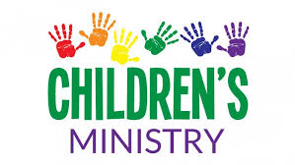

For February, we are collecting donations to support our children's ministry. The funds will be used for supplies for our Vacation Bible School (VBS) program and Easter egg hunt coming up in March. We also aim to organize more activities for children during the summer and fall. We appreciate any donations to help us share the word of God with our youth. You can drop off your donation at the church during worship, mail it in, or use our giving page and select "Mission of the Month." Thank you for your support!

