Our March 2026 Mission of the Month is Lutheran Church Charities. We will be collecting donations all month long. On Sunday, March 8th, two of the comfort dogs will be here during worship to give us an update and allow us to meet the dogs.

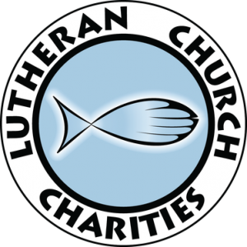

LCC's Mission
Share the Mercy, Compassion, Presence and Proclamation of Jesus Christ to those who are suffering and in need.
​Originally headquartered in Addison, Illinois, and currently in Northbrook, Illinois, Lutheran Church Charities (LCC) was founded in 1947 as a 501(c)(3) nonprofit ministry to help support Christian human care ministries of the Church. LCC works throughout the United States and Internationally in bringing the Mercy, Compassion, Presence and Proclamation of Jesus Christ to those Suffering and in Need. LCC works with and in partnership with our churches. LCC is an RSO (Recognized Service Organization) of the Lutheran Church - Missouri Synod. We operate with a Dollar In – Dollar Out funding process where EVERY dollar given for a cause goes directly to that cause or need, with LCC acknowledging the gift and overseeing that the money is used as intended.

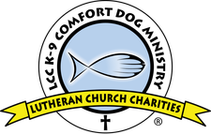

LCC K-9 Comfort Dog Ministry®
Launched in August 2008, the Lutheran Church Charities K-9 Comfort Dog Ministry is a national human-care ministry embracing the unique, calming nature and skills of purebred Golden Retrievers. The LCC K-9 Comfort Dogs are a bridge for compassionate ministry, opening doors for conversation about faith and creating opportunities to share the mercy, compassion, presence and proclamation of Jesus Christ.

The LCC K-9 Comfort Dogs serve every day in the community in which they are placed and are dispatched in times of disaster and crisis to bring comfort to all those affected, including first responders and the volunteers who serve them. LCC K-9 Comfort Dogs were in New York and New Jersey visiting victims of Superstorm Sandy, and in Connecticut after the tragedy at Sandy Hook Elementary School. Lutheran Church Charities currently has over 130 LCC K-9 Comfort Dogs serving in more than 27 states. LCC operates training facilities in Illinois and Nebraska.

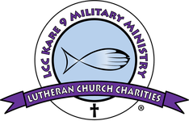

LCC Kare 9 Military Ministry®
The LCC Kare 9 Military Ministry® is a ministry by veterans for veterans. They strive to serve our military, veterans and their families. The Kare 9 Military Ministry dogs and their trained veteran handlers visit many places, including VFWs, VA hospitals, Traumatic Brain Injury (TBI) Care Centers, homes of veterans that are home bound, Expos, Vet Clinics, Yellow Ribbon Ceremonies and various other activities to help spread the mercy and compassion of Christ Jesus.

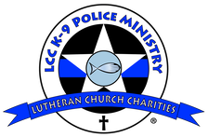

LCC K-9 Police Ministry®

The LCC K-9 Police Ministry handlers are law enforcement officers (current and former) who understand the unique challenges facing the law enforcement community. They bring Mercy, Compassion, Presence, and Proclamation of Jesus Christ to those who protect and serve, as well as their families.
​
Crisis Response – Serving law enforcement and family members in their time of need, by providing comfort following injuries, deaths, or major incidents.

Ongoing Support – K-9 visits (headquarters, substations, dispatch centers), assistance with department missions (Christmas shopping with children, summer camps, public events), comforting crime victims (prior to interviews, counseling, or courtroom testimony), and general support for department members and their families.

LCC Disaster Response Ministries coordinates the deployment of trained volunteers for Disaster Response. When disasters strike; lives, homes, businesses, churches and more are affected. LCC L.E.R.T. volunteers respond quickly to serve people affected by a disaster. LCC teams are trained to work through local churches to serve their communities. LCC Disaster Response provides on-site and online Lutheran Early Response Team (L.E.R.T.) basic training. Additional training includes expertise in the area of chainsaw, heavy equipment, debris removal, flood recovery, and emotional and spiritual care.

LCC Human Care Ministries work with pastors and congregations to pass through donor financial assistance, in-kind donations, volunteer people resources, emotional or spiritual support.

Hearts of Mercy & Compassion (HMC), Crosses for Losses provides a physical and spiritual symbol through the giving of hearts and crosses to families and friends who have suffered a loss or are experiencing the illness of a loved one. An HMC can also be given to celebrate a victory, honor service, as an expression of love, or to be an encouragement in the face of adversity. Given as a gift, each HMC provides the love and hope of Jesus through presence and prayer. Upon request, Lutheran Church Charities, working through churches, can provide an HMC at no charge.

Other LCC ministries include international and domestic ministries, church worker support, WORD Bible Studies, Congregational Preparedness, and support for pass-through needs and causes.

