AGNUS DEI

“Lamb of God” (Refrain)

O Lamb of God, sweet Lamb of God,
I love the holy Lamb of God!
O wash me in His precious blood.
My Jesus Christ the Lamb of God.

COMMUNION

COMMUNION SONG “Jesus, Refuge of the Weary”

PRAYER

Pastor: Gracious God, our heavenly Father, You have given us a foretaste of the feast to come in the Holy Supper of Your Son’s body and blood. Keep us firm in the true faith this Lenten season and throughout all the days of our pilgrimage that, on the day of His coming, we may, together with all Your saints, celebrate the marriage feast of the Lamb in His kingdom which has no end; through Jesus Christ, Your Son, our Lord, who lives and reigns with You and the Holy Spirit, one God, now and forever.
People: Amen.

BENEDICTION

Pastor: The Lord bless you and keep you.
The Lord make His face shine on you
and be gracious to you.
The Lord look upon you with favor
and give you peace.
People: Amen.

CLOSING SONG “There Is a Redeemer”

Living
Word

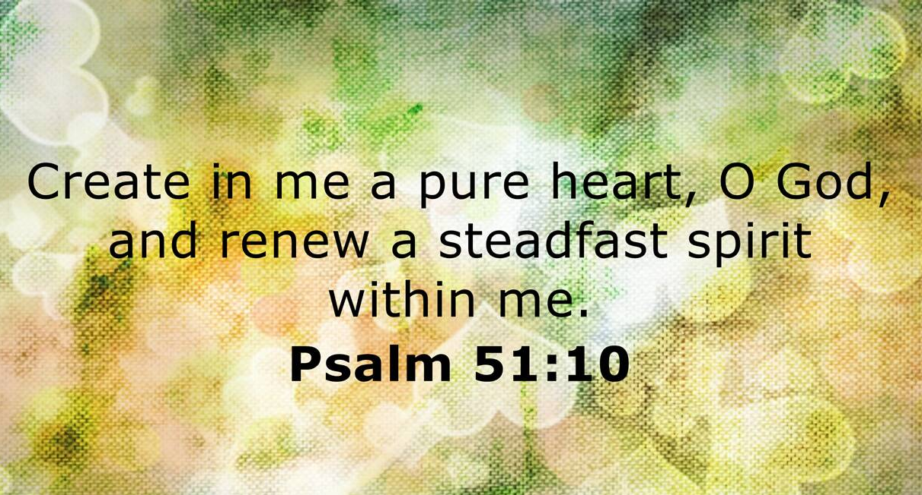

Ash Wednesday Service
February 18th, 2026
6:30 pm

WE BEGIN OUR LENTEN JOURNEY…

P: Adam and Eve were created to live forever in God’s presence, but they rebelled and then hid from Him. They brought Satan’s curse of sin, suffering and death to all of us. But we too have all rebelled. In Genesis 3:19, God pronounces the consequences of our choosing death
instead of life: “Dust you are and to dust you will return.” On Ash Wednesday we remember that because of sin we are but dust, but we also remember where our Lenten journey leads—to the cross of Christ, where by His death we find forgiveness and new life, both now and forever!

Litany for Ash Wednesday: Our Confession

Imposition of Ashes “Dust you are and to dust you will return.”

Opening Song “Christ, the Life of All the Living”

Invocation
P: We begin this penitential season of Lent in the Name of the Triune God—God our Creator and Father, God His Son our Savior and Shepherd, and God the Holy Spirit our Sanctifier, Helper and Comforter.
C: Amen.

Penitential Psalm Psalm 51:1-13

Absolution
P: God the Father of Mercies has reconciled the world to
himself through the life, death, and resurrection of His Son, Jesus Christ, not counting our sins against us. Upon your confession, I, a servant of the Word, assure you of God’s forgiveness for all your sins in the name of the Father, the Son, and the Holy Spirit.
C: Amen.

Scripture Readings

Joel 2:12-19 2 Corinthians 5:20-6:2 Matthew 6:1-6, 16-21

Message Hymn “Glory Be to Jesus”

Meditation “A Pure Heart” Text: Psalm 51:10

Song “My Jesus, I Love Thee”

Litany for Ash Wednesday: God’s Encouragement

Lord’s Prayer

SERVICE OF HOLY COMMUNION

Blessing, Thanks & Praise
Pastor: The Lord be with you.
People: And also with you.
Pastor: Lift up your hearts.
People: We lift them up to the Lord.
Pastor: Let us give thanks to the Lord our God.
People: It is right to give Him thanks and praise.

The Words of Our Lord
Pastor: Our Lord Jesus Christ, on the night when He was betrayed, took bread, and when He had given thanks, He broke it and gave it to His disciples and said: "Take, eat; this is My body which is given for you. Do this in remembrance of Me."

In the same way also He took the cup after supper, and when He had given thanks, He gave it to them, saying: "Drink of it, all of you; this cup is the new testament in My blood, which is shed for you for the forgiveness of sins. Do this, as often as you drink it, in remembrance of Me."

Pastor: The peace of the Lord be with you always.
People: And also with you.

